

Contents

1. Project Proposal 10

1.1 Current Business Introduction 10

1.1.1 History 10

1.1.2 Business Process 10

1.1.3 Issues 11

1.2 Propose System Scope 12

1.2.1 System to Be Development 12

1.3 Aims and Objectives 13

1.4 Estimate Cost and Duration 15

1.4.1 Software 15

1.4.2 Hardware 15

1.4.3 Development 16

1.4.4 Summary 16

1.4.5 Duration 16

1.4.6 Project Plan 17

2. Chapter – 1 Introduction 20

2.1 Current Business Introduction 20

2.1.1 History 20

2.1.2 Business Process 21

2.1.3 Issues 23

2.2 Propose System Scope 24

7.2.1 Process to be changed 24

2.3 Aims and Objectives 26

3. Chapter-2 Similar Product Comparison 30

3.1 Similar Product Introduction 30

3.2 Functional Comparison 31

3.3 Non-Functional Comparison 37

Visibility of system status 37

4. Chapter-3 Feasibility Study 42

4.1 Technical Feasibility 42

4.1.1 Methodology 42

4.1.2 Language (ASP.NET) 45

4.1.3 Database 48

4.2 DSDM Feasibility 51

5. Chapter-4 Foundation 56

5.1 Target User 56

5.2 Functional Requirement 58

5.3 MoSCoW Priorities 59

5.4 Non-Functional Requirement 60

5.5 Time Box Plan 62

10.5.1 The Whole Time Box Plan 62

Time Box 1: Purchase and Register of Books 63

Time Box 2: Member Register and Borrow Function 64

Time Box 3: Return and DueDate Calculation Function 65

5.6 Risk Management 66

5.6.1 Critical Success Factors 66

5.6.2 Major Sources of Risks 67

5.6.3 Personal 68

5.6.4 Technical 69

5.6.5 Risk Matrix 70

6. Chapter-5 Exploration and Engineering 81

6.1 Time Box-1 81

Project Plan For Time Box-1 81

6.1.1 Functional Requirement 81

6.1.2 Use Case Diagram 82

6.1.3 Use Case Description 82

6.1.4 Screen Design 83

6.1.5 Initial Class Diagram 88

6.1.6 Detail Class Diagram 89

6.1.7 Detail Class Definition 90

6.1.8 Sequence Diagram 92

6.1.9 Testing Plan 93

6.1.10 Test Script 100

6.1.11 Usability Testing 105

6.1.12 Iteration 111

6.1.13 Time box Summary 113

6.2 Time Box-2 115

Project Plan for Time Box-2 115

6.2.1 Functional Requirement 115

6.2.2 Usecase Diagram 115

6.2.3 Usecase Description 116

6.2.4 Screen Design 116

6.2.5 Initial Class Diagram 118

6.2.6 Detail Class Diagram 119

6.2.7 Detail Class Definition 120

6.2.8 Sequence Diagram 121

6.2.9 Testing Plan 122

6.2.10 Test Script 126

6.2.11 Usability Testing 131

6.2.12 Iteration 133

6.2.13 Time Box Summary 134

6.3 Time Box-3 136

Project Plan for Time Box-3 136

6.3.1 Functional Requirement 136

6.3.2 Usecase Diagram 136

6.3.3 Usecase Description 136

6.3.4 Screen Design 138

6.3.5 Initial Class Diagram 139

6.3.6 Detail Class Diagram 140

6.3.7 Detail Class Definition 141

6.3.8 Sequence Diagram 142

6.3.9 Testing Plan 143

6.3.10 Test Script 145

6.3.11 Usability Testing 149

6.3.12 Iteration 152

6.3.13 Time Box Summary 154

7.1 Deployment 156

7.1.1 Deployment Diagram 156

7.1.2 Explanation for diagram 157

7.2 Data Migration 158

7.2.1 Data to Migrate 159

Time Box 1: Purchase and 159

Register of Books 159

Time Box 2: Member 159

Register and Borrow 159

Function 159

Time Box 3: Return and 159

DueDate Calculation 159

Function 159

7.2.2 Plan 160

TimeBox 160

Time Box 1: Purchase and 160

Register of Books 160

Time Box 2: Member 160

Register and Borrow 160

Function 160

Time Box 3: Return and 160

DueDate Calculation 160

7.3 Training 161

7.3.1 Training plan 161

7.3.2 User Manual 162

8.1 Evaluation against Aim & Objectives 174

CHAPTER – 7 174

CONCLUSION 174

& 174

EVALUATION 174

Aim 175

Analysis 175

Design 175

Coding 175

Testing 176

Training 176

8.2 Evaluation against Similar System 177

8.3 Evaluation against Justification Mode 179

Method 179

Language 179

Database 180

8.4 Evaluation against Time Box Plan 181

Time Box 1: Purchase and Register of Books 181

Time Box 2: Member Register and Borrow Function 181

Time Box 3: Return and DueDate Calculation Function 181

8.5 Personal Evaluation 182

8.6 Strength & Weakness 182

Strength 182

Weakness 183

8.6 Future Amendment 183

APPENDIX 184

Section A: Use Case Descriptions 185

Time Box 1: Purchase and Register of Books 185

Time Box 2: Member Register and Borrow Function 186

Time Box 3: Return and DueDate Calculation Function 187

Section B: Detailed Class Definitions 188

Time Box 1: Purchase and Register of Books 188

Time Box 2: Member Register and Borrow Function 192

Time Box 3: Return and DueDate Calculation Function 195

Section C: Coding 196

Section D: Test Scripts 197

Time Box 1: Purchase and Register of Books 197

Time Box 2: Member Register and Borrow Function 256

Time Box 3: Return and DueDate Calculation Function 294

Class Diagram Detail (The Whole) 305

Usecase Diagram (The Whole) 306

13. Reference 306

Project Proposal

# Project Proposal

## Current Business Introduction

### History

The Shine library was opened from 2012 to until now. First their goal is to teach English language to the students. But by the requirement of the students, the manager of the school decides the library for the students to learn and to get more knowledge of the English. They use the normal way like the other libraries do to do library’s services. But In 2016, the library allows to borrow not only the students but also others. So, they replace the works that every days they do with the computer. After a few years passed, their old system became out date and they want to have a new update system which has is similar with the old system.

### Business Process

In the library, the library is run with the following process every day by the staffs. Those are

1. Ordering the books: To borrow the books to the members, the library need to have sufficient books. Those books can get from various ways. But mostly, they got from the various suppliers by buying them.
2. Recording the books: After buying the books from the suppliers, they need to be recorded in the data base of the library. In order to know that those books have been bought.
3. Managing the books: After recording the new books in the database, those need to be displayed in the bookcase according to the ID of the books and the themes of the books.
4. Registering the new members: To get all the services of the library, the new members need to make the library card which can allow the members to borrow the books from the library.
5. Extending the old members: For the old members of the library, they need to extend the life time of their library card in order to continue getting the services of the library like borrowing the books.
6. Return the books: If the members return the books back to the library, the staffs need to put it back to database in order to borrow for the next time. And also the fines for the overdue are calculated.
7. Borrow the books: To let the member to borrow the book, the staff needs to run this function. This function will put that book from the main section of the database to the list of borrowed of books section temporarily.
8. Donating the books: The books which are not interested by the members are donated to the other places like schools and libraries. Because they may not be popular by the borrower in library but they may be popular by the others in the other places.

### Issues

There are lots of issues that library is facing because there are many processes in to do. First is the library’ staffs have the difficulties in looking for the expired members in order to extend them. And also those expired members will borrow the books without extending their library by paying the cost. Because most of the library’s funds are based on registering the new members and extending the old users. The second is that the members of the library have the difficulties in searching the books. Because there are a lot of books in the library and they don’t know the place where the books they want to borrow is kept. It will take times to find the desired books. There are also the issues about the fine for the overdue books. In the first, the library’s staffs try to calculate the amount of the fines manually. But when the amount is high, they have the difficulties in calculating. But even if the staff can calculate the amount, it will take time to calculate manually. According to the feedbacks from the members and the staffs, there is an issue in Return and Borrow function. They said that it takes times to finish one member before doing the another person. While Checking In the books that the members return back to the library, there are complain that the staffs takes some times to finish checking the returned books. If the time is increased, the result is that the cost will also increase. And also they also have the security problem of the library because all the staff are allowed to use all the process of the system.

## Propose System Scope

### 1.2.1 System to Be Development

There are also solutions to solve the issues of the business. There will be the Entry Forms which are needed to fill at the start of the business. After that for the purchase of the books, it is built like the normal purchase form. In the purchase form, the staff that is going to register the data into the database is going to register into the database automatically. They system will automatically search the staff name from the Log In Form. In the Purchase Form, the staff only needs to select the book that is going to purchase and quantity and price If this function is applied, the purchase of the books will become easy and can be done easily. For searching the books that the members want, I plan to place a search engine which can allow the user to search the books from the library according to the name of the books, the ID of the books and the themes of the books. If the members an use that function efficiently, they will not much difficulties in searching the books. And about the calculating the fines manually, automate calculation will overcome it. The automation means the staffs don’t need to calculate it by themselves. The computer will do that process without giving the order. About the Return and Borrow function, the staff doesn’t need to fill all the data with taking too much time. In that forms, the system will allow to select the books form the database and the member. And the related are information is going to show automatically. Therefore, the staffs will only a little time to one process. The security problem is going to fix by making the LogIn function in the system. In the LogIn function, the staff will be allowed according to the level of the staff.

## Aims and Objectives

**Aim:** to reduce the overall cost of the library

**Objective:** When the updated version of the system is applied, it will reduce the cost for the salary for the staffs. Because only the half of them are needed to run this system. And most of the manual is replaced with the computer so it will take only a small amount of time to finish a task. Because the computer can do faster and more accurate that a person can.

**Aim:** to increase the income money for the library

**Objective:** Most of the funds for the library are from registering the new members and extending the old users. So, to get the more new members, advertising is needed. There are a lot of ways of advertising but among them advertising in the social media is the most effective ways. And also advertising in the newspaper is effective.

**Aim:** To make the members to find the books what they want easier

**Objective:** When the members want find the books from the library, they can find them from the search engine. In that function, the members can find the books according the name of the books, ID number of the books and the themes of the books.

**Aim:** To know that the library card is expired or not

**Objective:** This function will work only when the computer read the expired card of the member while borrowing the book. It means that the computer will inform the staff when the expired members try to borrow the books from the library.

**Aim:** To reduce the time of calculating the fine for the overdue books

**Objective:** When the borrowed books of the member are overdue, the staffs need to calculate the amount of fines to pay. But this function will calculate the fines automatically without giving the order and the result will more accurate than a person does. It wills only works on the books when the computer read them when the member returned them back to the library.

**Aim:** Change the system for Return and Borrow

**Objective:** When the borrower borrow the book from the library, the staff need to look at the ID numbers of the library card and the ID numbers of the borrowed book from the back. Then choose those ID numbers form the database to allow borrowing. About Returning back to the library, the library’s staff needs to search with the ID of member. Then select the returned book for returning and the process will finish.

## Estimate Cost and Duration

### Software

|  |  |  |  |  |
| --- | --- | --- | --- | --- |
| Software Name | Manufacturer | Quantity | Cost | Total Amount |
| Window 10 License Version | Microsoft | 5 | $ 139.00 | 5*$ 139.00=$ 695 |
| Norton 360 Deluex | Norton (Symantec) | 1(can use 5 devices) | $ 59.99 | 1*$ 59.99= $ 59.99 |
| Sublime | Jon Skinner, Will Bond | 3 | $ 80 | 3 *$ 80= $ 240 |

### Hardware

|  |  |  |  |  |
| --- | --- | --- | --- | --- |
| **Hardware Name** | Manufacturer | Quantity | Cost | Total Amount |
| **TacTronics USB barcode scanner** | TacTronics | 3 | $ 35.27 | 3*$ 35.27= $ 105.81 |
| **Epson Workforce Pro WF-3720** | Epson | 2 | $ 78.16 | 2*$ 78.16= $ 156.32 |
| **Zjiang POS Thermal Printer** | Zjiang | 2 | $ 27.48 | 2*$ 27.48= $ 54.96 |
| **Acer Widescreen LCD Monitor** | Acer | 5 | $ 92.99 | 5*$ 92.99= $ 464.95 |
| **Asus Micro ATX DDR4 LGA 1151 Motherboard** | Asus | 5 | $ 64.99 | 5* $ 64.99= $ 324.95 |
| **Havit 2.4G Wireless Mouse** | Havit | 5 | $ 8.99 | 5* $ 8.99=$ 44.95 |
| **AmazonBasics Wired Keyboard** | AmazonBasics | 5 | $ 13.78 | 5* $ 13.78=$ 68.9 |

### Development

|  |  |  |  |
| --- | --- | --- | --- |
| Name | Quantity | Cost | Total Amount |
| Software House (Hire developers) | 4 | $100 per hour | 4* $100= $400 per hour |
| Training Course | 1 | - | - |
| Library assistant | 3 | $ 500 | 3* $500= $500 |
| Library Manager | 1 | $ 1,000 | 1* $1,000= $1,000 |
| Database Administrator | 1 | $ 800 | 1* $800= $800 |

### Summary

|  |  |
| --- | --- |
| **Category** | **Cost** |
| Software | $ 994.99 |
| Hardware | $ 1220.84 |
| Development | $ 2,700 |
| **Total** | $ 4,915.83 |

### Duration

Before Implying the Library Service System Software, more than 10 library’s staffs are hired to works in the library. All the library’s staff members need to work the works without the help of the computer. All of the works are manual, so they need to take time to finish one task before doing the others. A staff cannot do multiple works at the same time so the others staff are hired. And also the salaries for the staffs are also raised due to the great number of the staffs. A staff can do only one job at one time so it will take times to finish the ordered jobs. As the time increases, the cost of the money will also increase. At that time the amount of the total cost for the library is for a month. But if the library uses the updated version of the library service system software, the total cost of the library will be reduced. If that system is implied, only the halves of the staffs are needed to do in the library. So, it will reduce the half amount of the staff’s salary than the original one. Although the amount of the staffs is reduced, now a staff cans multiple tasks at the same time with the help of the software. As the time for the tasks is reduced, the amount of money that will cost for those tasks will also reduce.

### 1.4.6 Project Plan

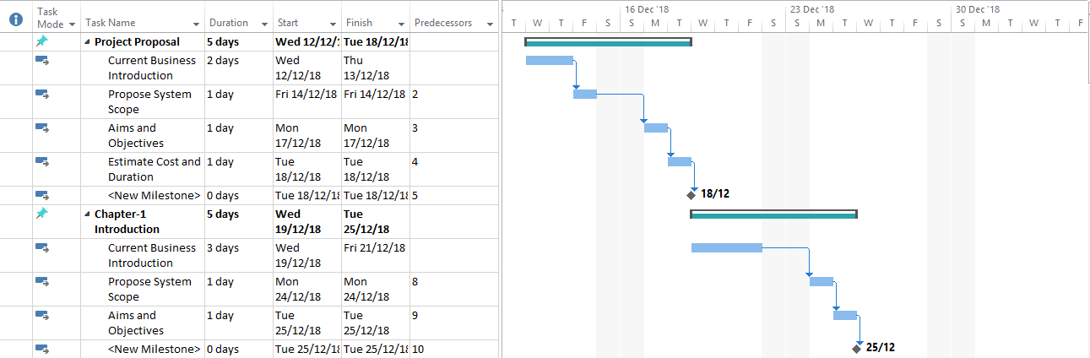

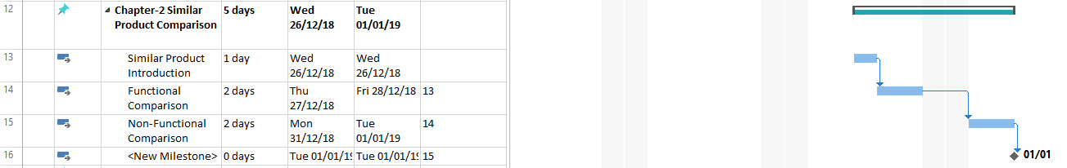



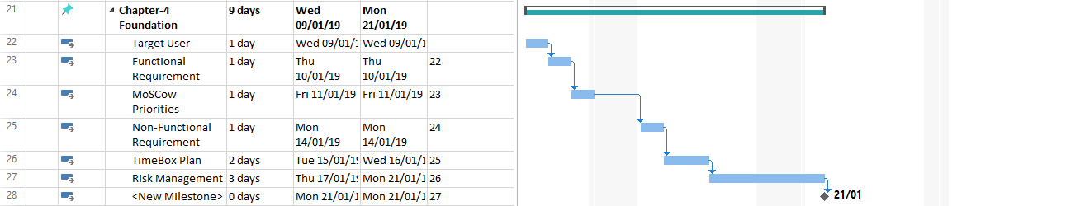

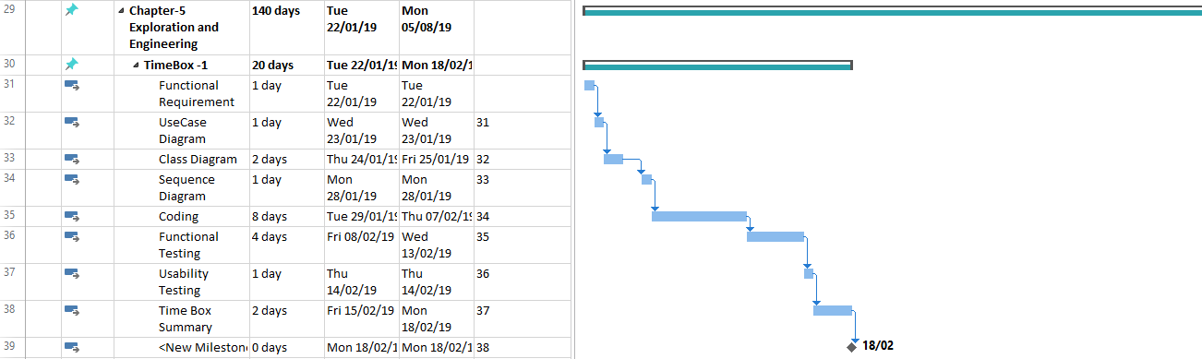

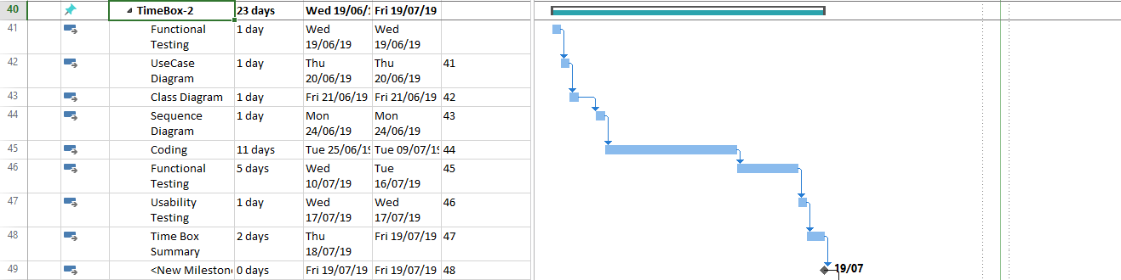

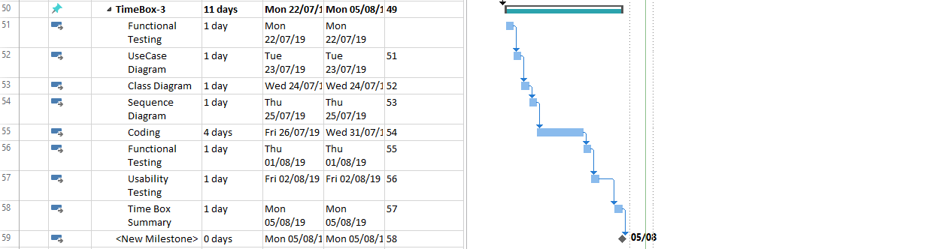

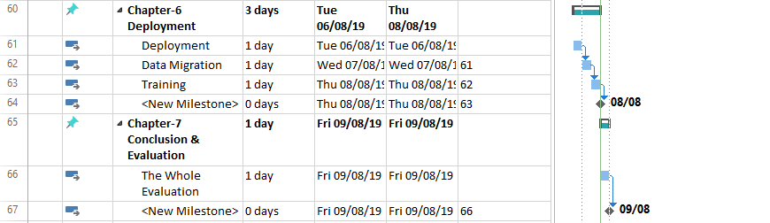

Chapter-1 Introduction

# Chapter – 1 Introduction

## Current Business Introduction

### History

The Shine library was opened in the year of 2012 until now. Since the library was opened, they use the normal method to register the new members and to expand the time of the old members by writing in the books again and again. They had to use the notebook while borrowing the books and receiving the borrowed books. So, they had many difficulties with borrowing the books because when the book is overdue or missing, they had to find in the notebooks and sometimes they couldn’t find those books because the books are too many and the list of the borrowed books are noted by the various librarians as they like. The books for the library had to be bought from the supplier and also there were donators who always donate books for the library. They had to manage those many books and put them in the bookcases. When they receive the books from the supplier or from the donators, the library’s staff had to make the list in the books. And when they want to check the list of the books, they had to open the list book and check if the books exist or not. To check the list, it might take a long time to finish but to reduce the time, they had to use more mans by splitting into different parts. After 4 years, the library needs to expand because of lots of borrowers. In order to control that amount, they replace all the most of the works with the computers using the library system service software from the software house. Because of using the software, they became easier. Return and Borrow didn’t take too much time and became faster. And the registrations of the new members and the extensions of the old members became easier and quicker. And the library’s staff used the computer to check the book in the storage every day because it could be done within a second. But after a few years had passed, some of the functions become old because the time had changed. So, they want to change the old library management system into an update one. They want to have a new update system which has the similar functions with the old one.

### Business Process

**Ordering the books:** To get the books for the library, the books need to be bought from the supplier. The suppliers may be one more than one. The books for the library are not only the supplier but also from the donators who donate the books that have been read. But most of the books from the library are from the supplier by paying the money.

**Recording the books:** The books for the library are delivered to the library after ordering them from various suppliers. When the library received the delivered books, those need to noted place at the right place. Before doing this, those needs to store in the database of the library in order to know them that they have been bought. In the database, those books are stored with the ID in order to reduce the duplicate books. Borrowing the books to the members is based upon that database. If the book is existed in the database, the member can borrow.

**Managing the books:** When the books reach to the library, the library’s staff members need to check what kinds of themes they are. For example, if they are science fiction or horror or others. After checking what kinds of themes they are, the books need to be numbered in order to place in the bookcase easily and also to find the books easily. After all the things have been done, the staff place the books to the right place in the bookcase according to the numbered and theme.

**Registering the New Members:** When the new members want to join the library, they need to make the library card which can give them access to all of the books in the library to borrow. First they need to fill the registration form to identify who they are. After that, the library’s staff member will register biography of the new member and make the library card. The fees for registering the new members is 30,000 kyats for each person.

**Extending the Old Members:** When the member got the library card, it has the time limitation. If the time limitation is over, the member cannot borrow the book from until he extends his library card. Extending the library card is not difficult as making the new one. The member needs to pay the money to extend the library card. If the library card has been extended, the member can borrow the books again. Like Registering the new members, when the user has to extend the member card, he need to pay the same amount money like the amount of Registering the new Members.

**Return:** When the members return the borrowed books to the library, the library’s staff member check the book and place it on the borrow list again. And if the book is overdue, they take the money as a fine not to happen like that again. The library’s staff member will inform the borrowers if they have left the books to return back to the library. And if the book returned is overdue, the fine will be paid by the users.

**Borrow:** When the library’s members want to borrow the books, the library’s staffs need to run the Borrow function. That function let the borrower to take out the book from the library within the limited time. The members can borrow at least three books a week without paying the fees. Because they have given the registration fees and also they have to extend the library card once per a year by giving the same amount of money as the registration fees.

**Donating the books:** The books that are not as popular as the past are considered as the books to donate to the others place like schools or others are checked once per a month. Because the books that are not popular nowadays become the waste of space for the upcoming books. To use them in the good ways, the library donates the books to the place like schools and other libraries.

### Issues

According the suggestions from the library’s members, there are issues to solve.

1. The members that have the library card can borrow books from the library. But not the expired members. The library card of a member is expired after one year is finished. In the early times, those members whose library cards are expired borrowed the books from the library. To know those expired cards, the staffs need to look at the card before lending the books. So, this will make the members feels uncomfortable for waiting.
2. Before the library’s member check out the books that they want to borrow, they have to find them in the library. It may be easy for them to find the books if the library is small and the books are no too many. But there are many books to find in the library so they have to take some times to find the books what they want. In order to the books they want, they need the assistants from the library.
3. And also when the borrower return the books, there may be the person that return the books with due date. So, the library’s staffs need to calculate the amount of fines for them to pay. It may not be difficult if the due date is 1 or 2 days. Some books are like 2 weeks or 1 month overdue. At that time the staffs become difficult to calculate the amount and they will need more time.
4. This issue is reported by most of the library’s staff members to change the method of Return and Borrow function. From the beginning of using the library service system and until now, the staff members need to type the numbers of the books not only when the borrowers borrow the books but also when they return the books to the library. At first, that problem is not serious because the amounts of the books are not too much and the borrowers are not as many as now. So, they can easily overcome that problem. But now the amount of the books increases and also the amount of the borrower is also increased. Therefore to control that amount of members, the library will need extra staffs and the costs will also increase due to time taken to finish and the number of staffs.
5. The security of the library is also needed. In earlier time, the library is allowed all the staff to work. Therefore, the problems become while purchasing the book and also the library data are also leaked to the outside. The important data of the library like the list of the purchase of the book, the borrow list, the return list and the member information is leaked. Therefore, the members complain about the problems. Because of the lack of the security, the staff become to feel unpleasant and they also doubt each other because they think that one of them is stealing their personal data.

## Propose System Scope

### 7.2.1 Process to be changed

According to the above issues, new systems have been considered to fix those issues.

To fix the problem, the solution is added the statement that will inform the staff if the library card is expired. That statement will appear on the computer after knowing the library card of the member. If that function is applied, the staffs don’t need to the expired date from the library card of the member. And the members need to extend the library card in order to continue borrowing the books from the library. And also the member doesn’t need to wait to the check by the library’s staff. They will know immediately and can extend their library card as soon as possible.

To make the purchase of the book much easier and without taking too much time, the staff only needs to put three information in the form, Book Name, Quantity and Price. After that the staff needs to list them in the temporary box of the page. If the data are added, the other information will fill automatically and the staff name is also retrieved from the LogIn form that has been used to get access into the system. And also the staff can do another purchase before the one is not fully complete which means that he can do all the purchase at the same time. And then they will be register into the database with pending status. After that the staff needs to confirm to finish the purchase process. By doing this, the staff will only take a time to finish the process.

First, to fix the problem of finding the books in the large library, I decide to add the new feature in the library service software without changing the original ones. I plan to put a new table which will allow the library’s member to find the books what they want. That function can work with the name of the books, and the number given to the books and also with the themes of the books. This function can works with these three kinds because there so many kinds of members. Some may know the name of the books from the other place and also from the others. Those members can find that books by typing the name of the books and that system will find the books if it is available. And also some of the borrowers who know the number of the books from the other members can find the books by searching with the numbers. And also if the borrowers want to borrow the books according the themes, it can also offer the members to find the books with themes.

To fix the issues of the overdue fines, I plan to add a new process in the normal Return function. A new process is simple and the library’s staffs don’t need to feel worry about it. That is new process can calculate the amount of fines that the members have to pay automatically. Therefore the library’s staff members will not have to calculate the amount of fines. For example, One of the member of the return the books back to the library with due date of two weeks. So, the staffs need to calculate the money to give as a fine. And it will take a little time to calculate. But this new process will overcome the calculation of the money with the automatic function.

To solve the problem of Return and Borrow function, the original borrow function is enhanced. The process of that system is simple and it is like the previous actions. In the previous times, the library’s staffs need to type the ID number of the borrower in to the computer and also they have to type the ID of the books that the members want to borrow. But now the staff needs to choose the books that the member want to borrow at the same time without one after another. After the borrowed books are listed, the staff only need to choose the member and the process will be finished. The different is all the borrow books can be borrowed at one single time without taking too much time. By doing this, it will save a lot of times and will allow the library’s staffs to work efficiently. It can also allow the library to borrow the books to the borrowers more than using the original method. And also the library’s staff members can focus on the other jobs instead of focusing only on the borrowing books.

To solve the security of the library, the LogIn function is added. But this LogIn function will not be the same as the others. In this LogIn function, the system will detect not only the email and the password of the staff but also the level of the staff. And the functions that the staff can use are different according to the level of the staff. Therefore the staff can only do the allowed functions according to the level of the staff. By doing this, leaking of information will be reduce and the unauthorized cannot use the functions of the system.

## Aims and Objectives

**Aim:** to reduce the overall cost of the library

**Objective:** When the library decides to use the above system for the library’s service, the overall cost for the library will reduce. By using the computer for the library’s service, the total number of staffs can be reduced because the implied system can do more quickly than a person can. So, half amount of the staff is reduced and also the salary for the staffs is reduced to half. A computer can work more quickly that a person does therefore the amount of time taken for a work of a computer is less than a person does. As the time for a work is reduced, the amount of the cost for that work is also reduced.

**Aim:** to increase the income money for the library

**Objective:** The income money for the library can be increased by using various methods. The main income money for the library is from registering the new members and extending the new members. To get more members, the library needed to be popular in the public. Then, new members will come to the library and the income will increase. To become like that, the best way is advertising in the public. Nowadays most of the people use social media so advertising about the library on the social media will be effective. And also advertising in the daily newspapers is also an effective way to increase the funds.

**Aim:** To make the members to find the books what they want easier

**Objective:** A new function which can let the borrower to search the books according to the Book’s Title, Book’s ID and Book’s Theme will be implied. The user can choose the choice between Title, ID and Theme. After choosing the choice and also typing associated text, the user needs to click Next Button. Then the computer will show about the book including Book’s Name, Book’s ID and Book’s Theme. If the computer show that the book is available, the user can borrow. But if it is not, he needs to wait for a few days. By doing this, the user can reduce the time for searching the book and it will be efficient for all users. The users can choose the way to find the books easily by clicking the drop down button. But in this function, the user can only see the detail of the books expect the picture of the book and the small brief of the book.

**Aim:** To know that the library card is expired or not

**Objective:** In order to know whose member card is expired, the library’s staffs don’t need to do anything. They just need to work their daily tasks. The staffs can look for the expired members easily while borrowing the books. When the expired member borrows the books from the library, the computer will automatically inform the staff that that member card is expired and need to be extended the life time of the membership. So, the member can also extend the library card immediately without taking a lot of times. The library’s staffs don’t need to worry about that problem and can focus on other jobs. And also the time for searching the expired members is reduced.

**Aim:** To reduce the time of calculating the fine for the overdue books

**Objective:** A new feature that allow the computer to calculate automatically according to the over due date of the book. The staff members don’t need to calculate by themselves or by using calculator. When the borrower returns the book, the computer will read if the book is overdue or not. If the book is overdue, the computer will automatically calculate the amount of fines according to the due dates. The staffs don’t need to click any button and that function will calculate as soon as the computer knows if it is overdue or not. So, the member can immediately pay the fines without waiting for a few times.

**Aim:** Change the original method for Borrow and Return

**Objective:** This will replace the original method for doing Return and Borrow function. First, the staff needs to go to the Borrow Page or Return Page. In the Borrow Page, when the member wants to borrow the book, the library’s staff needs to take a look at the Member ID from the library card and the Book ID from the back of the book. Then search the member and the book according to the each ID. And for returning the book back to the library, the library’s staff needs to check the Card ID of the member. After the ID number has been added, the associated information for the member will be shown. Then choose the returned book to finish the process.

Chapter-2

Similar Product Comparison

# Chapter-2 Similar Product Comparison

## Similar Product Introduction

|  |  |
| --- | --- |
| Software 1 | Software 2 |
| This is the demo version of the library Management System which is developed by the CSDT IT SOLUTION. This software can only run on the window dives but not in the others like android and etc. The software is developed for the purpose of the Library Management System. The main systems that are included are Lending the books and Receiving the lent books. And also there are extra functions which are need in Library System. First thing is that this software needs the admin password which had been given. After that, the users will reach home page of the software. In that page, the users need to choose one of the tabs to work. The general processes of this software are the following. The admin can add the new books and also register the new users. The admin can lent the books from the library and receive the lent books from the borrowers. And also the admin can check the detail of each book. | Just like the first software, this software is also the demo version of the library system developed by the Biblisoft. And also like the first one, this can only run on the computer which has the window operation system. This system is developed in the aim of not only for the library management system but also for the school management system. But the main is for Library Management System. As the software is for the library, the major process like lending the books and receiving the books are included. After running the software, if the admin run this for the first time, it will ask him to register the new admin including the password. If the admin account is already existed, just put the password and it will run. After that the general functions are followed. The admin can add the new books and add the new users. Lending the books to the members and receiving the books form the members can also be done. As this software is also for the school system, other functions like adding the teachers and adding the transfer students are also involved. |

## Functional Comparison

|  |  |
| --- | --- |
| Admin Log In | |
| Software 1 | Software 2 |
| When opening the software, it will ask the username and the password of the admin in order to confirm that he can be allowed or not. The user needs to put the right username and the password. If one is correct but the other one is wrong, the user cannot use this software. | When the admin run the software for the first time, the software will ask the user to create the admin account. If the user already has the admin account. The user needs to type the correct username and the password of the admin account. If they are not correct, the user will get the permission to use this software. |

|  |  |
| --- | --- |
| Registering the New Books | |
| Software 1 | Software 2 |
| After the username and the password of the admin are correct, the user will reach to the home page of the software. The new books that reach to the library needed to be recorded. To add the new books in the library database, first thing is that click on the Menu tab from the top section of the software page. After that choose the Add Books from the buttons. And then the admin can add the name of the books and description of the books. And also number of pages, the author of the books, the category and others can be added. After filling all the information about the book, click Save to add the book into the library. | After the admin account is correct, the user will reach to the process section of the software. There are a lot of menu bar to work. For registering the new book into the library, the admin need to click the Administrator tab from the menu bar. After that the processes that are related with the administrator will appear. To register the new book into the library, first click on Add on a Book button to add the book. And then the admin can add the information about the book like the name of the book and the author of the book. And also the other things like the publisher of the book, the covers of the book and etc can be added from this section. After all the information of the book have been added, click Save button to save the book into the database. |

|  |  |
| --- | --- |
| Registering the New Members | |
| Software 1 | Software 2 |
| To the register the members who are new to the library and want to have borrow the books from the library, click on Add Member button to register the members. Then the admin can add the name of the member and date of birth of the member. And for the contracting with the user, email and phone number are added. And the address and the other information can be also added. The information that is the most important are marked with the star beside it. It means that the marked information is important and the others are not much important compared to the star ones. | In order to register the new member of the library, the admin need to register those new members into the database of the library. To add the new members, Click on the Add Student button to continue. In this software, the library system is combined with the school management system, so registering the new student also means registering the new member into the library. Then the admin can add the name of the student and the address that he live. And also the picture of the student can also be added. Email and phone number for contracting and others for the additional information can also be added. |

|  |  |
| --- | --- |
| Detail of the Books | |
| Software 1 | Software 2 |
| To check the books which are stored in the database, click the Books Details button from the menu tab. After that the admin can check the books including the name of the book and how many copies they have. All the information that are added while registering the new books into the library can be seen in this place. | In this software, the books from the library storage cannot be checked again because this software didn’t support that function. |

|  |  |
| --- | --- |
| Lending the books | |
| Software 1 | Software 2 |
| For borrowing the books from the library, the admin need to go the borrow section by clicking the Book Issue button from the menu tab. After that the borrow section will pop out and the admin can lent the books from the library to the members. First type the Member ID in the top section. If the typed member is existed in the database of the library, the associated information with the ID will fill automatically like Member Name, DOB and Member Type. If the typed ID doesn’t exist in the database, the error box will appear. After that to choose the book to lent, click on the button that have the book picture and choose the book from the database. After that click on the Issue button to lent the book to the user. | When the member wants to borrow the book from the library, they need the conformation from the admin of the library. To lent book to the member, the admin need to click the Issue book button from the Book’s Circulation section of the menu bar. After that the admin can also type the ID of the book manually or just choose from the database by clicking the search button. And then the associated information of the selected book will fill the associated blanks. And then the admin need to fill the information about the member who wants to borrow the book manually like Student Name and Library Card number. After that click the Issue button to let the member to borrow the book from the library. |

|  |  |
| --- | --- |
| Receiving the lent books | |
| Software 1 | Software 2 |
| When the borrower returns the book back to the library, the admin need to place the book back into the database. In order to do this, click the return book button from the menu tab and the return book section will appear. Then type the member ID who borrowed the books from the library. And then the software will show that how many books did he borrow from the library. After that select on the received book from the user and click Return Book to finish the process. | When the borrowed book is returned by the user back to the library, the admin needs to record the return book into the database in order to lent to the other borrower again. To put back the lent book into the database, the admin of the library have to click the Return Book button from the Book Circulation tab. After that choose the Accession No of the book from the right middle corner. If the chosen number is correct, it will automatically show all the information of the returned book including the return date of the book and the overdue date of the book. And also the detail of the borrowed book and the fine for the due date. After that click Return button to finish the process. |

## Non-Functional Comparison

|  |  |
| --- | --- |
| Visibility of system status | |
| Software 1 | Software 2 |
| In this software, when the user clicks a function from the menu bar, it didn’t highlight on the function that the user is now using. This can cause the problem when the user doesn’t know what function is he using because the software didn’t highlight the current running process. | In this software, it highlights the current running function on the main menu bar. So, the user can look back easily what function is he using right now and if it is wrong he can change easily. |

|  |  |
| --- | --- |
| Help Section | |
| Software 1 | Software 2 |
| Most of the softwares have the help button which allows the user to know how to use the software at the first time. Including the help section is very efficient way for the new users. But in this software, there is no help section which will show how to use the software for the users. | And also like the first software, this software also doesn’t have the help function for the users. So, the user who uses this software for the first time will have to face with many difficulties because of not knowing how the function of the software works. |

|  |  |
| --- | --- |
| Consistency and standards | |
| Software 1 | Software 2 |
| This software can only run on the window devices so it needed to have the stable standard. If it does, the users can easily use without difficulties. In this software, it doesn’t have the stable standard. When the user use the function from the menu bar, some may pop out without covering the home page of the software. Some may cover the entire page and some may also change the background of the software. The backgrounds of one software should be the same because if the backgrounds of the software are keep changing, the user may be confused while using it. | Unlike the first software, this software has the stable standards. The background of the software is not changing and it is easy to use. And it is not using the photo as a background but using the color as background. All the backgrounds are using the same color. |

|  |  |
| --- | --- |
| Match with the real world | |
| Software 1 | Software 2 |
| All the functions and the way of displaying the function are like the thing that all kinds of users can understand how to use it. But one thing is that, the software uses the name of the function for lending the book and receiving the book as Issue Book and Return Book. At recent time instead of those words, Borrow and Return are the words that most of the people know in the library system. So some of the users can confuse while working those functions. | Like the first software, the other entire thing can be understand easily. But the words like Issue Book and Return Book are not familiar with most of the people. Instead of using them, using the words like Borrow and Return can be easily understand by many users. |

|  |  |
| --- | --- |
| Security of the software | |
| Software 1 | Software 2 |
| The security of this software can be said that it is in a good condition because it can give the username and the password to open the software. So, the unauthorized users cannot get into the software and change the information. Only the library’s staff members and others people who know the username and the password can use the software and change the information. | Just like the first software, this software also needed the username and the password to use the software. Only the authorized users can use the software so the information of the library don’t leak to the outside. |

|  |  |
| --- | --- |
| User Friendliness | |
| Software 1 | Software 2 |
| All the other things like buttons and menu bar from this software are all friendly with the users. But one things the sub menu bar is not really friendly with the users. Because when the user clicks on one of the functions from the menu bar, the sub menu bar appear on the right corner of the software with vertically. The user can confuse by finding the sub menu bar. So, for the user friendliness, that sub menu bar should appear under the main menu bar when the user clicks. | In this software, all the things are friendly with the users. The sub menu bars are also under the main menu bar of the software. There is no comment with the user friendliness with this software. |

Chapter-3 Feasibility Study

# Chapter-3 Feasibility Study

## Technical Feasibility

### Methodology

**Definition of two methodologies**

**DSDM (Agile Method):** Dynamic System Development Method is also called the agile software development methodology. DSDM is iterative and flexibility to use. It is based on the Rapid Application Development methodology called RAD. DSDM can use not only in the IT industry but also in the Non-IT Projects. It has eight principles to follow. The techniques like Time boxing and Prototyping are the techniques of the DSDM. (smartsheet, -)

**SSADM (Water Fall Method):** Structured System Analysis and Design Method are also called the Water Fall Model. This method only has one direction and cannot go back to the previous actions. It is like the water that flow from the higher level to the lower level. The three techniques that are used in SSADM are Logical Data Modeling, Data Flow Modeling and Entity Event Modeling. (smartsheet, -) (techopedia, -)

**Strength and Weakness of DSDM methodology**

* The final result of the system can reach the business requirements because the user is involved during the developing time.
* Testing can be also done parallel with the development stage because DSDM method allows the developer to do freely between the stages.
* In this method, the developer can communicate with the client therefore the developer can really know what the client wanted.
* In this method, the requirements of the system can be changed all the time if the user wanted so it is also a good point but if the customer changed the requirements all the time, it will be difficult for the developer to build the system.
* If the user doesn’t know what he really wanted, the result of the development will also meet with the requirements. (Vethics, -) (smartsheet, -)

**Strength and Weakness of SSADM methodology**

* In SSADM method, the quality of the system is agreed at the beginning of the project. So, the customer cannot change the scope and function of the system during the project. It makes the developer to develop the system easier.
* Developing the system will be simple and doesn’t need to much people because SSADM method allow the developer to do step by step and allow him to do the next stage after the previous one is finished.
* The involvement of the user is less so the result of the project will not meet with the user requirements.
* In this method, the developer need to do step by step so if he want to change the system, he need to start from the beginning again.
* Testing stage come after the Development stage is finished, so if the system doesn’t function correctly in the testing stage, the developer cannot simply go backwards and fix it because it is a one flow method. (smartsheet, -) (Quora, -)

**Comparison**

|  |  |  |
| --- | --- | --- |
| Criteria | DSDM (Agile Model) | SSADM (Water Fall Model) |
| Iteration | In DSDM, the developer can go to the stages as he like. For example, while the developer is building a function, he can also go the testing stage of the other functions when he wants. And also while developing the system, the developer can the additional information about the new functions. | SSADM method is one flow method. It is like the waterfall which flows only one direction from higher place to lower place. Like the method of the waterfall, the developer cannot change anything from the system until all the stages have been finished. |
| Flexibility | DSDM method is very flexible because the developer can build the system as he like without caring about doing steps by steps. | In SSADM method, the developer cannot built the system as he like. He need to step by step until the whole system is built. |
| Testing | Testing in the DSDM method can do while developing the system. Because all the functions are developed with the time box and the developer can text the finished functions. And if they | In SSADM method, the testing stage comes after when the development stage is finished. The developer cannot do the testing stage until the development stage is finished. SSADM is a one flow method. |
| Customer Involvement | DSDM method is focus on the customer satisfaction. Therefore customer can involve during the development process of the system. | In SSADM method, the involving of the customer is not allowed in the process. So, the method is lack at the customer involvement. |
| Scope and Requirement | Scope and Requirement of the system can change as the user like in this method. For example, while developing the system, the customer can replace the developed system with the new one. | In SSADM, the scope and requirement cannot be changed because those are already agreed at the start of the project. If the customer wants to change the system, the project need to be done from the first stage again. |

(flatworldsolutions, -)

**Recommendation for Methodology.**

Among the two methods, I prefer to use the DSDM method for the system. Because the developer can go back to the previous stage if he need to correct the weakness. And also the customers can also involve in the development stage of the system. So, the development of the system will become easier and if the functions are wrong or not match with the requirement, the developer can change immediately without waiting the finish of the development.

### Language (ASP.NET)

**Definition of two Languages**

**PHP**: is a Hypertext Preprocessor which can be written with the HTML codes. That means that PHP is a web scripting language which is embedded in the HTML codes while writing. There are two kinds of website; one is static website and dynamic website. PHP is used for writing the dynamic websites. It is an open source and free to use. (EDUCBA, -)

**ASP.NET:** is a Framework which is used to create the website. To write the code, it needed the Microsoft Visual Studio. As there are two kinds of website, ASP.NET is used to create the dynamic websites. It is based on the Common Language Runtime (CLR). (EDUCBA, -)

**Strength and Weakness of PHP**

* PHP language is easier to understand and easier to learn for the newbie in this language.
* And also the cost for using the PHP is free and the user can use it without paying the license fees like the others.
* If the user use the PHP while developing the website, connecting to the database becomes a lot easier.
* But the security of PHP is not secure because it is an open source and a lot of bugs are existed.
* It is not suitable for using in large systems. (EDUCBA, -)

**Strength and Weakness of ASP.NET**

* The security of the ASP.NET can be said in the good condition. The developer can built the secure websites and applications.
* It is suitable to use in the large systems because it can handle it.
* ASP.NET code is a little complicated and not easily understood or learnt by the new users.
* The users of the ASP.NET need to pay license fees to use it.
* The community of the ASP.Net is small because it is a paid version and most of the websites and applications don’t ASP.NET for developing. (EDUCBA, -)

**Comparison**

|  |  |  |
| --- | --- | --- |
| Criteria | PHP | ASP.NET |
| Security | As PHP is an open source and there are a lot of bugs. | As the user need to pay the license fees to use which means that not every can use ASP.NET. Therefore the security of ASP.NET is in the high standard. |
| Cost | PHP is an open source and it is free to use which means the user can use without paying the license fees or others. | ASP.NET is owned by the Microsoft which built the Windows Operation System. So, the user needs to pay the license fees for using it. |
| Learning the language | PHP is easier to understand and learn for the newbie in PHP. They can write a website with PHP in a short time. | ASP.NET is a little difficult to learn for the first time users. So, the user needs to take times to understand very well. |
| Support | As PHP is open source, the community of it is large. And most of the small and medium size websites use php to build the websites. And also there a lot of guidance on the internet because it is the most useful among the others. And PHP can be used on Mac, Windows and Linux machines. | ASP.Net is suitable to build the large website because it is more secure than the others. As the usage of ASP.Net is low, the community of it is also small. ASP.NET can only use on the Windows machine. |
| Market Share | As the analysis of the website, 57% of the websites use php codes to build the website. And some popular sites like Facebook use the PHP language. | According to the analysis, only 34% of the websites use asp.net to build. |

(PixelCrayons, -) (EDUCBA, -) (RISHABLESOFT, -)

**Recommendation**

I prefer to use php language while developing the system because most of the websites from the internet use php language. And also the community of it is large therefore when I have problem, I can easily solve the solution by the community’s help. And php is the open source and the user doesn’t need to pay the license fees. But the security of the php is not good but it is not really important in this case.

### Database

**Definition of two Database**

**MySQL:** is one of the most popular database systems in the world. It is an open source Relation Database Management System (RDMS) which is based on the Structure Query Language (SQL). My SQL is used for adding, removing and editing from the database. It is mostly used in the web servers. (Techopedia, -)

**Microsoft SQL Server**: is included in one of the most used database system in the world. It is a Relational Database Management System (RDMS). SQL Server can also support the ANSI SQL which is a standard of Structure Query Language (SQL). It can be used in 32 bit and 64 bit devices. (Techopedia, -)

**Strength and Weakness of MYSQL**

* MYSQL database can run on all kinds of platforms like Window, MacOS and Linux.
* MYSQL is free to use without paying the fees.
* The user of MYSQL can use the numbers of storage engines like InnoDB and others.
* The user cannot stop or cancel the execution of the query while running it.
* The security of MYSQL is not good because the user can manipulate the files while running which create a leakage of the database’s security. (EDUCBA, -) (Medium, -)

**Strength and Weakness of Microsoft SQL Server**

* Microsoft SQL Server allows the user to stop or cancel the Query Exeution while running it without killing the entire query.
* The users cannot manipulate the files while running so it became a difficult nut shell to crack by the developers.
* The users need to pay the license fees to the Microsoft Company for using their database system.
* This database can run all kinds of platform but it is more suitable for using Windows devices. Otherwise the performance and the speed of the database will be reduced.
* In Microsoft SQL Server, it allow the user to use only one storage which is created by the Microsoft. (EDUCBA, -) (Medium, -)

**Comparison**

|  |  |  |
| --- | --- | --- |
| Criteria | MySQL | Microsoft SQL Server |
| Supported Platforms | MYSQL is supported in all kinds of platforms like Windows, MacOS and Linux. | Since Microsoft SQL Server is developed by the Microsoft, it is more compatible on Windows OS. But it can run on MacOS and Linux but some features cannot be used. |
| Query Exeution | In MYSQL database, the user cannot stop or cancel the query while running. The user has to kill the entire query to stop the process. | In SQL Server, the user can stop the query while it is running. So, the user doesn’t need to kill the entire query to stop the process. |
| Security | In MySQL, the developers can manipulate the files of the database while running. This become a leakage of the security of the MySQL database. | In Microsoft SQL Server, the developers cannot manipulate the files while running. Because it is highly secured. And it became a difficult nut shell to cracks by the developers. |
| Storage | In MySQL, numbers of storage engines are supported. The example of those storage engine are InnoDB and MyISAM. | In Microsoft SQL Server, it only uses the storage engine that is developed by the Microsoft. |
| Cost | MySQL is free to use by all kinds of users. So, it most of the small business use MySQL database. | To use the Microsoft SQL Server database, the user needs to pay the license fees. Because of paying the license fees to use, it become less popular. |

(Medium, -)(EDUCBA, -)

**Recommendation**

MYSQL database can run on all kinds of platforms like Windows, MacOS and Linux devices. And the cost for using the MYSQL database is free and doesn’t need to pay the license fees. As the language that is used to develop the website is php, MYSQL database is the most suitable database to use. Therefore I recommend to use the MYSQL database as the database system for the library.

## DSDM Feasibility

|  |  |
| --- | --- |
| Principle | Description |
| Focus on Business Need | In my library management system, I try to focus on the business requirement of the library. First in order to know flow of the process of the library, I interview with the library’s staffs and the admin of the library. According to the report of the library’s staffs and the admin, to lend the books to the members, the library needs to have the books to lend. And then they need to put those books into the database before doing the Return and Borrow function. And also fine for the book that are overdue are also involved. Therefore according to the result of interviewing, I will create the new library management system that will obey all kinds of business needs. |
| Deliver on time | For example, when the customer order the product from online or by manually, the ordered product must be delivered to the customer by the company. When delivering the product to the customer, the product must be reached to the customer at the exact deliver time. If it is not reach to the customer at the exact time, the customer will disappointed and he will not order the product from this company. So, the company will lose one customer. And not to happen like this for our product, I will have two people who will develop the functions of the systems. And we will split the work for each other to reduce the time. Doing with the group is better than doing alone. It will reduce the cost and the time taken for developing the software. And also we will test the functions as soon as the coding is finished. By doing this, the system for the library can use right one time without crossing the deadlines for the implementation the system at the library. |
| Collaborate | As I said working a task with a team is better than working alone. When working with the group can have more ideas because the discussion about the system is always taken. The members of the team share their thinking and more ideas to use in the system are appeared. And also it will also reduce the time for developing the system because the team members will split the coding processes for each. And those split coding processes will finish at the same time and we can get more time for testing and correcting the errors of the system. During the developing time of the system, not only the members of the development team can involve but also the staff from the library can involve in the development to check if the system meets the requirements or not. If it isn’t reach to the business requirements, the developers can change easily during the development time. But when the system has been developed, it will be difficult to change the processes. |
| Never Compromise Quality | There are lots of problems between the developers and the customer that changing the systems a lot. Because they didn’t make the agreement about the quality of the system before the developing stage starts. This will give lots of pressure to the developers when the customers change the processes of the system during the development time of the system. Because the customers don’t know the difficulties of the developers and they want their system to be in up to date. In order not to happen like this I will make the agreement before developing the system. And also I will notify the admin of the library to confirm when the development time is near to know that if he wants to add some function or not. After that we will start to develop the system. If the customer really wants to change the processes of the system, I will renew the contract with the library. Because we need to add the new functions into the system and it will take extra times to finish. |
| Build incrementally form firm foundation | Also in the real world, making the good foundation is the best way to avoid to future serious problems. For example, in the construction sites, the engineers build the large and tall buildings. While building them, the foundations need to strong in order to withstand earthquakes and others. In order to get the firm foundation of the system, the most important thing is to get the exact and clear information of the business process. Therefore I ask the staffs of the library to get the information about how the business flows in the current time. |
| Develop iteratively | While building the system, the customers may want to change some of the functions after looking at the others. It can be changed as the customer’s desire but it will take more time. Because we need to find and change the function that the user want and the current development need to stop a little to change. The customers can change the functions even if they have been built. |
| Communication continuously and clearly | I will have the discussion with the admins of the library before the development of the system starts. From that discussion, I will make the conformation about the system to develop. And then I will discuss with my team about the system that the customer want. Because we will develop the system and if we don’t know how to do it, it will be difficult. After the discussion with the team is finished, we will build the proto type of the sample system that will be built. If the admins of the library like the prototype, we will continue with it. And also during the development time, we will allow one of the admin to check the functions one by one after they have been finished. If the admin of the library doesn’t like it, we can change immediately without taking too much time. But if the developing of the system is finished, it will be difficult to change the processes from the system. |
| Demonstrate Control | When this Library Management System is applied to use in the library, all the staffs from the library are new to this system and cannot use it properly. So, if they are not well trained before applying the system, the library will face with many difficulties. To solve those problems, one of the developers from the team will teach the staffs how to use the systems. And also while during the staff training, the slide show that show how to use the system will be also used. Not only the teaching but also the real training will be also involved. By doing this, if the staffs don’t know, the developer can explain immediately how the system works. |

(TECH ACADEMY, -)

Chapter – 4 Foundation

# Chapter-4 Foundation

## Target User

|  |  |  |  |  |  |
| --- | --- | --- | --- | --- | --- |
| No. | User Name | Technical Skill | Language Skill | Age | Description |
| 1. | Library Manager | 50/50 | 50/50 | 30 - 45 | The library Manager can get access to all kinds of functions like database and others. He can also check all kinds of information from the database. He is the head in the library who has the authorities to do everything in the library. He has all the responsibilities that are happening in the library. |
| 2. | Database Administrator | 100/100 | 100/100 | 20 -45 | Database Administrator has the authority to do everything within the database like Checking the student information, checking the book storage of the library. He main work is to add the new books into the database and checking all the things in the database. |
| 3. | Library Assistant | 25/100 | 25/100 | 20 -45 | Library Assistant is the lowest staff in this library. They work is to help the database administrator in receiving the ordered books, Return and Borrow and Registering the new members. |
| 4. | Library Members | 15/100 | 15/100 | Over 15 | For the library’s Members, they can only search the books from the library. The others functions are not allowed. |

## Functional Requirement

**Library Manager:** Library Manager is the most important person in the entire group. He decides what kind of books that are needed to be ordered and what kind of books are needed to donate to the others. In this system, the library Manager has all access to all kinds of functions. He can also add the new books into the database. He can also edit the recorded books from the database and also delete them. He also has the permission to change and add the information about the members of the library. In other ways, He has all the authorities to do everything in the library system.

**Database Administrator:** Like the Library Manager, He also has the same authorities to do everything with the library system. But unlike the Library Manager is that his authorities are only inside the database of the library. He has no authorities in other places. He can add the ordered books into the database when the supplier of the books arrives. And also like the Library Manager, he can check what is changing in the database and also he is allowed to do everything in the database as he likes.

**Library Assistant:** Library Assistant is the lowest staffs among the library staff members. He only has the permission for adding the new members for the library and takes a role at doing the Borrow and Return functions. He doesn’t have the permission for changing the information about the books and the members from the database. He is only allowed to do the simple jobs. He has to obey the order from the Library Manager and the Database Administrator. As the conclusion, the Library Assistant doesn’t have much permission to work in the library management system. They are mainly worked for manual works.

**Library Member:** Library Member doesn’t have the permission to use the library management system of the library. They are only allowed to search the books from the library because a lot of books are stored in the library and it will be difficult to find them. They cannot change or add the information from the database or into the database. And also the books that they searched will only just read only and cannot do anything with that information. That means that he is a guest which is only allowed to sit at the living room.

## MoSCoW Priorities

|  |  |  |  |  |
| --- | --- | --- | --- | --- |
|  | Must Have | Should Have | Could Have | Won’t Have |
| Admin Login | ✓ |  |  |  |
| Adding the Supplier | ✓ |  |  |  |
| Add ItemType | ✓ |  |  |  |
| Add Category | ✓ |  |  |  |
| Adding the library Staff | ✓ |  |  |  |
| Payment for new Books | ✓ |  |  |  |
| Recording the new Books | ✓ |  |  |  |
| Detail of the Books |  | ✓ |  |  |
| Register the new Members | ✓ | ✓ |  |  |
| Extend the old Members |  | ✓ |  |  |
| Detail of the Members | ✓ |  |  |  |
| Payment for registering and due date | ✓ |  |  |  |
| Record Borrow | ✓ |  |  |  |
| Record Return | ✓ |  |  |  |
| Checking the recent borrowed books and registered members |  |  | ✓ |  |

## Non-Functional Requirement

**Security:** For the security of the software, the user of this software needs to put the correct username and the password. If the username and the password are correct, the staffs can use the functions from the software. So, the authorized users like one of the members from the library or the other outsiders cannot use the software or change the information from the database unless the username and the password are corrected.

**Performance:** In this Library Management System, when the user clicks one of the buttons from the system, it will take the user to the associated function immediately. And also when the user saves the new book into the database or the new member into the database, it will not take a lot of times to finish. When the user recalls the information from the database, the results will be shown quickly and accurately. The use can also delete from the database without having too much too much troubles. It will not take times to open the system because the use interface is simple and the extra things like videos ad gifs are not used. Only the color that are suitable with the users and which are the most useful are used as the user interface.

**Usability:** This software is used by the various staff members from the library. In order to use the software clearly and easily, the software built by taking references from other software like library management software. And also the references from the old software are also taken. For the user visibility, the software has the background color and also the texts are in normal size. The functions names are given the names that all the people are familiar with. In order not to confuse while using, all the functions are displayed with the menu bar in one place. And also the information about the books and the information about the members always up to date. When the user add the new information into the database, that information will exist in the database of the system until the user delete that information.

**Maintainability:** When the software is facing with errors or cannot run, it can be easily be maintained. While developing the software, each function are built in each session. For example like developing the Borrow Function in one session and the other function is the other tabs. Therefore when the software cannot run and the company give the developer to fix it, it will be easy to find the error and the point that is not working without difficulties. Even the developer is not the one that developed that develop this software but the new one can also fix the software by looking through by session of the codes.

**Testability:** All the software and the program needed to test before applying it into the actual work. If the software or program is not tested properly, errors and problems will cause while working by using them. This software can test whether if the action is succeeded or not. And also if the function is succeeded, whether the data is stored or not can be tested. It can also be tested what kind of action will happen if the user do something. All the functions from this software can be tested.

## Time Box Plan

### 10.5.1 The Whole Time Box Plan

|  |  |  |  |  |  |
| --- | --- | --- | --- | --- | --- |
| Time Box Name | | | | Library Management System Plan | |
| Start Date | | | | 12.12.2018 | |
| End Date | | | | 9.8.2019 | |
| Time Box Plan | Main Task | | Duration | Start Date | End Date |
| 1 | Purchase Function | | 3 Months | 22.1.2018 | 18.2.2019 |
| 2 | Borrow Function | | 2 Months | 19.6.2018 | 19.7.2018 |
| 3 | Return Function | | 1 Months | 20.7.2018 | 9.8.2019 |
| Key Description | Plan 1 | In this time box plan 1, StaffGrade table is created firstly and later Supplier, Staff, Category, ItemType, Product and the Purchase. The information form the StaffGrade is going to used in the Staff table therefore StaffGrade is created firstly. And The Purchase table is created at the last because in this table, all the information from the previously created are going to be reused. | | | |
| Plan 2 | In this time box plan 2, MemberType table is created first and then Member table, BorrowDetail and Borrow table are created. The information from MemberType and Member table going to reuse in later process therefore they are stored firstly in time box plan 2. Borrow Process is going to undertake with the previous filled information from time box 1 and time box 2. | | | |
| Plan 3 | In time box plan 3, there is no entry form which means that the only form that exists in Return form. Return form is going to undertake by reusing the pervious filled information from above forms of time box 1 and time box 2. | | | |

### Time Box 1: Purchase and Register of Books

|  |  |  |  |  |
| --- | --- | --- | --- | --- |
| Time Box Name | | Purchase and Register of Books | | |
| Start Date | | 22.1.2018 | | |
| End Date | | 18.2.2019 | | |
| Task | Duration | Start Date | End Date |
| Functional Requirement | 1 | 22.1.2018 | 22.1.2018 |
| Use Case Diagram | 1 | 23.1.2018 | 23.1.2018 |
| Class Design | 2 | 24.1.2018 | 25.1.2018 |
| Sequence Diagram | 1 | 26.1.2018 | 26.1.2018 |
| Coding | 15 | 27.1.2018 | 11.1.2018 |
| Functional Testing | 5 | 12.1.2018 | 16.2.2019 |
| Usability Testing | 2 | 17.2.2019 | 17.2.2019 |
| Time Box Summary | 1 | 18.2.2019 | 18.2.2019 |
| Key Deliverables   * Record StaffGrade * Record Supplier * Record Staff * Record Category * Make Item Type * Record Product * Make Purchase | | | |

### Time Box 2: Member Register and Borrow Function

|  |  |  |  |  |
| --- | --- | --- | --- | --- |
| Time Box Name | | Member Register and Booking Function | | |
| Start Date | | 19.6.2018 | | |
| End Date | | 19.7.2018 | | |
| Task | Duration | Start Date | End Date |
| Functional Requirement | 1 | 19.6.2018 | 19.6.2018 |
| Use Case Diagram | 1 | 20.6.2018 | 20.6.2018 |
| Class Design | 2 | 21.6.2018 | 22.6.2018 |
| Sequence Diagram | 1 | 23.6.2018 | 23.6.2018 |
| Coding | 19 | 24.6.2018 | 12.7.2018 |
| Functional Testing | 3 | 13.7.2018 | 15.7.2018 |
| Usability Testing | 2 | 16.7.2018 | 17.7.2018 |
| Time Box Summary | 1 | 18.7.2018 | 19.7.2018 |
| Key Deliverables   * Record Member Type * Record Member * Record Borrow | | | |

### Time Box 3: Return and DueDate Calculation Function

|  |  |  |  |  |
| --- | --- | --- | --- | --- |
| Time Box Name | | Return Function | | |
| Start Date | | 20.7.2018 | | |
| End Date | | 5.8.2019 | | |
| Task | Duration | Start Date | End Date |
| Functional Requirement | 1 | 20.7.2018 | 22.7.2018 |
| Use Case Diagram | 1 | 23.7.2018 | 23.7.2018 |
| Class Design | 1 | 24.7.2018 | 24.7.2018 |
| Sequence Diagram | 1 | 25.7.2018 | 25.7.2018 |
| Coding | 7 | 26.7.2018 | 1.8.2019 |
| Functional Testing | 2 | 2.8.2019 | 3.8.2019 |
| Usability Testing | 1 | 4.8.2019 | 4.8.2019 |
| Time Box Summary | 1 | 5.8.2019 | 5.8.2019 |
| Key Deliverables   * Record Return | | | |

## 5.6 Risk Management

### 5.6.1 Critical Success Factors

**Foundation:** Every works from the world needs the firm foundations. If the foundation is not strong, that project or work will not be successful in the future. The most important part in the Foundation of a project, is knowing what are the requirements of the business and how the business runs. In order to get those information clearly and correctly, the interview to the staffs and the surveys are needed. Those are the best ways to know the flows of the business. In order to get the firm foundation, the correct and firm information of the flows of the business are needed.

**Communication:** In order to get the successfully system, the communication between the customer and the team members are needed. And also the communication between the customer and the team members need to be done regularly. Before the project is started, the communication about how to build the system is needed to be held between the customers and the development team. And also during the process of developing the system, the communication between the customers should not be cut off. Because the customer may be want to change some of the function from the original system. Therefore to get the system that is matched with the user requirements, Communication is needed.

**Design:** User Interface of the system can also be called the Design of the system. The success of the system is also depending on the Design of the system. Because if the Design is complicated and cannot understand clearly, the system will be lead to failure. For example, using the suitable background color without using too much photo is suitable for the user friendliness. And also using the menu bar to save some space on the surface.

**Prices:** The cost for developing the system played an important role in the critical success factor. Some of the people said if the cost of the system is low at the start, it is good to use but not in all things. Some of the system needs to use a lot of money to have the great system. When the cost of the developing the system is very low, that system definitely cannot reach the business requirements. Therefore the cost for developing the system need to be neither low nor high.

### 5.6.2 Major Sources of Risks

**Environmental:** This kind of kind of risk is included in one of the most occurred risks in the world. Environmental Risks consists of many types of risks including the change of the policy from the government and the Natural Disasters. When the government changes the policy, the older system will become useless and not be used by the organizations. In order to match with the policy, the system need to be changed and then the cost for developing the new system will follow. And also Natural Disasters like Earthquake and others can destroy the devices that the developed system is stored. In order to avoid those, the backup file of the system needs to be stored at the different place.

**Time Consuming:** When the time for developing the system takes too long, it became the risk that can harm the development team. Time Consuming is means submitting the project after the end date. This can be caused because of the customers and also because of the team members. About the cause of the customers, when the customer wants to change the original functions from the system, the developer needs to change again. And also the time for changing the new system form the old system will be added and the system cannot be finished right on time. And also because of one of the members from the team or a whole team, the submitting date of the project can be late.

**Problem and errors detected late:** When the system has been developed, the testing of the system need to be followed. While testing the software, the errors and the problems of the system appeared. In order to get the perfect system and to match with the user’s requirements, those errors and problems need to be fixed. While testing the software, the developer forgets to fix the error or initially left the error and that error is found while using the system in the organization. And then the customer will complain about the system and will have to fix the system again. Therefore at the testing stage, the developers need to concentrate only on the project without doing the other things.

### 5.6.3 Personal

**Wrong Grade:** Giving all the staff the same grades from the department can lead to the risk. In a department, all the staffs need to be divided into the grades and also the permission for using the system is considered according to the grades. When the grades are not permitted and allow all the users to use all functions from the system, that department cannot last long. For example, allowing the database control to the ordinary staff will lead the uncertain and untruthful information. For controlling the database, the department needs to have a database administrator and allowing only him to do everything with the information from the database. It is called Wrong Grade Risk.

**Wrong Training:** As the system is applied to the organization for the first time, they will be a lot of staffs who are not familiar with it and cannot use it. So, they need the training about the current system. And also Training is also different according to the grade of the organization. Before starting the training, the grades of the organization need to be confirmed. For example, the training about how to use the database of the system is for the database administrator of the organization. If it is taught to the other staff, it will be useless.

**Wrong Expertise:** At the developing of the system, the developers of the system need to be well known in their specific fields. Thus, the errors that can be caused during the development and after development can be solved easily. If the developer is not expert, it will be difficult for the team and the developed system will not meet the requirements. Therefore all the members of the development team need to have strong technical skills and plenty of technical knowledge.

**Having no Backup Files:** During the development of the system, the developed system can be destroyed by many cases like because of the natural disaster or because of the careless action of the user. And also because of the thief can lose the information that the developer has. If the system is lost during the development time, the developer needs to build the new one if the backup file of the system doesn’t exists.

**Hardware Devices Errors (broken):** The developing of the system can be interfered by the broken hardware devices like hard disc or monitor and others. If the hardware devices are broken, the developer needs to wait until those are able to use again. So, the developer will have less time to build the system because of the waiting time for the broken devices. In some other cases, the memory of the computer is destroyed and the developed system is also involved in the case. Then the developer needs to build the new system which is the same with the first one. If the developer doesn’t have the backup file of the system, it will be difficult and he will not be able to submit the system right in time.

### 5.6.4 Technical

**Requirements Changes:** This kind of risk is one of the most happened risks in developing the system. This risk is caused because of the customer who ordered to develop the system. This kind of risk is depending on the customer decision. If the customer want to change the functions from the system, the developer need to develop according to the user’s desire. For example, if the user changes the requirements of the system when developing the system is nearly to finish, the developer need to build the new system according to the user’s desire and it will take more the end date of the project to complete building the new system.

**Failure to meet requirements:** The requirements of the system need to be discussed with the customer before starting to develop the system. And the developer needs to build the system which is match with the discussed requirements. And in order to meet the user requirements, the developer need to about the business processes of the organization. And also need to build the prototype of the system that is going to build and show it to the customer. If the requirements are not met, it will be difficult to use by the user and also the developer will get complain about this.

**Problem Error Detected:** Before developing the system, the analysis stage needs to come first. At that stage the developer need to take enough time to get the perfect information about the system. After that he needs to build the system based on the information from the analysis. This will reduce the risk like missing the function from the system and misunderstanding the system. And also while developing the system, the errors can be found. To know the place that the error is existed, testing is needed to do. If the testing is not done well, the error will be found during using in the real business. This will reduce the reputation of the developer.

**Virus:** Virus threat is the most important threat that can destroy the development of the system and will take more time to finish the project. The computer can be affected by the virus by many ways like the USB devices which already have the virus and are transmitted to the computer. And also virus can be occurred from the files downloaded from the internet. Because of the virus, the developed system can be leak to the others and also the software from the computer can be destroyed.

### 5.6.5 Risk Matrix

|  |  |  |  |  |  |
| --- | --- | --- | --- | --- | --- |
| Title and Description | Risk Status | Potential Impact | Risk Owner | Actions | Action Log |
| Environmental | High | If Environmental risk happens, the devices that the developed systems are stored can be damaged. And if those developed are damaged and unable to reuse, the developer needs to build the new one. | Like the Earthquake and also Flooding. And also changing the policy of the system from the government. | In order to prevent those kinds of risks, the developer need to make the backup file of the system and that backup file need to be stored in the another place. | This kind of risk can be at any time. The developer of the system cannot predict the cause. The best way to overcome is to have the backup file of the system. |
| Time Consuming | High | When the developing of the system cannot finish in the correct time, the customer will complain about it and also the developer will lose his reputation. If like this happen all the time, there will be no customer who will hire that developer. | It can be because of the developer and also the customer. Less train developer and the customer who change his system all the time can lead into this risk. | In order to prevent this, the developer need to work with the team and the team member are also well trained and needed to have much knowledge. And if the customer changes his system all the time, the developer needs to ask to give more time for replacing the changed system. | This always happen all the time when starting the developing of the system. And the amount of changing the system is depending on the customer. |
| Problems and errors detected late | High | This kind of thing can be known while working with the system in the organization. If the errors are detected while working in the organization, the customer will complain and order to fix those errors. Then, the developers of the system need to look back and fix the errors and it will spend the time from developing the other ordered systems. The reputation of the developers will lose too. | This kind of risk is caused because of the lack of testing. After developing the system, the developer need to test all the functions form the system. If the developer forget to test one of the functions from the system or left it without testing, the errors can appear while using it. | Testing the functions one by one while developing the system and testing the overall system after finish developing the system can prevent form happening this kind of risk. | This kind of risk is rarely happen because most of the developer the testing after the development section is finished. |
| Wrong Grade | Medium | In one department, all the staffs are needed to be divided into grades. And also the permission is also divided according to the grade of the staff. While dividing the staff into grade, the correct staff needs to be in the correct grade. For example, if the simple staff who don’t know about the technical terms is assigned to the database administrator, the information that he stored will not be correct and useless | This can be happen because of the staff and also the one who decided for placing the staffs in the associated grades. | In order to protect this, need to think clearly and carefully while placing the staff into the different grades. And also make the permission for using the functions in the system for each grade. | This is barely to happen in a organization. |
| Wrong Training | Medium | When the new system is applied into the organization, the staffs from the organization cannot use because they are not familiar with it. Thus they need the training about the system from the developer. When giving the training to the staffs, the training will be different according to the grades of the staffs. If the training for each grade are wrong, it will be useless and the staffs will become more difficult to use. For example, if the database training is taught to the normal staffs, they will be confused and cannot use the system properly. | This is happen because the training are not divided according to the grades of the staffs from the organizations or the wrong training is taught to the wrong grades of the organization. | To overcome this kind of risk, the grades of the staffs from the organization needed to be certain and also the training course are divided according to the grades of the staffs. And also before the training is started, the staffs need to register to the training according to their grades. | This is also the risk that barely happen in the organization. |
| Wrong Enterprise | Medium | In the development team of the system, all the developers need to be well trained and have plenty of IT knowledge. If the developer of the system is not expert in his field, it will be difficult to fix the system when the error is appeared. And also the time for developing will be long because of the lack experience developer. The right developer needed to be assigned into the right development section of the system. | This happen because of the developer who is not well trained and has a few knowledge about the technical terms. And also this is because the person who let that developer as a member of the team. | To prevent this, all the developer from the development team need to be good at in all IT fields. If they are only good at one specific field, they needed to be assigned at the right section of the development of the system. | This is also a case that barely happen in the development team. |
| Having no Backup Files | High | When the developer doesn’t have the backup file of the developing system, it will be difficult when the system file is lost or destroyed because of some situation. Then it will take the developer to develop the similar product like the first one. Thus, the developer cannot finish the system in time and will cost more because the longer the time is, the more money that it will cost. | This is happen because of the developer. The developer need to carful as how the system is important. Making the backup file is not difficult but the backup file has not made because of the laziness of the developer which can cause more trouble and cost more money. | To prevent this, the developer needs to make the backup file of the developing system each day. And those backup files have to store at the different place where the original doesn’t exists. | This can happen at any time without being informed to the developer of the system. |
| Requirements Changes | Medium | While developing the system based on the original requirements, the customer may change the requirements of the system. If the requirements are changed, the developer needs to change the system according to the changed requirements of the system. It will take more time to develop the new system and the developer may feel annoyed because the requirements are changing. And the previous built system becomes useless. | This kind of risk is depending on the decision of the customer. If the customer changes the requirements, the developer needs to follow the customer decision. | To prevent this, the developer needs to make the agreement with the customer before the development stage starts. If not it is difficult to refuse to follow the decision of the customer. | This happen all the times between the developer and the customer when they order to develop the system. |
| Failure to meet requirements | High | While building the system, the developer may be misunderstand the requirements of the system or don’t know the requirements. Then the problem that doesn’t meet the requirements will happen. If that happens, the users will become difficult to use. The more difficult to use the system is, the more time is taken to finish the task. And also if the requirements are not match, the user will return and ask the developer to fix the system. So, the developer has to check and fix again which will take times and money without getting paid. | This happens because of the developer of the software. While discussing with the customer about the requirements of the system, the developer misunderstood or doesn’t understand. And he didn’t ask again and develop the system. Then the developed system didn’t match the agreed requirements of the system. | To prevent this, the developer needs to pay attention while discussing about the requirements of the system with the customer. If the they don’t understand, the developer should ask again directly. | This can be happen when the developed system didn’t match with the requirements of the system. |
| Problem Error Detected | Medium | After building the system for the organization, the testing stage comes before using in the actual fields. In the testing stage, the errors like and problems of the developed system are introduced. This is usual that the part that cannot work properly from the system will be introduced at that stage. The developers of the system need to fix those errors in order to run again. It is not too serious but it a waste the time for the developer to finish the project within in time. | This is happen because of the developer while developing the system. It is usual that problems and errors are appeared when testing is finished. | There is no way to stop having the errors and problems while developing the system. But the developer can test the system and point out which parts are not working properly and fix them. | This can be happen all the time while developing the system, because everyone is not perfect. Even the great developer can have errors and problems while the testing stage is finished on a system. |
| Virus | High | When the virus is appeared in the computer where the developing is stored, the information about the system can be leaked. Because those viruses can be spread by the hacker in order to know the secret information of the others. And also some virus can slow down the performance of the software and some can even damage the software that is installed in the computer. | This can happen because of the files download form the internet or form the USB stick while sharing the files between the computer and the USB stick. | In order to prevent this, the antivirus software needed to be run on the computer and also a certain USB stick can be used with the computer of the development team. | This can happen all the time and need protection every time. The antivirus software needed to be run all the time and always be aware of using the USB sticks. |

Chapter – 5

Exploration and Engineering

# Chapter-5 Exploration and Engineering

## Time Box-1

### Project Plan For Time Box-1



### Functional Requirement

* Record StaffGrade
* Record Supplier
* Record Staff
* Record Category
* Record ItemType
* Record Product
* Record Purchase

### Use Case Diagram

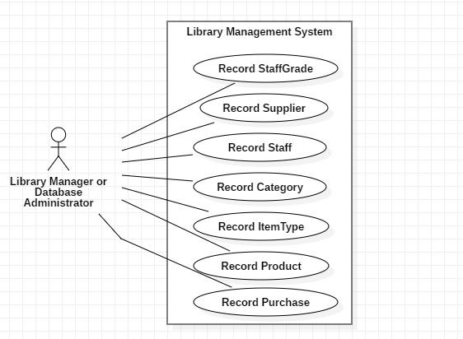

### Use Case Description

|  |  |
| --- | --- |
| **Use Case Name** | Record StaffGrade |
| **Actor** | Library Manager or Database Administrator |
| **Flow of Event** | In the library system, there were will be a lot of staffs who are working inside the building. Those staffs are divided according to the each ranks. And also those information of the StaffGrade will be going to use in the Purchase section of the items to borrow in the library. |

|  |  |
| --- | --- |
| **Use Case Name** | Record Supplier |
| **Actor** | Library Manager or Database Administrator |
| **Flow of Event** | The manager or the administrator needs to put the supplier into the database before ordering the product. Most of the purchase products are from the certain suppliers. And also the library can also buy form the other suppliers. At that time, they just need to add the new supplier into the database. |

|  |  |
| --- | --- |
| **Use Case Name** | Record Staff |
| **Actor** | Library Manager or Database Administrator |
| **Flow of Event** | And also while making the purchase the book for the library, the record of the staff who receives the order need to be recorded. And also that staff needs to be one of the staffs from the library. By recording the list of staff into the database, it will be easy to record while during the purchase recording time. |

To see the rest, go to the Appendix Page: 185

### Screen Design

#### 1. Record Supplier

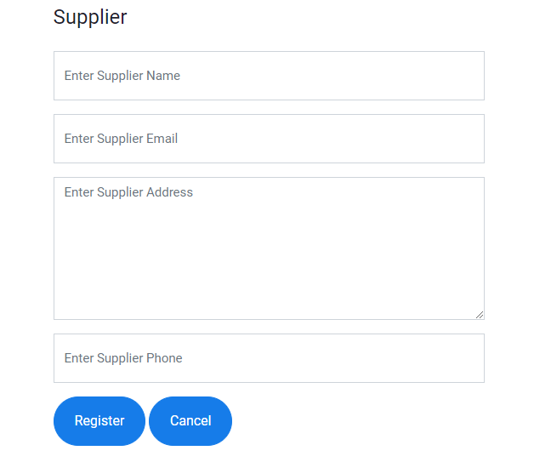

#### 2. Record StaffGrade

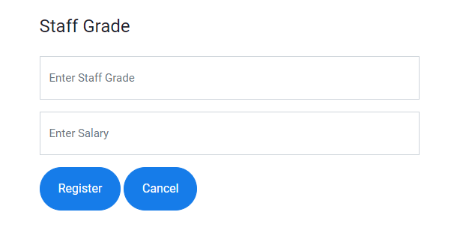

#### 3. Record Staff

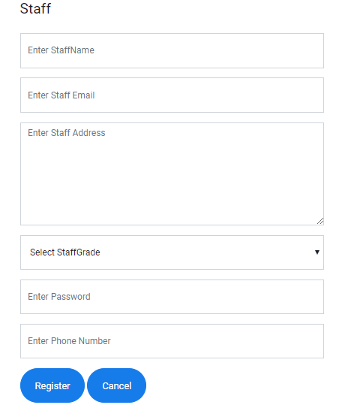

#### 4. Record Category

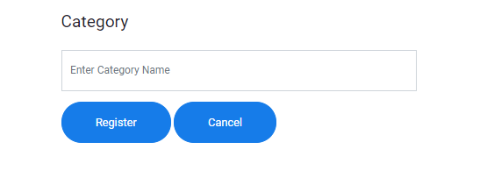

#### 5. Record ItemType

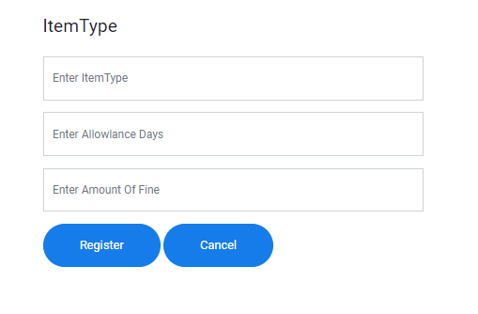

#### 6. Record Product

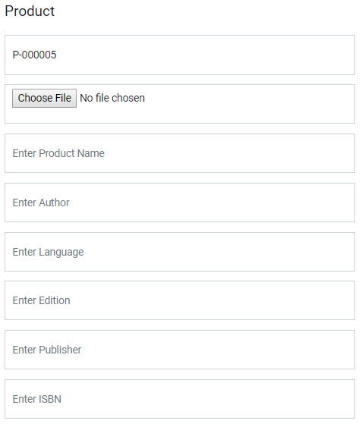

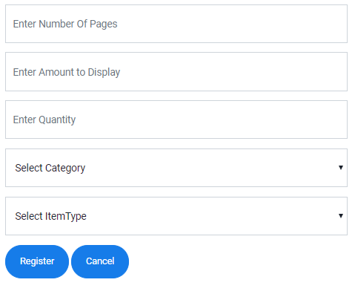

#### 7. Record Purchase

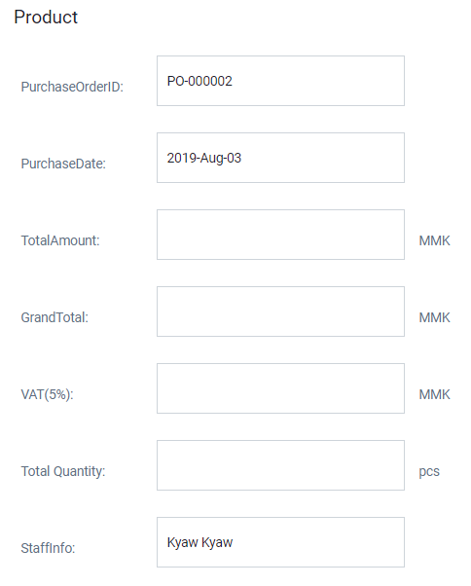

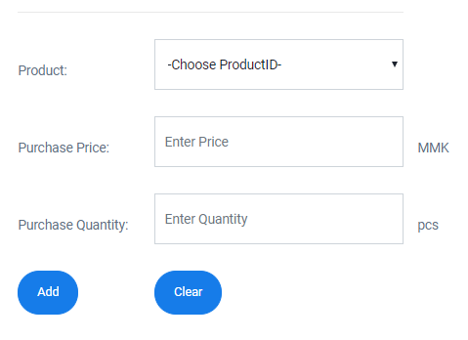

### Initial Class Diagram

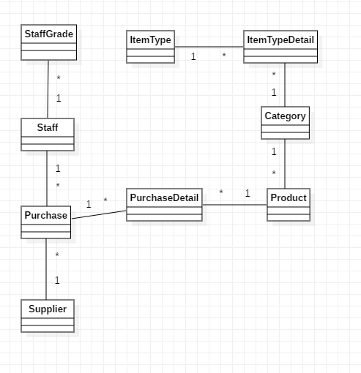

### Detail Class Diagram

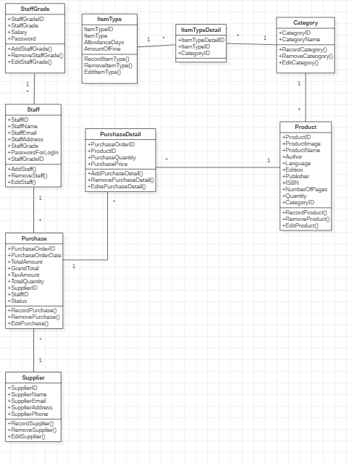

The above detail class is for only the time box plan 1 and the other detail class diagram are not involve in this time box plan. The main functions that are included in time box one are Record Supplier, Record Staff, Record Product and the Record Purchase. According to the class diagram, StaffGrade, ItemType and Category are built in order to use in the future. And also there are two dummy table which makes the relationship between the two tables. One connects the ItemType and Category and the other connects the Product and the Purchase.

### Detail Class Definition

|  |  |
| --- | --- |
| Class Name | StaffGrade |
| Attributes | StaffGradeID  StaffGrade |
| Operation | AddStaffGrade()  RemoveStaffGrade()  EditStaffGrade() |
| Description | The StaffGrade is recorded in the separate table because in the future, the staffs from the library can be added or reduced. At that time the grade for the staffs can also added new or reduced the existing ones. All the information from this table is necessary to fill without leaving the blanks. |

|  |  |
| --- | --- |
| Class Name | Staff |
| Attributes | StaffID  StaffName  StaffEmail  StaffAddress  StaffGrade  PasswordForLogIn |
| Operations | AddStaff()  RemoveStaff()  EditStaff() |
| Description | While recording the staff information into the database, the most important is recording the ID for each Staff. ID will not the same and different for each staffs. All the information from the above are essential to fill because those information will be used in the others place like recording the purchase. These information are recorded in the earlier times. |

|  |  |
| --- | --- |
| Class Name | Supplier |
| Attributes | SupplierID  SupplierName  SupplierEmail  SupplierAddress  SupplierPhone |
| Operations | AddSupplier()  RemoveSupplier ()  EditSupplier() |
| Description | And also like the first one, while recording the ID for each supplier, that information cannot be duplicate. And all the information are recorded clearly because they are going to use in another tables. Therefore all the information from this table are important and cannot be wrong. |

To see the rest, go to the Appendix Page: 188

### Sequence Diagram

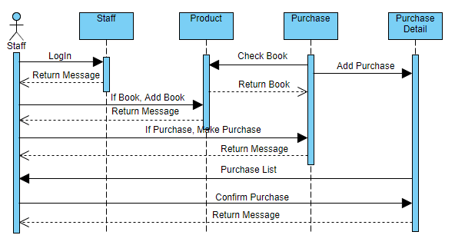

#### Sequence Diagram Description

The staff LogIn to the system with the staff level, staff email and address. Then the system check the inputted data with the database whether they are in the database of the library or not. If they are not in the database, the system will inform the staff with the LogIn fail message but if they are in the database, the system will inform the staff with the LogIn Successful message and allow him to use the function from the library system. While adding the Product into the database, if it is successful, the system will inform that product register is successful but if it is not successful, the system will inform that the product register is fail. If the staff makes the purchase, the system will check if the product that is going to purchase is existed or not. Then the system will inform the staff that the purchase of the product is successful or not. Then that data will add into the Purchase Detail as Pending. The system will give the list of Purchase from the Purchase Report Page and Confirm the purchase. The system will inform the staff if the purchase confirm is successful.

### Testing Plan

|  |  |  |  |  |
| --- | --- | --- | --- | --- |
| **No.** | **Test Script** | **Description** | **Date** | **Tester** |
| 1.1 | Register the Supplier without filling the Supplier Name | While registering the new supplier into the database of the library, Supplier Name is left without filling any information and the other fields are added with the information. | 12,2,2019 | Min Khant |
| 1.2 | Register the Supplier without filling the Email | While registering the new Supplier into the database of the library, Email is left without filling the information. | 12,2,2019 | Min Khant |
| 1.3 | Registering the Supplier with the incorrect format of Email | While registering the new supplier into the database of the library, all the information is filled in the blanks but the Email of the Supplier is filled with the incorrect format. | 12,2,2019 | Min Khant |
| 1.4 | Register the Supplier without filling the Address place | While registering the new supplier into the database of the library, all the others information are filled expect the Supplier Address place. | 12,2,2019 | Min Khant |
| 1.5 | Registering the Supplier without filling the Phone | While registering the new supplier into the database of the library, all the information are filled expect the Phone number of the suppler is left. | 12,2,2019 | Min Khant |
| 1.6 | Register the supplier with full information | The new Supplier is added into the database of the library with filling all the information without leaving any information. | 12,2,2019 | Min Khant |
| 2.1 | Registering the Grade for Staff by leaving the StaffGrade while filling | While registering the Grade for the Staff into the database of the library, the other information is filled while leaving the StaffGrade as a blank. | 13,2,2019 | Min Khant |
| 2.2 | Register the Grade without filling the Salary information | The other information is filled and the information for the Salary is left while adding into the database of the library. | 13,2,2019 | Min Khant |
| 2.3 | Register the StaffGrade with the full information without leaving anything behind | All the information are filled at the associated location and added into the database. | 13,2,2019 | Min Khant |
| 3.1 | Register the Staff into the database without filling the Name | While adding the Staff information into the database of the library, all the other information are filled expect the name of the name of the staff. | 13,2,2019 | Min Khant |
| 3.2 | Register the Staff data into the database expect the email of the staff | Register the all the information for the staff without filling the Email of the staff into the database. | 13,2,2019 | Min Khant |
| 3.3 | Register the Email of the Staff into the database with the incorrect format | Register all the information for the staff to add into the database but the format for Email is wrong. | 13,2,2019 | Min Khant |
| 3.4 | Leaving the Address while registering the staff | While registering the staff into the database of the library, the information for the address of the staff is left without filling it. | 13,2,2019 | Min Khant |
| 3.5 | Register the staff without giving the password | The information for the password of the staff is left as a blank while registering the staff’s information into the database. | 13,2,2019 | Min Khant |
| 3.6 | Leaving the Phone number of the Staff | When the information of the staff is added into the database of the library, the phone number is left as blank without filling anything. | 13,2,2019 | Min Khant |
| 3.7 | Adding the complete information into the database | Fill all the information for the staff and added into the database of the library without leaving anything. | 13,2,2019 | Min Khant |
| 4.1 | Register the Category without filling it | Leave the blank while filling the information about the category of the product. | 14,2,2019 | Min Khant |
| 4.2 | Register the Category | Fill the information about the Category of the product to add into the database of the library. | 14,2,2019 | Min Khant |
| 5.1 | Register the ItemType information without filling the ItemType Name | Fill all the information for the ItemType for all the product expect the Name of the ItemType into the database of the library. | 14,2,2019 | Min Khant |
| 5.2 | Leaving the information for the allowance days | Leave the information for the allowance days for each itemtype and add it into the database of the library while the other information are filled. | 14,2,2019 | Min Khant |
| 5.3 | Add the ItemType into the database without filling the Amount Of Fine | While adding the information about the ItemType into the database, the Amount Of Fine is left without filling and the others are filled with the associated information. | 14,2,2019 | Min Khant |
| 5.4 | Add the ItemType into the database without leaving anything | Fil all the information for the itemtype and add it into the database of the system. | 14,2,2019 | Min Khant |
| 6.1 | Register the product into the database giving the name of the product | The name of the product is left without filling while all the others information are filled and added into the database. | 15,2,2019 | Min Khant |
| 6.2 | Register the product without the author name | The author name of the product is left without filling and added into the database of the library. | 15,2,2019 | Min Khant |
| 6.3 | Register the product without the Language | All the other information for the product are filled and the language is left without filling while adding into the database. | 15,2,2019 | Min Khant |
| 6.4 | Registering the product without the Edition of the product | While adding the product into the database of the library, all the information is filled but the Edition of the book is left without filling it. | 15,2,2019 | Min Khant |
| 6.5 | Registering the Product without the Publisher Name | While registering the product into the database of the library, the information for the Publisher is left without filling anything. | 15,2,2019 | Min Khant |
| 6.6 | Add the product without the number of pages | All the other information is filled expect the number of pages and click the register button to add into the database. | 15,2,2019 | Min Khant |
| 6.7 | Register the Product with the full information | Fill all the information about the product without leaving behind and click register button to add into the database. | 15,2,2019 | Min Khant |
| 7.1 | Register the data into the box to show the list of the purchase product | Fill the Product, Purchase Price and the Purchase Product and click the add button to show the list of the purchase product. | 16,2,2019 | Min Khant |
| 7.2 | Test if the other data are automatically calculated while the above three data are added | Fill the Product, Purchase Price and the Purchase Product and click the add button to calculate the other data automatically. | 16,2,2019 | Min Khant |
| 7.4 | Register the purchase into the database of the library | After the purchase list of the product is shown, choose the supplier and click the save button to add it into the database of the library with the status Pending. | 16,2,2019 | Min Khant |
| 7.5 | Make Recent Purchase into the Confirm State in order to Confirm that that product is purchased and ready to lent to the member | After Purchase of the Product, it cannot be borrowed by the member yet. The staff need to confirm that it had been reached into the database and into the actual library storage. | 16,2,2019 | Min Khant |

### Test Script

|  |  |  |  |  |
| --- | --- | --- | --- | --- |
| Unit Test 1 | | Test Case : 1.1 | Designed by: Min Khant | |
| Data Source: Supplier Form | | Objective: Test the Supplier Form | Tester: Min Khant | |
| **Test Case** | **Description** | **Test Procedure** | **Expected Result** | **Actual Results** |
| 1.1 | Testing the null value at the Name of the Supplier | Set Supplier Email as [kaungkaung@gmail.com](mailto:kaungkaung@gmail.com) and Supplier Address as Mandalay and Supplier Phone as 094615432 and click the Register button. | Show Supplier Register Successfully Message. Insert into the database. | See Fig:1.1.2 |

Before Testing



Fig: 1.1.1

After Testing

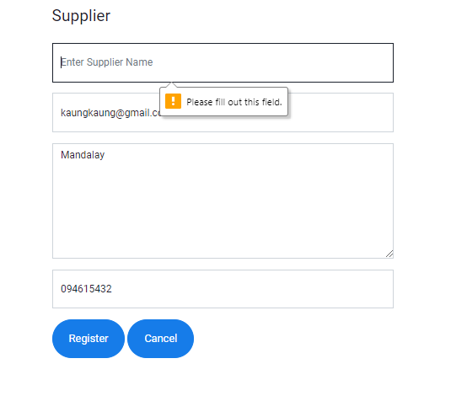

Fig: 1.1.2

|  |  |  |  |  |
| --- | --- | --- | --- | --- |
| Unit Test 1 | | Test Case : 1.2 | Designed by: Min Khant | |
| Data Source: Supplier Form | | Objective: Test the Supplier Form | Tester: Min Khant | |
| **Test Case** | **Description** | **Test Procedure** | **Expected Result** | **Actual Results** |
| 1.2 | Testing the null value at the Email of the Supplier | Set Supplier Name as Kaung Kaung and Supplier Address as Mandalay and Phone as 094615432 and click the Register button. | Show Supplier Register Successfully Message. Insert into the database. | See Fig:1.2.2 |

Before Testing



Fig: 1.2.1

After Testing

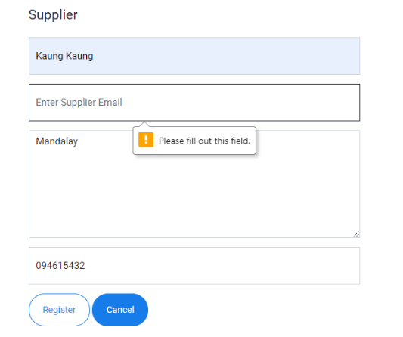

Fig: 1.2.2

|  |  |  |  |  |
| --- | --- | --- | --- | --- |
| Unit Test 1 | | Test Case : 1.3 | Designed by: Min Khant | |
| Data Source: Supplier Form | | Objective: Test the Supplier Form | Tester: Min Khant | |
| **Test Case** | **Description** | **Test Procedure** | **Expected Result** | **Actual Results** |
| 1.3 | Testing with the incorrect format of Email in the Email form | Set Supplier Name as Kaung Kaung and Supplier Email as kkkkk and Supplier Address as Mandalay and Phone as 094615432 and click the Register button. | Show Supplier Register Successfully Message. Insert into the database. | See Fig:1.3.2 |

Before Testing



Fig: 1.3.1

After Testing

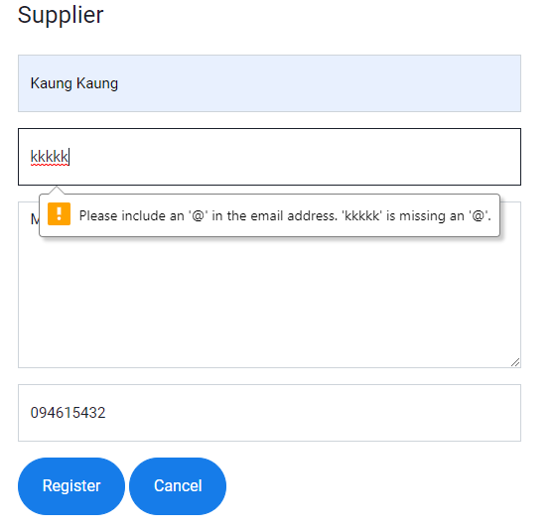

Fig: 1.3.2

To see the rest, go to the Appendix Page: 197

### Usability Testing

By according to the above the comparison between the two similar software, this function is built according to the comparison between those two software. A lot of information that can improve the usability of the user by the above comparison.

**Constancy and Standards**

|  |  |
| --- | --- |
| Fig: 1 | Fig: 2 |
|  |  |

According to the above two pages from the library system website, it can be called that it is has constancy and standards because the color of the button and the position of the button from the two pages are the same. And also the location of the textbox, the size of the textbox and the menu bar are the same.

**Error Preventing**

|  |
| --- |
| Fig: 1 |
|  |

According to the above screenshot, this library system website can prevent the user from making the mistakes. If the user makes the mistakes while storing the data into the database of the library, the library will face with many difficulties in the future due to inaccurate data. The above mistake is the action that the user forgets to fill one data which is important for the library. And also the other error prevention like inform the staff that if the information are already been existed in the database because in order to reduce duplications.

**User Friendliness (Feasibility)**

|  |  |
| --- | --- |
| Fig: 1 | Fig: 2 |
|  |  |

According to the above two pictures, there is a list of each information from the database of the library at the end of each pages. Therefore the staff can easily check the data from the library database with easily without taking too much steps. If the list is not existed, the staff needs to open the database and look for the data. And also the staff can delete and update the data from each page without going to the database and updating the data. By doing this, the staff will have more times to do the other jobs.

**Login Form (Security)**

|  |  |
| --- | --- |
| Fig: 1 |  |
| Fig: 2 |  |

According to the above two picture, the functions that the staff from the library can used are different according to the position of the staff. The important function of the library are not allowed by the normal staff. Therefore the data from the library cannot be leak to the outside because the staffs. And also in order to use those functions of the library system, the user need Email Address and Password to Login. If the user Login is correct the system will take the user to the system according to the position of the Login staff.

**Visibility of the system**

|  |  |
| --- | --- |
| Fig: 1 | Fig: 2 |
|  |  |

As the above screenshot, this website also has the visibility that let the user what he is going to click by changing the color. In the first picture, the blue button into the white button and in the second the grey text change into the black text. And also this website have the features that if the user point the arrow in one of the buttons or links, it will change into the pointing hand.

**User Friendly Design**

The Design of the system is not different like the other same systems. The logo of the company is at the left top of the system. And beside that the menu bar is located. After that below them is the position for the entry of the information. And the buttons are also simple and user friendly.

**Search Function**

|  |
| --- |
| Fig: 1 |
|  |

According to the above picture, the staff can search the book of the library without opening the database of the library. The way it works is simple. It will show all the data of the books from the library in the default state. If the staff needs to search by the advance search, the staff needs to check on the radio button that he wants to search and type the information. Then click Search and the associated book list will show. Having the Search Functions will reduce the work that the staff need to do.

**Help Function**

|  |
| --- |
|  |

The above screen shot shows that this system has the function that allows the newbie user to look at the user manual before working with the system. If the staff click on the button, the staff will be taken to the User Manual Page which explain how to works all the function of this system.

### Iteration

**Making the StaffGrade table in the database**

At the first, only Staff data is stored into the database and it became difficult to use because in some cases, the normal staff from the library cannot do by himself. Works from the library are separated according to the position of the staff. Therefore StaffGrade table is needed to make in the database. StaffGrade information is already stored in the database. And this data is going to reuse while register the new staff into the database. And also the permission to use functions from this system is also different according to the level of the staff.

**Making the LogIn according to the Staff Level**

In this library system, the functions that can be used by the staff are different according to the level of the staff. Therefore the system needs to distinguish the staff that going to Login whether he has the access to specific function or not. Therefore at the start of the system, Login page, there will be two processes, one to the functions that normal staff can do and the other to the functions that higher level can access. The system will divide according to the level of the staff that is trying to Login.

**Having the List at the end of each Pages**

At the end of each pages, I put the list of the data that exists in the database of the system. Because if the staff want to see the stored data from the database, he need to open the database and look for the data that he want. By making the list of data from the database, the staff doesn’t need to go and look for the data. He can just look the data from the pages and will reduce the time that he needs to take. And also in some List, the staff can update and delete the data from the database by clicking the link from the list of each page. Therefore, the user doesn’t need to go to the database and do the processes.

**Making the Print Function at the Purchase Detail**

In Purchase Detail Page, Print Function is added to print the specific purchase from the supplier. It may not be very important but it can increase the system’s convenience and effectiveness while using it by the staff.

**Making Update & Delete link in the list of each page**

At the end of most Entry form, there is a list that display the data from the database which allow the staff to search the data while using the system without going to the database of the library. The purpose of placing Update & Delete is that the staff doesn’t need to go to the database and update the data if he has to. And now he only need to click on the line and can easily change the data of the library database without taking too much time.

### Time box Summary

1. **Problems**

**Difficult to collect information:** collecting the data which are needed for the system is very difficult because in order to know the process, investigation on the real system is needed. While gathering information, the staffs don’t have time to involve and some of don’t want to get involved.

**First time making Project:** it is a little difficult because it is the first time making like this kind of projects. A lot of time is taken to consider the stable scope for the system. And the helps from the other people who have done like this kind of projects are requested in order to make the perfect project.

**Cannot manage time properly:** time management is very important in developing the system because the system needs to be delivered to the customer at the right time. If the customer cannot get the system at the right time, the reputation is going to fall.

**Unknown codes for the system:** As a newbie in the field, there are a lot of things that are not still known. In that things, the codes that are needed to write the system are involved. Some of the codes are already known but some are not. It will be difficult to build the system if the codes are not known.

1. **Solve**

To solve the above problem, I volunteer as the library staff for a month to know the process of the library and during that time I interview the staffs who always work at the library. And some research for the library are done form internet. And I also get the help from the people who have the experience with the company projects. Because they are dealing with the real situation and they will be a great help to do this project. For the time management, the system and documentation are done according to the times which are decided in the time box plan. While developing the system, a lot of unknown codes appear that are needed for the system. Those unknown codes are discovered and learnt from w3schools which is an online website that allows varieties of codes for the programmer.

1. **Lesson Learn**

By doing this, the lesson that has learnt is that there are a lot of things that needed to learn. The things that we know are not enough and need further more learning. And there are lots of ways to learn by studying by self from the internet or attending the courses. By doing this, the knowledge of the how the real life works are difficult is got. And everything cannot get easily without working hard.

1. **Plan for Future time box**

In this Time Box 1, they are just the only entry part therefore, the future plan for this time box doesn’t exists.

## 6.2 Time Box-2

### Project Plan for Time Box-2



### 6.2.1 Functional Requirement

* Record Borrow
* Record Borrow Detail
* Update in Product

### 6.2.2 Usecase Diagram

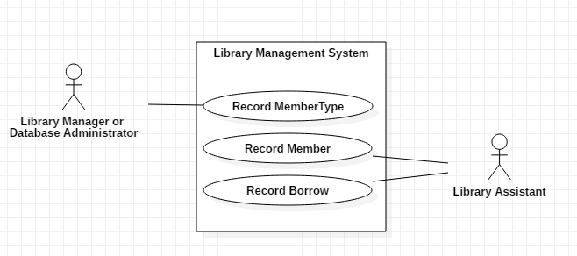

### 6.2.3 Usecase Description

|  |  |
| --- | --- |
| **Use Case Name** | Record MemberType |
| **Actor** | Library Manager or Database Administrator |
| **Flow of Event** | There are two kinds of MemberType that this library offers to the people. According to the MemberType, the permission that the member can get is also different. According to the types of the member, the card cost and the amount books that can borrow are changed. |

To see the rest, go to the Appendix Page: 186

### 6.2.4 Screen Design

#### 1. Record MemberType

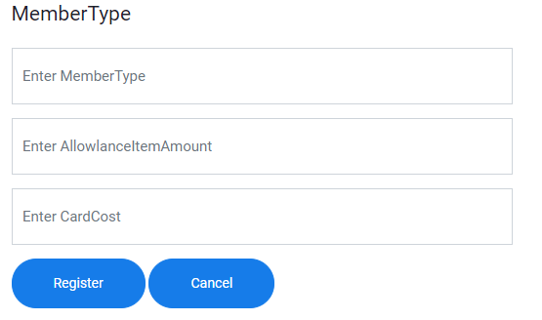

#### 2. Record Member

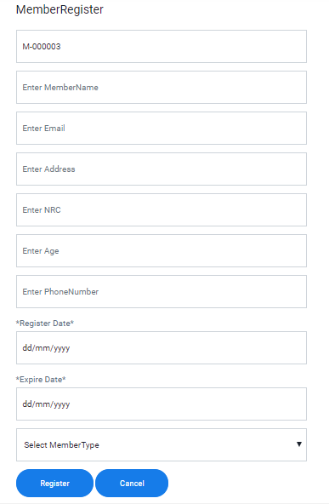

#### 3. Record Borrow

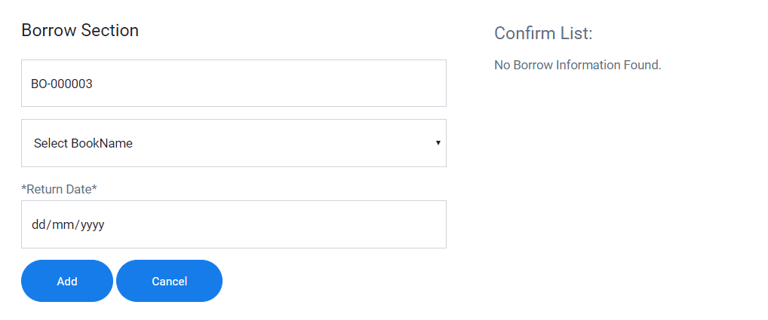

### 6.2.5 Initial Class Diagram

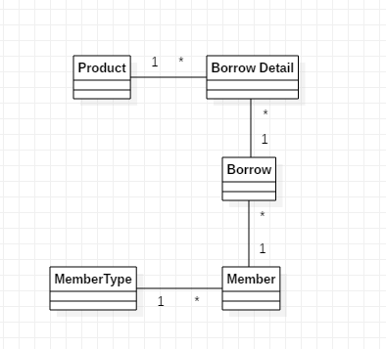

### 6.2.6 Detail Class Diagram

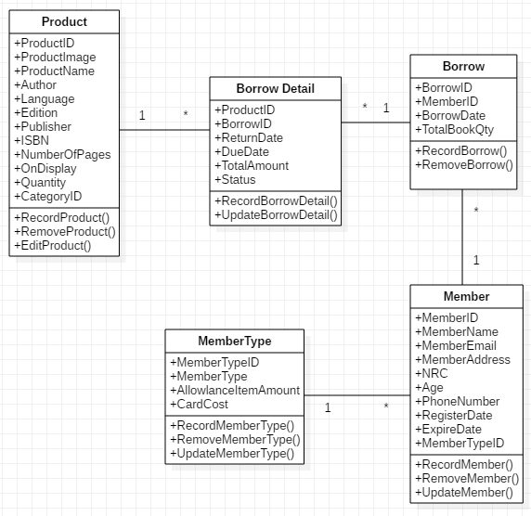

### 6.2.7 Detail Class Definition

|  |  |
| --- | --- |
| Class Name | MemberType |
| Attributes | MemberTypeID  MemberType  AllowlanceItemAmount  CardCost |
| Operation | RecordMemberType()  RemoveMemerType()  UpdateMemberType() |
| Description | MemberType data are stored into the database before storing the member of the library which means that those data are stored at the start of the library. Those data are going to use in Member Register, Borrow and Return. |

To see the rest, go to the Appendix Page: 192

### 6.2.8 Sequence Diagram

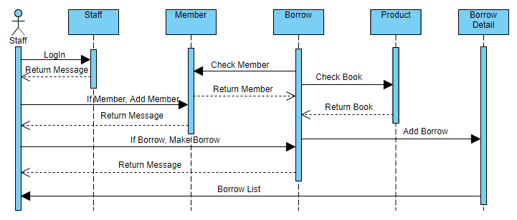

#### Sequence Diagram Description

The staff LogIn to the system with the Staff Level, Staff Email and Password. If the LogIn is successful, show LogIn successful message and if it is not successful, show LogIn fail message. While adding the member into the database, successful message will show if the data are stored into the database but it is not, fail message will show. While making the borrow, the system will check if the current member and the borrowed book is existed or not. If they are exists and Borrow is successful, successful will message will show. Then the borrow data will store into Borrow and BorrowDetail. After that the system will show the staff the list of borrow from the Borrow Detail.

### 6.2.9 Testing Plan

|  |  |  |  |  |
| --- | --- | --- | --- | --- |
| **No.** | **Test Script** | **Description** | **Date** | **Tester** |
| 1.1 | Register the MemberType Data into the database without filling MemberType | When registering the MemberType data into the database of the library, all the others information are filled expect the MebmerType. And click Register button. | 13.7.2018 | Min Khant |
| 1.2 | Register the MemberType information into the database leaving the Allowance Item Amount as blank | The information for the Allowance Item Amount is left without filling anything while the others are filled. | 13.7.2018 | Min Khant |
| 1.3 | Register the MemberType information into the database without filling amount of the cost of the card | All the information from the MemberType Register form are filled expect the CardCost and register it into the database. | 13.7.2018 | Min Khant |
| 1.4 | Register the MemberType data into the database correctly and without making any mistakes | All the information are filled and register it into the database of the library. | 13.7.2018 | Min Khant |
| 2.1 | Register the member information without filling the name of the member | While Registering the Member Data into the database, MemberName is lift without filling it. | 14.7.2018 | Min Khant |
| 2.2 | Register the Member data into the database of the library without filling the Email Address | The data for Email Address is left without filling it while registering it into the database. | 14.7.2018 | Min Khant |
| 2.3 | Register the Member Email data into the database with the wrong format | Member Data is stored into the database with the wrong format of the Email Address. | 14.7.2018 | Min Khant |
| 2.4 | Register the Member data leaving the Address behind | Address data is not fill while registering the member into the database. | 14.7.2018 | Min Khant |
| 2.5 | Register all the information from the Member Register page expect NRC | The information of the Member’s NRC is not registered while Member Information is stored into the library database. | 14.7.2018 | Min Khant |
| 2.6 | Register the Member Information without Age | All the other information from the Member Form are filled expect Age. And click Register button. | 14.7.2018 | Min Khant |
| 2.7 | Register the Member Informaiton into the database without filling Phone Number | Phone Number is left while filling the data of the Member Form. And then Register it. | 14.7.2018 | Min Khant |
| 2.8 | Register the data of the member without filling the Register Date of the Member | The data about the date when the member first register is not filled in the blank and stored it into the database. | 14.7.2018 | Min Khant |
| 2.9 | Register the Member Data by leaving the Expire Date of the Member Card | The date when the member card will expire is not filled and registered it into the database. | 14.7.2018 | Min Khant |
| 2.10 | Register the Member Data into the database with full data and correct data | All the information from the Member Register Page is filled and stored it into the database. | 14.7.2018 | Min Khant |
| 3.1 | Adding the borrow books into the temporary table after filling all the information | All the data are filled and click the Add button | 15.7.2018 | Min Khant |
| 3.2 | Add the another book to borrow after the first one is done | Repeat the steps taken in the first time to add the new one. | 15.7.2018 | Min Khant |
| 3.3 | When the inputted data are added into the temporary tables and choose Member to register it into the Borrow table of the library Database | When the data are appeared in the temporary table, choose the Member who is trying to borrow and add it into the database. | 15.7.2018 | Min Khant |
| 3.4 | Check whether the number of Books Display is changed in database or not | After the borrow process is complete, the borrow information is stored into the database and reduce the amount of display books on product table. | 15.7.2018 | Min Khant |

### 6.2.10 Test Script

|  |  |  |  |  |
| --- | --- | --- | --- | --- |
| Unit Test 1 | | Test Case : 1.1 | Designed by: Min Khant | |
| Data Source: MemberType Form | | Objective: Test the MemberType Form | Tester: Min Khant | |
| **Test Case** | **Description** | **Test Procedure** | **Expected Result** | **Actual Results** |
| 1.1 | Testing with the null value in the MemberType data | Set AllowlanceItemAmount as 3 and Card Cost as 30000 and leave the MemberType data. And then click Register button. | Show MemberType Register Successfully Message. Insert into the database. | See Fig:1.1.2 |

Before Testing

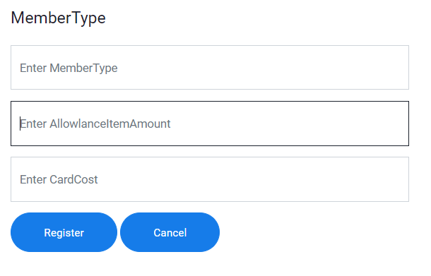

Fig: 1.1.1

After Testing

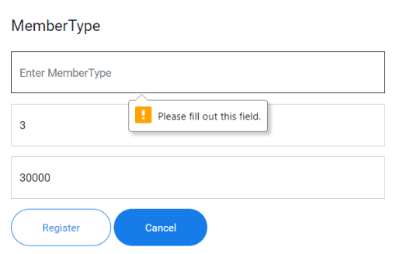

Fig: 1.1.2

|  |  |  |  |  |
| --- | --- | --- | --- | --- |
| Unit Test 1 | | Test Case : 1.2 | Designed by: Min Khant | |
| Data Source: MemberType Form | | Objective: Test the MemberType Form | Tester: Min Khant | |
| **Test Case** | **Description** | **Test Procedure** | **Expected Result** | **Actual Results** |
| 1.2 | Testing with the null value in the AllowlanceItemAmount data | Set MemberType data as Gold and Allowlance Item as null and Card Cost as 30000. Then click Register button. | Show MemberType Register Successfully Message. Insert into the database. | See Fig: 1.2.2 |

Before Testing



Fig: 1.2.1

After Testing

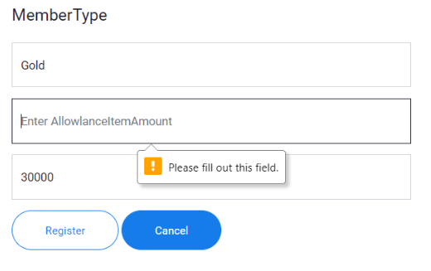

Fig: 1.2.2

|  |  |  |  |  |
| --- | --- | --- | --- | --- |
| Unit Test 1 | | Test Case : 1.3 | Designed by: Min Khant | |
| Data Source: MemberType Form | | Objective: Test the MemberType Form | Tester: Min Khant | |
| **Test Case** | **Description** | **Test Procedure** | **Expected Result** | **Actual Results** |
| 1.3 | Testing with the null value at the Card Cost data | Set MemberType as Gold and AllowlanceItemAmount as 3 and Card Cost as null. Then click Register button. | Show MemberType Register Successfully Message. Insert into the database. | See Fig: 1.3.2 |

Before Testing



Fig: 1.3.1

After Testing

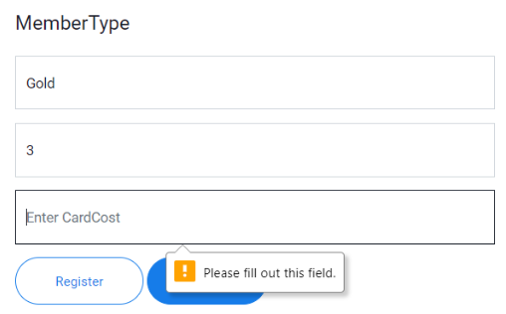

Fig: 1.3.2

To see the rest, go to the Appendix Page: 256

### 6.2.11 Usability Testing

**Constancy and Standards**

|  |  |
| --- | --- |
| Fig: 1 | Fig: 2 |
|  |  |

According to the above two screenshot, the system has Constancy and Standards. Because the locations of the buttons are the same with each other and the color are the same. And also the locations to input the data are the same. Therefore, this system has its own Constancy and Standards.

**Error Preventing**

|  |
| --- |
| Fig: 1 |
|  |

By the above screenshot, the system can inform the user if he make the mistakes. The above screenshot is about leaving null in date and register it. That left data is important and cannot be null in database so the system informs the user to fill the blank again. Then the user knows that he cannot leave that data and prevent future errors like inaccurate data and lack of data. And also other error preventions like inform the user if the inputted data is already exist in the database to prevent data duplication.

**Visibility of the system**

|  |  |
| --- | --- |
| Fig: 1 | Fig: 2 |
|  |  |

According to the above two screen shot, this webpage has visibility because it allows the user to know where he is pointing right now by changing the color. And also it also has the function that show with the pointing when the user places the arrow on button or link.

**Help Function**

|  |
| --- |
|  |

According to the above screenshot, this system has the help function for the staff who are going to use it. The staff just needs to click on the button and they will be taken to the User Manual Page. In that page, they can learn how to work with all functions of the system.

### 6.2.12 Iteration

**Allow the staff to record all the borrows in single one time**

At the start of the project, I decide to borrow process to do one book after another which is like the manual system always does. In manual system, they record the first book into the book and later the next. Then, recording one by one is not efficient and will take too much time for one member. Therefore, the borrow process is changed into the system that can be multiple at one time. That means the staff can record all the borrow from one member at a single time.

**Having the function that the staff can look back the borrow record**

At the first, only the list of the borrow books from the database is going to show but it will be difficult in the future. Because the record of the borrow will increase and it will be inconvenient to find what the staff want to find. Therefore, Searching function from borrow is added to solve those problems. In Search Function, the borrow record can be search with three options.

**Changing the place for selecting member who is trying to borrow**

At first, in borrow process, the staff need to fill the member name when the member try to borrow the book. But now as the borrow process is changed, way of selecting member name is also change. In the first system, the staff needs to select the member name again and again until the borrowed books are all register. But now borrow process is changed and selecting the member is at the end of book selecting process. This new process can reduce the time taken for doing borrow function and reduce duplication functions.

* The other two changes in system are having the list at the end of pages and having update & delete link in the list of the pages and they are like the explanation from Time Box 1 Iteration.

### 6.2.13 Time Box Summary

**1. Problems**

**Flow the Borrow System:** while deciding to create the Borrow Function for the library, a lot of difficulties appeared. Because the way the process perform need to be simple and can be easily learnt by the staff. Therefore, thinking the flow of process which will be efficient for the staff.

**Making Design for the Borrow Page:** After deciding the flow of the borrow process, the design for the Borrow Page needs to decide. The design need to simple without too much color or without being complex and more over the design need to friendly with the user.

**Unknown code for the process:** As usual, after the flow of the process and design are decided, the developing part always comes. The main Functions form this project is different and the flows of them are also different. So, they cannot be written the same code again and again. In order to fit with the flow and design, the new codes is needed.

**2. Solve**

To solve the above problems, the data of the borrow function is collected from the actual data and also research through online. After finding the solution for the problem, the solution appears. Borrow Function is based a little on the process of Purchase of the book and gets the flow of functions which the staff can understand clearly and easier to learn. And also the design is also take a little base from the Purchase Design. And the code also base on the Purchase a little and the other are searched from online website.

**3. Lesson Learn**

While doing Borrow Function for Time Box 2, I get the knowledge that the user familiar is very important. If the user is not familiar with the system, they will have difficulties to use and will take times to finish. If the design is user friendly and similar with the design with the others, they can easily learn to use and can increase productivity.

**4. Plan for Future Time Box**

In Borrow Function, the function that detects the user member card and said that whether it is out of date not is going to add in the future. If that function is added, the staff doesn’t need to check the database again and again. And also there will be no problems about lending the books to out of date member.

## 6.3 Time Box-3

### Project Plan for Time Box-3



### 6.3.1 Functional Requirement

* Record in Returns
* Update in Product
* Update in BorrowDetail
* Record in DamageLost

### 6.3.2 Usecase Diagram

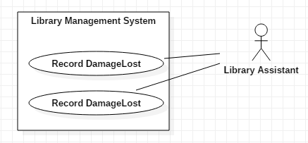

### 6.3.3 Usecase Description

|  |  |
| --- | --- |
| **Use Case Name** | Record Return |
| **Actor** | Library Assistant |
| **Flow of Event** | When the member return the borrowed book to the library, the staff need to select the member name from the combo box and the borrow record of the member will appear. After that calculate the Fine of the book that he want to borrow and choose the returned book name from the combo box to return. When the return process is complete, it will update Due Date, TotalAmount from BorrowDetail table and OnDisplay from Product table. |

To see the rest, go to the Appendix Page: 187

### 6.3.4 Screen Design

#### 1. Return

#### 2. Damage&Lost

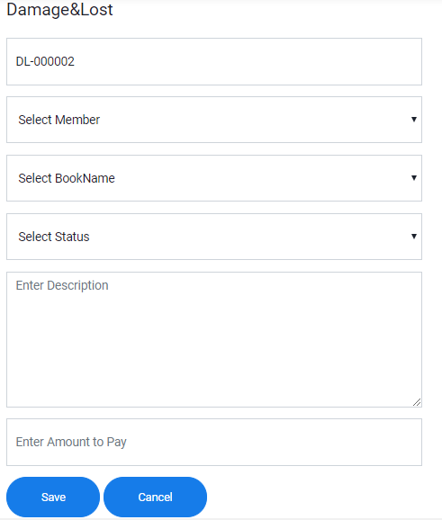

### 6.3.5 Initial Class Diagram

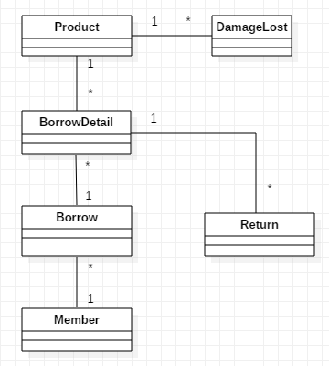

### 6.3.6 Detail Class Diagram

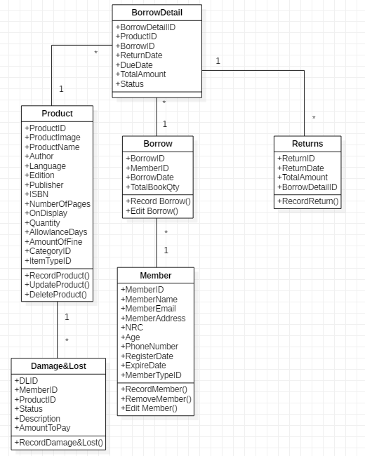

### 6.3.7 Detail Class Definition

|  |  |
| --- | --- |
| Class Name | MemberType |
| Attributes | ReturnID  ReturnDate  TotalAmount  BorrowDetailID |
| Operation | RecordReturn() |
| Description | When the Member returns the borrowed book back to the library, the staff needs to store it into the return table of the library database. If the user returns the book, the associated amount of book from product table will be added. This can also act like evidence that the member had returned the borrowed book from the library. |

To see the rest, go to the Appendix Page: 195

### 6.3.8 Sequence Diagram

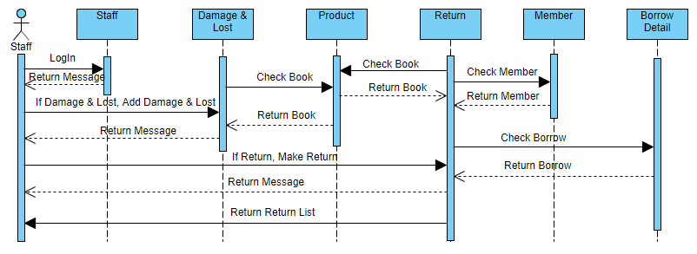

#### Sequence Diagram Description

If the staff LogIn with the correct data, the successful message will show and he can use the function of the library system. Successful message will show if the adding Damage & Lost is registered in the database. If it is not, fail message will show. While adding Damage & Lost, the system will check if the book is existed in the database or not. And also while adding the return into the database, the system will check if the returned book and member are existed in Product, Member and Borrow Detail. If they are success, successful message box will be shown to the staff by the system. And the system will show the list of return record from Return to the staff.

### 6.3.9 Testing Plan

|  |  |  |  |  |
| --- | --- | --- | --- | --- |
| **No.** | **Test Script** | **Description** | **Date** | **Tester** |
| 1.1 | Check whether the related borrow information is shown after choosing from the Member combo box | Choose the MemberID and MemberName from the combo box if the member returns the book to the library. And the related borrow record will appear in the list under it. | 2.8.2019 | Min Khant |
| 1.2 | Check what happen when the staff click on the link from the table of the form even the book is not overdue | When the records are appeared, firstly check if the returning book is not overdue or not. Because if it is overdue, fine is needed to collected from the member | 2.8.2019 | Min Khant |
| 1.3 | Check what happen when the staff click on the link from the table of the form when the book is overdue | When the records are appeared, firstly check if the returning book is not overdue or not. Because if it is overdue, fine is needed to collected from the member | 2.8.2019 | Min Khant |
| 1.4 | Add the return record into the database after choosing the returned book from the combo box of the table and click return button | When calculation of due date is finished, choose the returned book from the combo box from the list to add it into the database of the library | 2.8.2019 | Min Khant |
| 1.5 | Check if changes happen in On Display from Product table and Status from BorrowDetail table of the database after the borrowed book is returned back to the library and made the return record | After the return is completed, the record will record in the database of the library. | 2.8.2019 | Min Khant |
| 2.1 | Check if the Damage&Lost data is saved without filling the Description | Fill all the other information expect the data for the Description column and click Save | 3.8.2019 | Min Khant |
| 2.2 | Check if the Damage&Lost data is saved without filling the Amount to Pay information | Fill all the other information expect the data for the Amount to Pay column and click Save | 3.8.2019 | Min Khant |
| 2.3 | Add the data into the database after filling all the information from the form | All the data from the form are filled and save them into the database of the library | 3.8.2019 | Min Khant |
| 2.4 | Check whether changes happen in Quantity of Product and Status from BorrowDetail | After recording the Damage&Lost is complete, the data from Quantity of Prodct will reduce and Status from BorrowDetail will change | 3.8.2019 | Min Khant |

### 6.3.10 Test Script

|  |  |  |  |  |
| --- | --- | --- | --- | --- |
| Unit Test 1 | | Test Case : 1.1 | Designed by: Min Khant | |
| Data Source: Return Form | | Objective: Test the Return Form | Tester: Min Khant | |
| **Test Case** | **Description** | **Test Procedure** | **Expected Result** | **Actual Results** |
| 1.1 | Check whether the related information of the borrow record is appear in the list after the Member Name is selected from the combo box | Select M-000001 – kyawkyaw and click Search button | Show related borrow record of the member in the list below it. | See Fig:1.1.1 and Fig:1.1.2 |

Before Testing

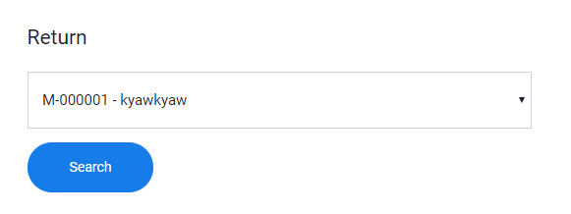

Fig: 1.1.1

After Testing

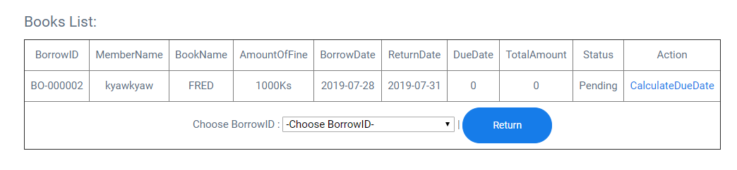

Fig: 1.1.2

|  |  |  |  |  |
| --- | --- | --- | --- | --- |
| Unit Test 1 | | Test Case : 1.2 | Designed by: Min Khant | |
| Data Source: Return Form | | Objective: Test the Return Form | Tester: Min Khant | |
| **Test Case** | **Description** | **Test Procedure** | **Expected Result** | **Actual Results** |
| 1.2 | Click the CalculateDueDate link to check if the book is overdue or not even the book is not overdue | Click on the link from the list to calculate | Show Calculation of Due Date Successful | See Fig:1.2.2 |

Before Testing



Fig: 1.2.1

After Testing

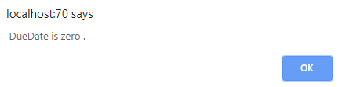

Fig: 1.2.2

|  |  |  |  |  |
| --- | --- | --- | --- | --- |
| Unit Test 1 | | Test Case : 1.3 | Designed by: Min Khant | |
| Data Source: Return Form | | Objective: Test the Return Form | Tester: Min Khant | |
| **Test Case** | **Description** | **Test Procedure** | **Expected Result** | **Actual Results** |
| 1.3 | Click the CalculateDueDate link to check if the returned book is overdue or not while the book is overdue | Click on the link from the list to calculate | Show Calculation of Due Date Successful | See Fig:1.3.2 and Fig:1.3.3 |

Before Testing

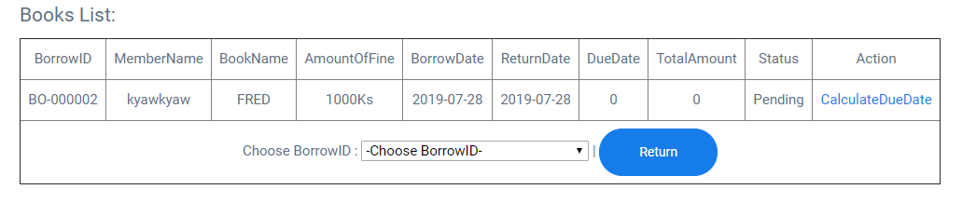

Fig: 1.3.1

After Testing

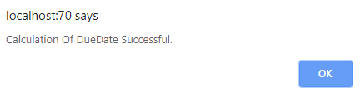

Fig: 1.3.2

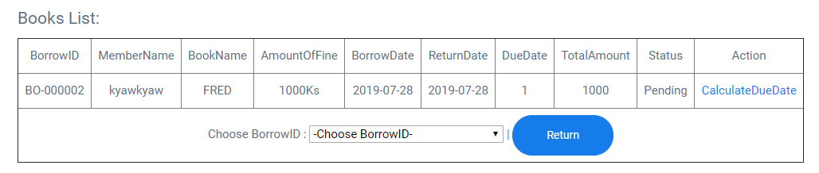

Fig: 1.3.3

To see the rest, go to the Appendix Page: 294

### 6.3.11 Usability Testing

**Constancy and Standards**

|  |  |
| --- | --- |
| Fig: 1 | Fig: 2 |
|  |  |

According to the above two screen shot, these web pages can be said that they have constancy and standards. The color of the button is the same with each other and the sizes of the font are also same. The location of the button and the text box are the same with the equal size. The user will not feel strange because of having constancy and standards.

**Error Preventing**

|  |
| --- |
| Fig: 1 |
|  |

Like in the above Time Box 1 and Time Box 2, this also has the error prevention that informs the user that they are making the mistakes. And if they correct the mistakes, the process will continue smoothly without errors. Having like this kind of prevention can prevent the inaccurate data and incomplete data in the future.

**Visibility of the system**

|  |  |
| --- | --- |
| Fig: 1 | Fig: 2 |
|  |  |

This website has the function that allows the user to know where they are pointing right now by changing the color. In the above screenshots, the staff is pointing at the buttons of the pages. And it also has the function that change the arrow on the desktop to the pointing hand.

**User Friendly Design**

|  |
| --- |
| Fig: 1 |
|  |

The above screenshot is the page of return function from the system. By looking at the page, the user can easily know what he need to do to start working. The design is simple and the words used in this page are easy to understand for the rookie. In this page, the user only need to choose what he want to find from the combo box therefore he will not take too much time.

**Help Function**

|  |
| --- |
|  |

They system has the help system that allow the user to learn how to use the function of the system. They just need to click on the button and they will be taken to the use manual page.

### 6.3.12 Iteration

**Adding the Damage & Lost function**

At the first of Time Box 3 plan, Damage & Lost function is not included but it is going to added in the future. So, only Return function is going to make in time box 3. But in real system, fine calculations are done at the same time with returning book back to the library. Therefore, Damage & Lost function is added into the Time Box 3 from the future plan. In this function, there is not too much process. The staff registers the Damage & Lost book record and the system automatically do the rest in the database.

**Having Due Date Cost Calculation in Return Page**

From the start, adding due date calculation is included in the plan but whether to use manual system or automatic system is not been decided. But now, Due Date Calculation is built into the automatic system which calculate the due date of the borrow book and give the result. It is very simple, in the page, the staff just need to click on CalculateDueDate link to calculate fine automatically. And it will only take a second.

**Having the Return Report Page**

Like the Borrow Search Page from time box 2, Return Search is not included in the first plan. When the return record become very many and it will become difficult to find what the staff is trying to find. Therefore, Return Search Page is built with three criteria. Because of this function the staff will become convenient to use.

**Making the function that find book automatically according to the member**

In the Return function, the staff needs to choose the member name that is trying to return the borrowed book back to the library. After selecting the member name, the related borrow data will be shown at the list below it. At the plan, the list is not in included and the staff needs to choose member name and book name. Now the process is changed therefore this save a lots of time and easier to use than the first one.

### 6.3.13 Time Box Summary

**1. Problems**

**Flow of Return System:** When the new Function is going to build, the first thing to think is with which flow does the function is going to perform. And that decided flow of function is need to be easier to understand and easier to learn how to use by the user.

**Design of Return System:** After the flow of function is complete, the design of the Return Page is needed to decide which is user familiar and has a good interface.

**Making Automatic DueDate Calculation:** They calculate the fine for the book manually in the actual library. But in this system the calculation is changed into automatic which means the staff doesn’t need to calculate. But the problem is where to put that function in the Return Page.

**2. Solve**

In order to make the function for the Return Page, I base it from the similar system of the library system which is shown in similar system comparison and change some of the things. And also the design is based on that thing. But not all the process is copy. I change the flow of the function by choosing the borrowed book at the end of the list. And Automatic Calculation is added at each book. The staff has to click on the link and the fine will automatically calculated.

**3. Lesson Learn**

While developing the Return System, the automatic function can be added in the system if they are needed. And also I know that the Return Functions can be built in many ways which are user friendly and can learn easily. After Time Box 3 is finished, I get the knowledge that how to build the system which are easier to use without following the rule.

**4. Plan for Future Time Box**

In this Time Box, Return Function and Damage&Lost Function are involved. But in the future, Donation Function is going to add in this time box. Actually in the real library system, donation process is involved but it is very rare. But that function is going to add in the future to have the complete Library Management System.

Development

## 7.1 Deployment

### 7.1.1 Deployment Diagram

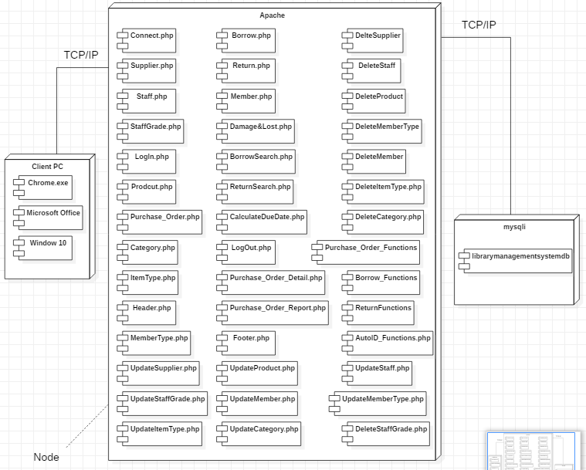

### 7.1.2 Explanation for diagram

In order to use the software, the staff’s computer needs to have the internet browser like Chrome. FireFox can also be used for this system. The client computer need to be in window 10 to have the great performance. And in the mysql database of the system, the name from the above screen shot need to be given. The middle one from the above screenshot is the name of php codes which are essentials part to run the system. And the file from the above are connected with each other. In every pages, Connect.php, Header.php and Footer.php are needed to have the full design of the system and allow the access to the database of the system. And in some pages like Product.php, Purchase_Order.php and other need the AutoID_Function.php which allows them to put the automatic ID with text and numbers into the database. In some pages, they cannot run their alone they the functions which are written in other .php files. For example, in Purchase_Order Page, it needs to use the functions which are written in Purchase_Order_Functions.php. And in every Entry Pages like Category.php and others, it connected with their associated Update and Delete .php files. Therefore, every files from this system cannot be deleted. If one of the files is deleted, the problems will come after.

## 7.2 Data Migration

Data Migration is used to send the data from one computer to another or to the storage system of the database, computer system and the data formats. Data Migration is done on data for various reasons. It is used when the current system is replaced with the new one or the system is upgraded or when the first system is applied to the company. Data Migration is used for various purposes like replacement or upgrading the server or storage, website consolidation and data center relocation.

**Data Migration Procedure**

In order to use the Data Migration, it has its own step by step procedures. They are Analysis Stage, Data Migration Plan, Build and Testing, Execution Stage and Verification Stage. By doing the provided stages, the user can plan and scope what he need to do about the changes.

**Analysis Stage:** Collect the data and information about the system that is going to change. The detail analysis of the system is needed to use Date Migration.

**Data Migration Plan:** According the collected information and data from the Analysis Stage, the plan is needed to create. The way to use the Data Migration and the basic design are needed in the plan.

**Build and Testing:** According to the Plan, Data Migration is needed to build to change the system. After building it, it is needed to test before deploying it into the actual system.

**Execution Stage:** Deploy the built and tested Data Migration plan to change the system and migrates the data of the company.

**Verification Stage:** Test the new system and documents the changes of the new system and the whole processes.

(techopedia, -) (TechTarget, -)

### 7.2.1 Data to Migrate

|  |  |  |
| --- | --- | --- |
| Time Box | Master Data | Transaction Data |
| Time Box 1: Purchase andRegister of Books | Supplier, StaffGrade, Category, ItemType, Staff, Product | Purchase, PurchaseDetail |
| Time Box 2: MemberRegister and BorrowFunction | Member, MemberType | Borrow, BorrowDetail |
| Time Box 3: Return andDueDate CalculationFunction | Damage&Lost | Return |

### 7.2.2 Plan

|  |  |  |  |  |  |
| --- | --- | --- | --- | --- | --- |
| TimeBox | Data To Migrate | Duration | Start Date | End Date | Responsible person |
| Time Box 1: Purchase andRegister of Books | * Supplier * StaffGrade * Category * ItemType * Staff * Product * Purchase * PurchaseDetail | 1 | 10.8.2018 | 10.8.2018 | Library Manager & Database Administrator |
| Time Box 2: MemberRegister and BorrowFunction | * Member * MemberType * Borrow * BorrowDetail | 1 | 11.8.2018 | 11.8.2018 | Library Assistant |
| Time Box 3: Return andDueDate Calculation | * Damage&Lost * Return | 1 | 12.8.2018 | 12.8.2018 | Library Assistant |

## 7.3 Training

### 7.3.1 Training plan

|  |  |  |  |  |  |  |
| --- | --- | --- | --- | --- | --- | --- |
| No | Contact | Trainer | Start Date | End Date | Venue | Time |
| 1 | Time Box 1   * Supplier * StaffGrade * Category * ItemType * Staff * Product * Purchase * PurchaseDetail | Library Manager & Database Administrator | 20.8.2019 | 21.8.2019 | At Company | 11:00 p.m. to 1:00 p.m. |
| 2 | Time Box 2   * Member * MemberType * Borrow * BorrowDetail | Library Assistant | 22.8.2019 | 22.8.2019 | At Company | 11:00 p.m. to 1:00 p.m. |
| 3 | Time Box 3   * Damage&Lost * Return | Library Assistant | 23.8.2019 | 23.8.2019 | At Company | 11:00 p.m. to 1:00 p.m. |

### 7.3.2 User Manual

#### 1. Staff LogIn

Firstly select the Level of the staff

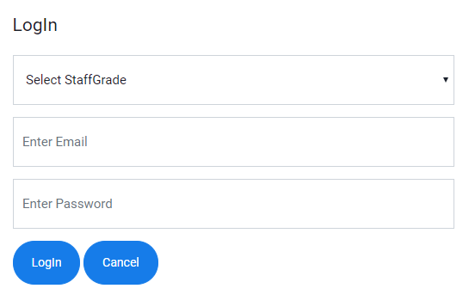

Then write the email address of login staff

Fill the password of the staff

Click LogIn to get access and Click Cancel to reset

#### 2. Supplier Register

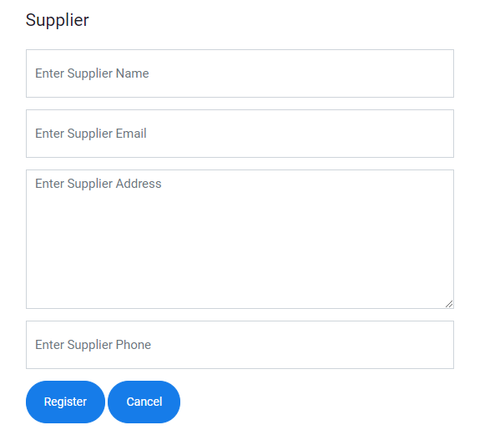

Input the phone number of the Supplier

Input the address of the Supplier

Input the email of the Supplier

Input the name of the Supplier

Click Register to register the data into the database and Click Cancel to reset

#### 3. Category

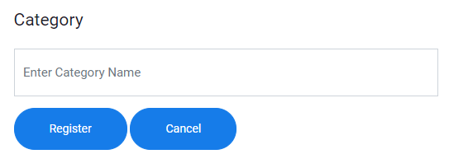

Click Register to register the data into the database and Click Cancel to reset

Input the name of the Category

#### 4. ItemType

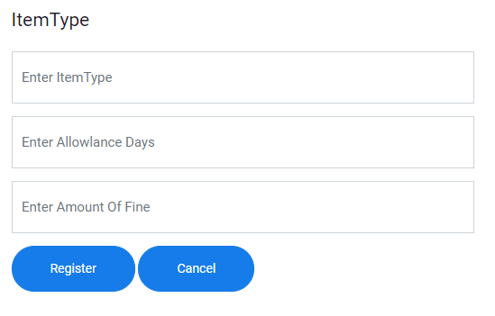

Click Register to register the data into the database and Click Cancel to reset

Input the allowance days for each itemtype

Input the amount of fine for each itemtype

Input the name of the ItemType

#### 5. MemberType

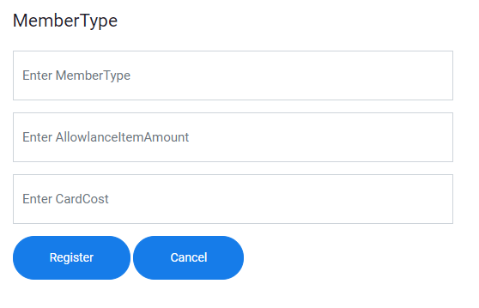

Click Register to register the data into the database and Click Cancel to reset

Input the cost of making the member card

Input the amount of book that can borrow

Input the name of the membertype

#### 6. StaffGrade

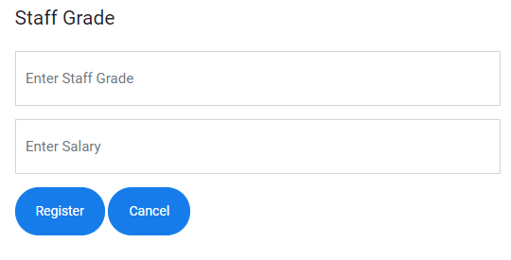

Click Register to register the data into the database and Click Cancel to reset

Input the salary according to the level of staff

Input the staff level that is going to have in library

#### 7. Staff

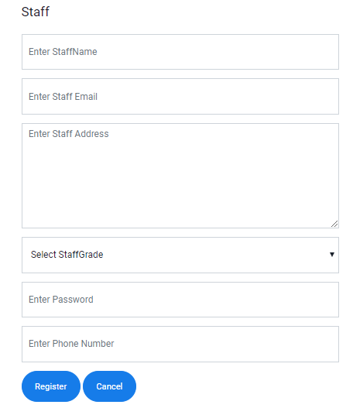

Click Register to register the data into the database and Click Cancel to reset

Input the phone number that the staff

Input the password that the staff is going to use

Choose the staff level from the combo box

Input the address of the staff of the library

Input the name of the staff of the library

Input the email address of the staff of the library

#### 8. Product

Choose the image for the Book from local file

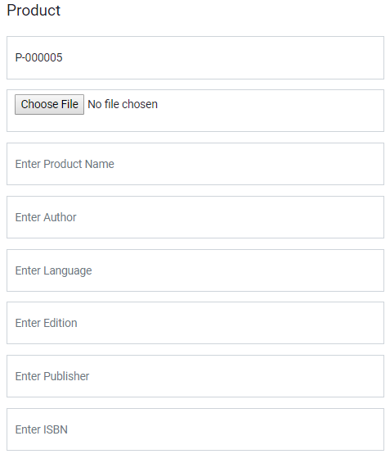

Input the ISBN number of the Book

Input the Publisher of the Book

Input the Edition of the Book

Input the Language of the Book

Input the author name of the Book

Input the name of the Book

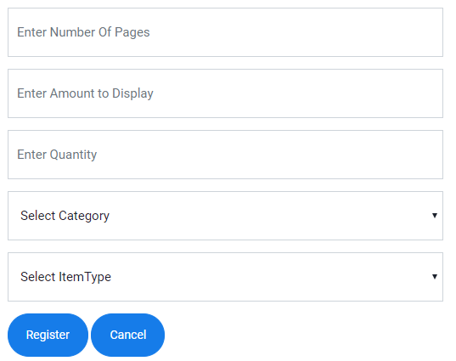

Select the Itemtype of the book

Select the Category of the book

Input the quantity of the book that exists in library

Input the amount to display on the library

Input the number of pages of the Bok

Click Register to register the data into the database and Click Cancel to reset

#### 9. Purchase



These data will fill automatically

Choose the BookName that is going to purchase



Click Add to add the data into the list below it and Click Clear to reset

Input the quantity of book that is going to purchase

Input the price of the book

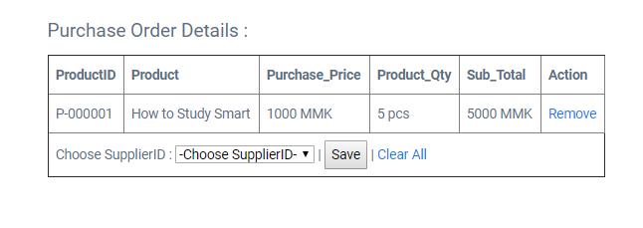

Click Save to register the purchase data into the database and Clear All to reset

Choose the Supplier Name and ID

#### 10. PurchaseReport

Select on radio button and search by Date

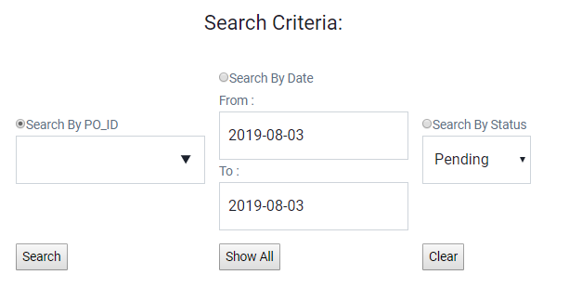

Select on radio button and search by Status

Click Search for specific search

Click Show All to show all the list and Clear to reset

Select on radio button and search by Product ID

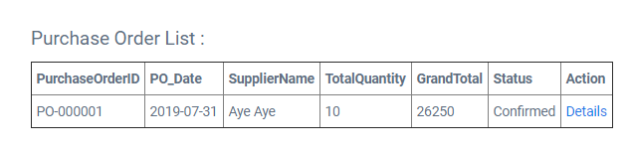

Click Detail if the Purchase is pending to confirm

#### 11. MemberRegister

Input the name of the member

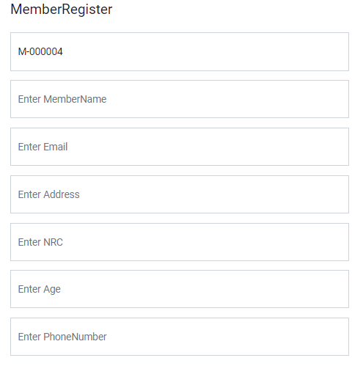

Choose the register date of the member

Input the phone number of the member

Input the age of the member

Input the NRC number of the member

Input the address of the member

Input the email address of the member

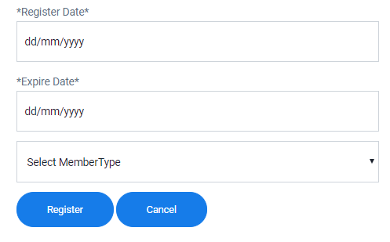

Click Register to register the data into the database and Click Cancel to reset

Choose the Membertype for the mebmer

Choose the expire date of the member

#### 12. Borrow

Choose MemberName that is trying to borrow

Choose BookName that is going to borrow

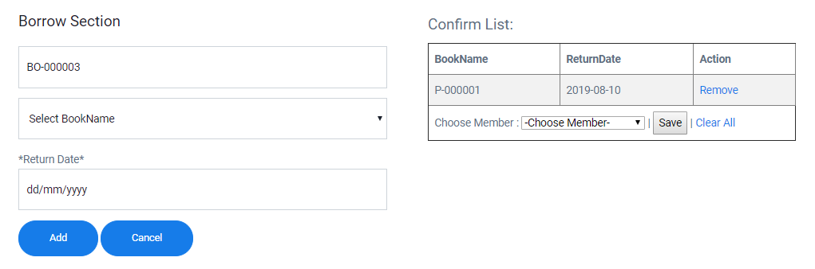

Click Add to add the data into the list and Clear All to reset

Click Save to register the borrow data into the database and Clear All to reset

Choose the date that member should return back

#### 13. Return

Choose MemberName of the returned book

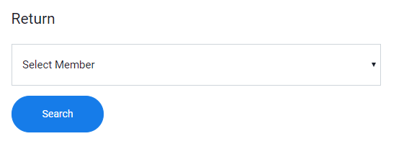

Click Search to show the list of borrow book in the list below

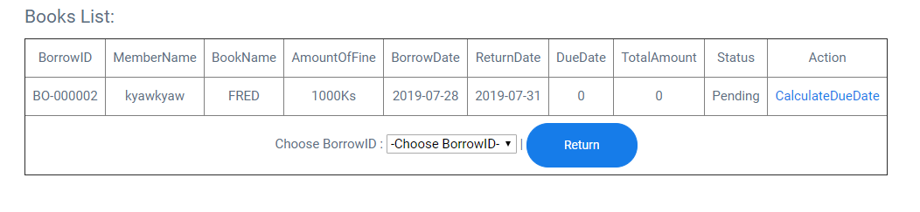

Click Return to store in the database and finish process

Choose BorrowID of the returned book

Click to Calculate Amount of fine and duedate

#### 14. Damage&Lost

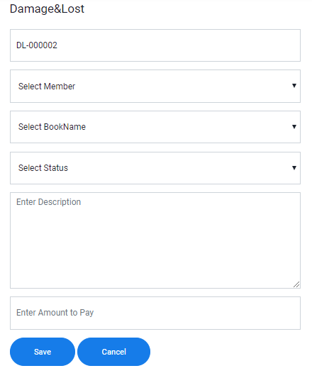

Click Save to register the data into the database and Click Cancel to reset

Enter amount of fine to pay

Input description for the book

Choose the name of the Member

Choose the name of the returned book

Select status of the returned book

## 8.1 Evaluation against Aim & Objectives

### CHAPTER – 7

### CONCLUSION

### &

### EVALUATION

### Aim

The library has many difficulties and they want to overcome them. Those become Aim. Aim is received after the analysis on the business process is finished. It is the thing that is going to reach in the future by studying the current situation. By the current process of the library, a lot of aim appeared. According to those aims, the new system is built and developed which overcomes all the difficulties and problems of the past system.

### Analysis

Analysis is done at the start of the project which means that the programmer doesn’t know about the current system and how they are working right now. It is only the information gathering stage. The programmer need to gather the correct data in this stage but if he doesn’t, the system that is going to build will not meet with the user requirement and will have to redo it again. Therefore, Analysis Stage needs to more time the other process.

### Design

Design is also involve one of the most important in considering how great the system developed. Because user friendliness and usability are compare with the Design of the system. If the design is visible and user friendly, the user can easily use and will feel while using it. And it can also determine how fast the user can do while using the system due to the design of the system. And also in the interface of the system, having too much photo is not good because the user confuses while using it and having too much photo is not good also because user will get bored while reading it.

### Coding

In development Stage, PHP language is used to develop the system. Because the developed website is dynamic website and PHP is compatible to use. There are a lot of difficulties while developing the system. Because some of the codes are not already known. Therefore, those codes are search from the internet and take the reference. Then imply the code by referencing those researched codes. From Time Box 1 to Time Box 3, most of the codes are from the lecture and some are from the internet.

### Testing

Testing is very important it determines that the developed system can work as estimate or not. Testing need to do properly in order to avoid serious cases. If the testing is not done properly, there will be a lot of problems when the system is implies in the real business. If the Testing is done properly, those cases will never happen. And if the testing is done, the programmer will not know if the system reach user requirements and it can do what the customer asks or not. Therefore testing is needed to do to have the great and efficient system.

### Training

If the new system is applied into the business process, the staffs are not familiar with it. And if they directly use it, there will be a lot of troubles because they don’t know the system works. And they will take a lot of time to use because of lacking experience. Therefore, before applying the system into the business process, the company needs to hold the training of the system for the staff. After attending the training, they know how to use the system and become easy to learn. There will be no difficulties to use the system and the process will become faster.

## 8.2 Evaluation against Similar System

|  |  |  |
| --- | --- | --- |
| No. | My System | Similar System |
| 1 | While the pointer is place on the button from the system, it changes into the pointing hand and also the color the button change. The developed system has the visibility. | In this system, the arrow still stable and nothing changes happen. Therefore this system don’t have the visibility |
| 2 | The developed system have the security system that check with the staff level because the access into the system is different according to the staff level. | In this system, the entire staff member can enter the system and do what they like. Therefore, this system is lack on security. |
| 3 | In the developed system, the staff can search the book in the library from the Search Function. By using that it will redue time for searching. | In this system, the book from the database cannot be search because the Search Function is not included. |
| 4 | In Return form of the development system, the staff need to choose member name to display the list of borrowed books and choose the borrowid that membe is trying to return. | In this system, the staff needs to choose the member form the database and the list will be displayed. And the staff need to check on the check box that the user is trying to return. |
| 5 | Help funciton is existed for the staff who don’t know how to use it. If the staff click on it, User Manual will appear with pdf. | In this system, the help function is not existed. |

## 8.3 Evaluation against Justification Mode

### Method

There are a lot of methodologies that can be use but for this system, DSDM methodology is used. Because in DSDM methodology, the developer can do the parallel job for developing the system. And also the developer can redo the previous one because of the changes of the requirements. By using this, the system can meet the user requirement because during the development time, the user can also involve and tell whether he want to change or not. Testing the system can also be done without waiting the finish of the development of the system.

#### Problem

**Changes of Requirements:** In this methodology, the scope and user requirements can change easily because of user involvement. User involvement can also be good but it also has disadvantages.

#### Solve

Changes of Requirements cannot be solved because if this methodology is used, user will be involved and requirements can be changed. But we can reduce the amount of changes of requirements. At the first of the project, a discussion will make to get the correct user requirements. And if the changes of Requirements are many, we will inform that we need more time to develop because of the changes.

#### Lesson Learn

The lesson that I learnt was, a perfect plan cannot be get at the first time. To get the flawless plan, time and motivation are needed. If it is not perfect at the first time, don’t be depress and keep trying to be the top.

### Language

PHP language is used to develop the system because this website is going to be dynamic website and PHP language is used to build the dynamic website. PHP code is embedded in the HTML code therefore it is easier to learn how to use it. This system needs to use the database and PHP is also compatible to use the database. Most of the websites across the internet are written with PHP codes.

#### Problem

**Unknown Codes & First Time:** This is the first time of making the project and this is the first time using this language. Therefore, there are lots of unknown codes that are needed to use this system to meet the user requirements.

#### Solve

In order to solve that problem, I search through the online to get the sample code which has the same process as mind or similar process. And also I also read the book about the language and to get the idea of how to write to achieve the require function.

#### Lesson Learn

The thing that I learnt is that there are lots of things to study even if you are already known. Therefore, for the things that you don’t really know how to do it, you need to extra careful and need to focus to get the knowledge of how to do it. I also know how to write the system using the php codes.

### Database

MySQL is used to make the database of the system. The language that is going to use PHP and MySQL is suitable to use with it. The system that is going to develop is web page based system and MySQL is mainly used as the database for webpages. But the security of the MySQL is not quite safe but it is good to use. If the user know the other database, he will also easy to use MySQL database.

#### Problem

**First Time Experience of Using:** using the MySQL database is the first time and I don’t how it works and how the processes are.

#### Solve

I already have the experience of using Microsoft SQL Server and the way MySQL works is the same as SQL Server does. I don’t have quite difficulties while studying the MySQL database. And I also read the book about how it works and what are needed to do.

#### Lesson Learn

I learnt that, when you are trying to learn something new, the old things that you have learnt can be useful to learn the new one. I also know how to work with the MYSQL database for the system.

## 8.4 Evaluation against Time Box Plan

### Time Box 1: Purchase and Register of Books

In Time Box Plan 1, the start date is 22.1.2018 and the end date is 18.2.2019. Most of the pages in Time Box Plan are entry form which is the start of the project. And one transition, Purchase, is existed. In order to run the Purchase Function, the early data from the time box 1 should be finished. In order to run the Borrow Function and Return Function, the data from time Box 1 is needed to finish. Developing Time Box Plan finishes at the estimate time (18.2.2019).

### Time Box 2: Member Register and Borrow Function

In Time Box 2, the start date is 19.6.2018 and the end date is 19.7.2018. In this time box plan, the main function of the library Borrow is existed. There are two Entry Form which are for the registration of the member. In Borrow Function, it reuse the data which are already stored into the database in Time Box 1. In Time Box 2, only a few pages are developed and it doesn’t need a lot of time to finish. Borrow Function cannot be complete if the data from Time Box 1 are not stored yet. It finishes at the estimate development time (19.7.2018).

### Time Box 3: Return and DueDate Calculation Function

In Time Box 3, the start date is 20.7.2018 and the end date is 5.8.2019. In this Time Box 3, the last main function of the library Return is existed. In Return Form, the data from the Product and Borrow are needed because the member will return the books which are borrowed in earlier days. Therefore, return function cannot be used if there is no borrow data and book data in the database. Developing this time box ends at the estimate time (5.8.2019).

## 8.5 Personal Evaluation

For my view for the developed system, I would consider that it is a great job. Because the website is user friendly and easy to learn. And the functions in the system are also not too complex and can easily learn. The system has functions that reduce the time for working of the staff. It has visibility and standards. Therefore, I consider it that it is suitable to use in the real business process.

## 8.6 Strength & Weakness

### Strength

**Having Search Function:** In this system, the staff can search the books that are existed in the library and the borrow list and return list can be also searched. By doing this, the time taken for finding the data will reduce.

**Having Automatic Calculation:** In the Return Page, the staff doesn’t need to calculate the amount of due date that the user has. The system will automatically calculate if he clicks on the link.

**Can do all Borrow at one time:** In the borrow page, when the staff make the first borrow, it is stored in the temporary list of the page waiting for another borrow. If the staff finish listing the borrows, choose the member who is going to borrow and finish the process.

**Good User Interface Design:** The website of the system has the good interface with the clear color and text. The website also the visibility and standards.

**Having the list at the end of Pages:** At the end of each pages, the list of the associated are displayed from the database of the system. Therefore, the staff doesn’t need to go to the database often to check whether the data are existed or not. From that list, the staff can do updating and deleting the data of the database.

**Having tight Security:** This system cannot allow all the staff to use all the functions. They are different according to the level of the staff which is already decided. Library Assistant can only do Borrow and Return Functions while the others can do the rest.

Responsive Pages: This website can also be in the size of phone screen. It changes its interface design according to the platform that we are using.

**Having Help Function:** In this system, help function is existed for the newbie staff. If the staffs don’t know how to use the system, they just need to click on the button and User Manual will appear with the pdf format. In the User Manual, tips for all the pages are included.

### Weakness

**Cannot do all return at one time:** Not like the Borrow Function, Return Function cannot do all the return at once. It can only be done one by one. But in the future that new feature is going to add into the return function.

**Lack Checking member out of date:** In the Borrow Page, the system doesn’t check whether the member card is out of date or not. Therefore, there will be the problem that the library borrow the books to the member whose member card is out of date.

## 8.6 Future Amendment

As I said in above, there will be future plan for Time Box 2 and Time Box3. In Time Box 2, I am going to add the new feature that check whether the member card is expire or not in order to prevent lending the book to the expired members. And in Time Box 3, I would like to add a new function Donation. In the real process of the system, Donation is also involved but it is very rare. Therefore I didn’t add it now. But in the future I am going to add it. And also in this library, there are students who are studying. Therefore, in the future I would like to add the school management including library system for the school. For now, I am gathering the information how the school works and what the processes are.

### APPENDIX

## Section A: Use Case Descriptions

### Time Box 1: Purchase and Register of Books

|  |  |
| --- | --- |
| **Use Case Name** | Record Category |
| **Actor** | Library Manager or Database Administrator |
| **Flow of Event** | Just like the others, while recording the purchase from the supplier, the category of the item needs to be recorded. At that time recording the category will take more time. Therefore, the categories of the item that will be purchased are recorded early before the item arrived. When the item arrived, choosing from one of the categories from the database will be sufficient. |

|  |  |
| --- | --- |
| **Use Case Name** | Record ItemType |
| **Actor** | Library Manager or Database Administrator |
| **Flow of Event** | And also the informations for the ItemType are recorded before the recording of the item is started. When recording of the item is started, the user only needs to choose from the inserted data of the ItemType from the database. So, the user doesn’t need to think too much about how to add the ItemType for each item. |

|  |  |
| --- | --- |
| **Use Case Name** | Record Purchase |
| **Actor** | Library Manager or Database Administrator |
| **Flow of Event** | When the ordered item reaches to the garage of the library, the recording for the purchase item are recorded. Including the Itemname and the other information like the staff who make the purchase and the itemtype are recorded. Those information are already been recorded in the database and the user just need to choose from those recorded information. |

|  |  |
| --- | --- |
| **Use Case Name** | Record Product |
| **Actor** | Library Manager or Database Administrator |
| **Flow of Event** | Just like the recording of the purchase of the item, the detail information of the items is recorded including the itemtype and the category which are already recorded in earlier time. The user can easily choose the recorded information from the database by the dropdown button. |

### Time Box 2: Member Register and Borrow Function

|  |  |
| --- | --- |
| **Use Case Name** | Record Member |
| **Actor** | Library Assistant |
| **Flow of Event** | The Information of the member is needed to register before borrowing the books from the library. Which means that the user cannot borrow the books from library unless if he made the library card. And also the staff can look back the record of the borrow book in order to know who borrows it. This data act like the id card that confirm if he can borrow books or not. |

|  |  |
| --- | --- |
| **Use Case Name** | Record Borrow |
| **Actor** | Library Assistant |
| **Flow of Event** | When the Member wants to borrow the books from the library, the staff needs to record the list of the books that he is going to borrow. While recording the borrow list, the information from the member and product of the library database are used. According to the data from Member Database and Product Database, the Borrow process is undertaken. And then the information from the borrow form are recorded into two database Borrow and BorrowDetail. |

### Time Box 3: Return and DueDate Calculation Function

|  |  |
| --- | --- |
| **Use Case Name** | Record Damage & Return |
| **Actor** | Library Assistant |
| **Flow of Event** | When the member returned book is damaged or lost, the staff need to make a record for the status of the book in the library database. When the returned book is record into DamageLost table, it will reduce the amount of Quantity column from Product table and will change the data from Status of BorrowDetail table |

## Section B: Detailed Class Definitions

### Time Box 1: Purchase and Register of Books

|  |  |
| --- | --- |
| Class Name | Category |
| Attributes | CategoryID  Category |
| Operations | AddCategory()  RemoveCategory()  EditCategory() |
| Description | There will be different category for books. Those categories will be needed to record before the item is bought. Like the others, ID for each Category will be different and they will be used in the other tables. |

|  |  |
| --- | --- |
| Class Name | ItemType |
| Attributes | ItemTypeID  ItemType  AllowlanceDays  AmountOfFine |
| Operations | AddItemType()  RemoveItemType()  EditItemType() |
| Description | In this table, the ID for each ItemType will be different. And also the allowance days and the fine can be different according to the itemtype of the associated itemtype. And the information from this table will be used in the other tables like Borrow, Product and the others. |

|  |  |
| --- | --- |
| Class Name | ItemTypeDetail |
| Attributes | ItemTypeDetailID  ItemTypeID  CategoryID |
| Operations | AddItemTypeDetail |
| Description | This table is use as the dummy between the ItemType table and Category table. And it allows the table to connect the relationship with each others. |

|  |  |
| --- | --- |
| Class Name | Purchase |
| Attributes | PurchasOrderID  PurchaseOrderDate  TotalAmount  GrandTotal  TaxAmount  TotalQuantity  SupplierID  StaffID  Status |
| Operations | AddPurchase()  RemovePurchase()  EditPurchase() |
| Description | In this table the purchase of the product for the library are recorded. Like Prices for each item and the amount of each items. And also including the total Amount and the total Quantity that the library had bought. |

|  |  |
| --- | --- |
| Class Name | PurchaseDetail |
| Attributes | PurchaseOrderID  ProductID  PurchaseQuantity  PurchasePrice |
| Operations |  |
| Description | This table acts like the dummy table for the Product table and the Purchase table. And it allows those two tables to have the relationship with each others. |

|  |  |
| --- | --- |
| Class Name | Product |
| Attributes | ProductID  ProductImage  ProductName  Author  Language  Edition  Publisher  ISBN  NumberOfPages  Quantity  CategoryID |
| Operations | AddProduct()  RemoveProduct()  EditProduct() |
| Description | Before letting the member to borrow from the library, those items are needed to recorded in the list of the item in the library’s database. The detail of the each item are recorded in this table including the edition of the books, the author of the books and the others. And also there are other information that which are used from the earlier recorded tables. The ID for each product are different and doesn’t have the duplicate numbers. |

### Time Box 2: Member Register and Borrow Function

|  |  |
| --- | --- |
| Class Name | Member |
| Attributes | MemberID  MemberName  MemberEmail  MemberAddress  NRC  Age  PhoneNumber  RegisterDate  ExpireDate  MemberTypeID |
| Operation | RecordMember()  RemoveMember()  UpdateMebmer() |
| Description | In this database, the information about the people who want to be the member of the library are stored. Their personal information and others for library are stored. According the data in the database, whether they can borrow the books from the library or not. |

|  |  |
| --- | --- |
| Class Name | BorrowDetail |
| Attributes | ProductID  BorrowID  ReturnDate  DueDate  TotalAmount  Status |
| Operation | RecordBorrowDetail()  UpdateBorrowDetail() |
| Description | BorrowDetail is acts as the dummy table in order to make the relationship with the Product table and the Borrow table. And while making the Borrow Function, some of the information of the book are stored in here. |

|  |  |
| --- | --- |
| Class Name | Borrow |
| Attributes | BorrowID  MemberID  BorrowDate  TotalBookQty |
| Operation | Record Borrow()  Remove Borrow() |
| Description | When the user borrows books from the library, those books need to be stored in the table of the database of the library called Borrow. Those data are used in order to know which member borrow which books from the library. And also those data are also going to use in receiving the borrowed books from the member. |

### Time Box 3: Return and DueDate Calculation Function

|  |  |
| --- | --- |
| Class Name | Damage&Lost |
| Attributes | DLID  MemberID  ProductID  Status  Description  AmountToPay |
| Operation | RecordDamage&Lost() |
| Description | When the member borrowed book back to the library, the staff need to check if the book is damage or lost. If one of the above case happens, the staff need to make the record those book into the separate table in the library database. And the book that are recorded in that table are no longer able to borrowed. |

## Section C: Coding

|  |  |  |
| --- | --- | --- |
| Form | Function | Purpose |
| Purchase Form | Save() | It is for making the purchase of the books for the library. The books to purchase are already inserted into the database. The staff needs to choose the purchased book and click the Save button to save the data into the database with the working of sql statements behind it. |
| Borrow Form | Save() | It is for making the borrow of the book from the library. In this form, the data from member and product that are already registered at the start are going to use. Those data are retrieve using the sql statement SELECT. Then click Save to register the borrow data into the database by using the sql statements, the data is inserted. |
| Return Form | Save() | This is for registering the book into the database which are returned by the member. The member data from the database is choose to start the process. And choose the returned Borrow ID and click Return button to register it into the database. In the behind of the process, SQL statement INSERT is ran and in addition UPDATE statement is also run if the register is successful. |
| Home, Purchase Report, Borrow Search and Return Search | - | This is used to search the data from the database without going into the database. The data are retrieved from the database into the form by using SELECT SQL statements. The user need to click on the radio button that he want to search and click Search to start. |
| Category Entry, Staff Entry, Product Entry and other Entry Forms | Save()  Update()  Delete() | These entry forms are used to insert the data into the database at the start. Behind the process, SQL statements like INSERT, UPDATE, DELETE are run. |

## Section D: Test Scripts

### Time Box 1: Purchase and Register of Books

|  |  |  |  |  |
| --- | --- | --- | --- | --- |
| Unit Test 1 | | Test Case : 1.4 | Designed by: Min Khant | |
| Data Source: Supplier Form | | Objective: Test the Supplier Form | Tester: Min Khant | |
| **Test Case** | **Description** | **Test Procedure** | **Expected Result** | **Actual Results** |
| 1.4 | Testing with the null value in the address of the supplier | Set Supplier Name as Kaung Kaung and Supplier Email as [kaungkaung@gmail.com](mailto:kaungkaung@gmail.com) and Phone as 094615432 and click the Register button. | Show Supplier Register Successfully Message. Insert into the database. | See Fig:1.4.2 |

Before Testing



Fig: 1.4.1

After Testing

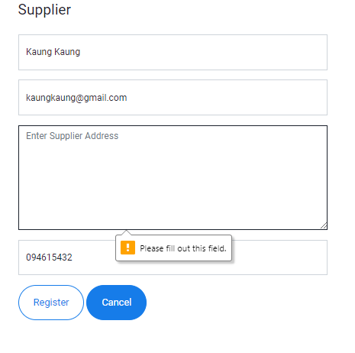

Fig: 1.4.2

|  |  |  |  |  |
| --- | --- | --- | --- | --- |
| Unit Test 1 | | Test Case : 1.5 | Designed by: Min Khant | |
| Data Source: Supplier Form | | Objective: Test the Supplier Form | Tester: Min Khant | |
| **Test Case** | **Description** | **Test Procedure** | **Expected Result** | **Actual Results** |
| 1.5 | Testing with the null value in the Phone Number of the Staff | Set Supplier Name as Kaung Kaung and Supplier Email as [kaungkaung@gmail.com](mailto:kaungkaung@gmail.com) and Address as Mandalay and click the Register button. | Show Supplier Register Successfully Message. Insert into the database. | See Fig:1.5.2 |

Before Testing



Fig: 1.5.1

After Testing

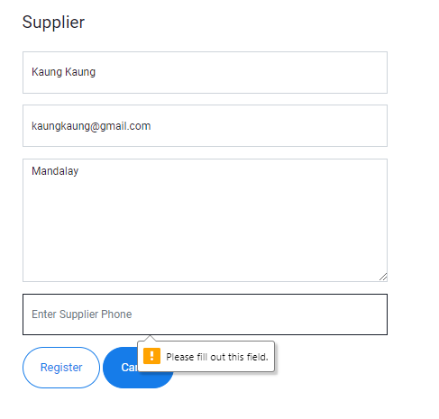

Fig: 1.5.2

|  |  |  |  |  |
| --- | --- | --- | --- | --- |
| Unit Test 1 | | Test Case : 1.6 | Designed by: Min Khant | |
| Data Source: Supplier Form | | Objective: Test the Supplier Form | Tester: Min Khant | |
| **Test Case** | **Description** | **Test Procedure** | **Expected Result** | **Actual Results** |
| 1.6 | Testing the Supplier Table with the full correct data | Set Supplier Name as Kaung Kaung and Supplier Email as [kaungkaung@gmail.com](mailto:kaungkaung@gmail.com) and Address as Mandalay and Phone Number as 094615432 and click the Register button. | Show Supplier Register Successfully Message. Insert into the database. | See Fig:1.6.2 , Fig:1.6.3 and Fig:1.6.4 |

Before Testing

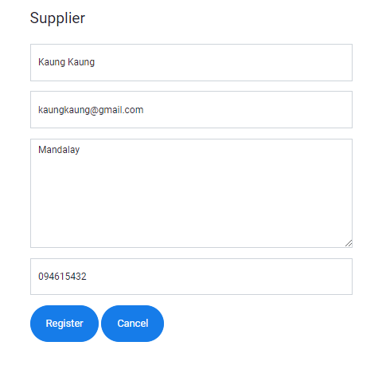

Fig: 1.6.1

After Testing

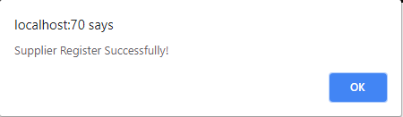

Fig: 1.6.2

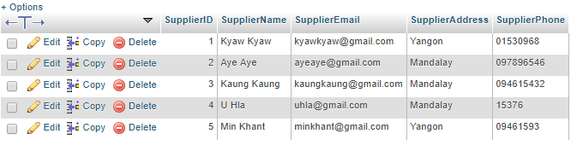

Fig: 1.6.3

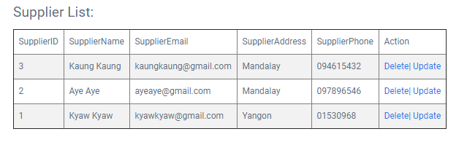

Fig: 1.6.4

|  |  |  |  |  |
| --- | --- | --- | --- | --- |
| Unit Test 2 | | Test Case : 2.1 | Designed by: Min Khant | |
| Data Source: StaffGrade Form | | Objective: Test the StaffGrade Form | Tester: Min Khant | |
| **Test Case** | **Description** | **Test Procedure** | **Expected Result** | **Actual Results** |
| 2.1 | Testing the StaffGrade table with the null value of the StaffGrade | Set Salary as 200 and click the Register button. | Show StaffGrade Register Successfully Message. Insert into the database. | See Fig:2.1.2 |

Before Testing



Fig: 2.1.1

After Testing

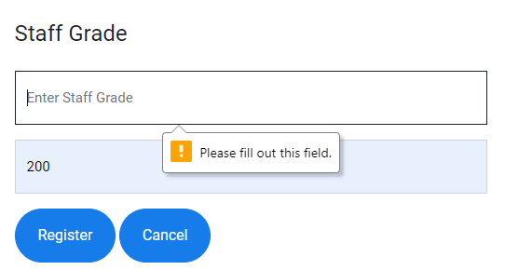

Fig: 2.1.2

|  |  |  |  |  |
| --- | --- | --- | --- | --- |
| Unit Test 2 | | Test Case : 2.2 | Designed by: Min Khant | |
| Data Source: StaffGrade Form | | Objective: Test the StaffGrade Form | Tester: Min Khant | |
| **Test Case** | **Description** | **Test Procedure** | **Expected Result** | **Actual Results** |
| 2.2 | Testing the StaffGrade table with the null value of the Salary | Set StaffGrade as Library Management and click the Register button. | Show StaffGrade Register Successfully Message. Insert into the database. | See Fig:2.2.2 |

Before Testing



Fig: 2.2.1

After Testing

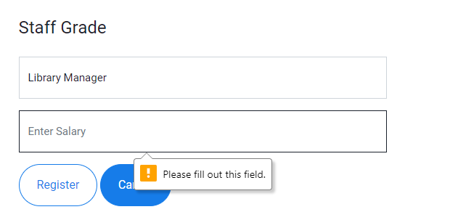

Fig: 2.2.2

|  |  |  |  |  |
| --- | --- | --- | --- | --- |
| Unit Test 2 | | Test Case : 2.3 | Designed by: Min Khant | |
| Data Source: StaffGrade Form | | Objective: Test the StaffGrade Form | Tester: Min Khant | |
| **Test Case** | **Description** | **Test Procedure** | **Expected Result** | **Actual Results** |
| 2.3 | Testing the StaffGrade table with the full and correct data | Set StaffGrade as Library Manager and Salary as 200 and click the Register button. | Show StaffGrade Register Successfully Message. Insert into the database. | See Fig:2.3.2 and Fig:2.3.3 |

Before Testing

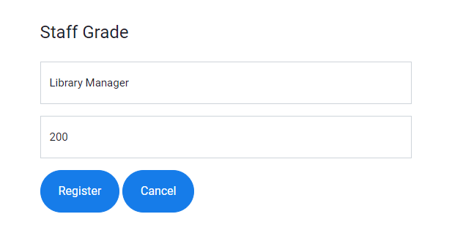

Fig: 2.3.1

After Testing

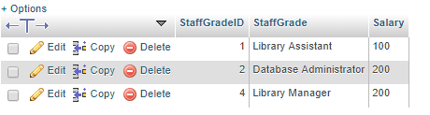

Fig:2.3.2

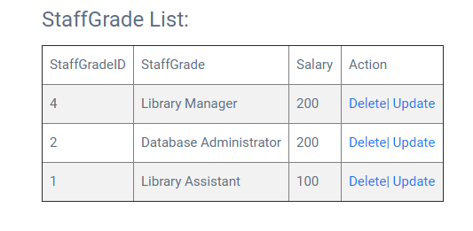

Fig: 2.3.3

|  |  |  |  |  |
| --- | --- | --- | --- | --- |
| Unit Test 3 | | Test Case : 3.1 | Designed by: Min Khant | |
| Data Source: Staff Form | | Objective: Test the Staff Form | Tester: Min Khant | |
| **Test Case** | **Description** | **Test Procedure** | **Expected Result** | **Actual Results** |
| 3.1 | Testing the Staff table with the null value of the Name of the Staff | Set Staff Email as [dawhla@gmail.com](mailto:dawhla@gmail.com) and Address as Yangon and Staff Grade as Database Administrator and password as dawhla and Phone Number as 0946159. | Show Staff Register Successfully Message. Insert into the database. | See Fig:3.1.2 |

Before Testing



Fig: 3.1.1

After Testing

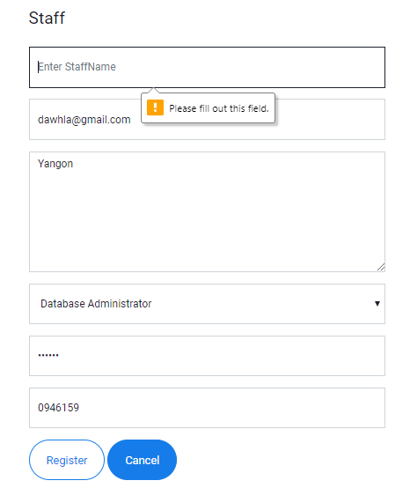

Fig: 3.1.2

|  |  |  |  |  |
| --- | --- | --- | --- | --- |
| Unit Test 3 | | Test Case : 3.2 | Designed by: Min Khant | |
| Data Source: Staff Form | | Objective: Test the Staff Form | Tester: Min Khant | |
| **Test Case** | **Description** | **Test Procedure** | **Expected Result** | **Actual Results** |
| 3.2 | Testing the Staff table with the null value of the Email of the Staff | Set Staff Name as Daw Hla and Address as Yangon and Staff Grade as Database Administrator and password as dawhla and Phone Number as 0946159. | Show Staff Register Successfully Message. Insert into the database. | See Fig:3.2.2 |

Before Testing



Fig: 3.2.1

After Testing

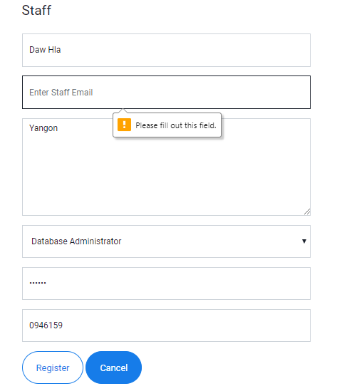

Fig: 3.2.2

|  |  |  |  |  |
| --- | --- | --- | --- | --- |
| Unit Test 3 | | Test Case : 3.3 | Designed by: Min Khant | |
| Data Source: Staff Form | | Objective: Test the Staff Form | Tester: Min Khant | |
| **Test Case** | **Description** | **Test Procedure** | **Expected Result** | **Actual Results** |
| 3.3 | Testing the Staff table with the incorrect format of the Email of the Staff | Set Staff Name as Daw Hla and Email as hji and Address as Yangon and Staff Grade as Database Administrator and password as dawhla and Phone Number as 0946159. | Show Staff Register Successfully Message. Insert into the database. | See Fig:3.3.2 |

Before Testing



Fig: 3.3.1

After Testing

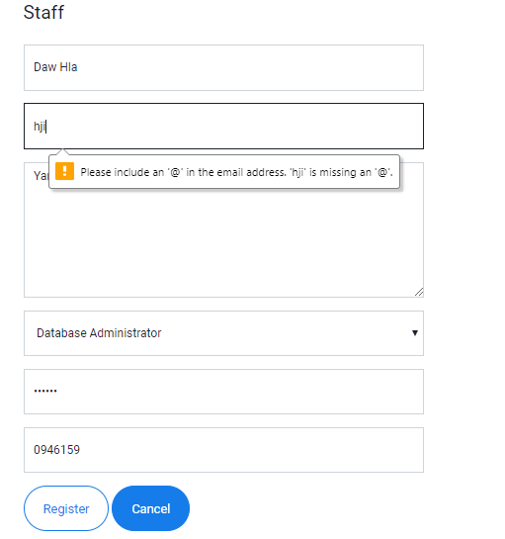

Fig: 3.3.2

|  |  |  |  |  |
| --- | --- | --- | --- | --- |
| Unit Test 3 | | Test Case : 3.4 | Designed by: Min Khant | |
| Data Source: Staff Form | | Objective: Test the Staff Form | Tester: Min Khant | |
| **Test Case** | **Description** | **Test Procedure** | **Expected Result** | **Actual Results** |
| 3.4 | Testing the Staff table with the null value of the Address of the Staff | Set Staff Name as Daw Hla and Email as dawhla@gmail.com and Staff Grade as Database Administrator and password as dawhla and Phone Number as 0946159. | Show Staff Register Successfully Message. Insert into the database. | See Fig:3.4.2 |

Before Testing



Fig: 3.4.1

After Testing

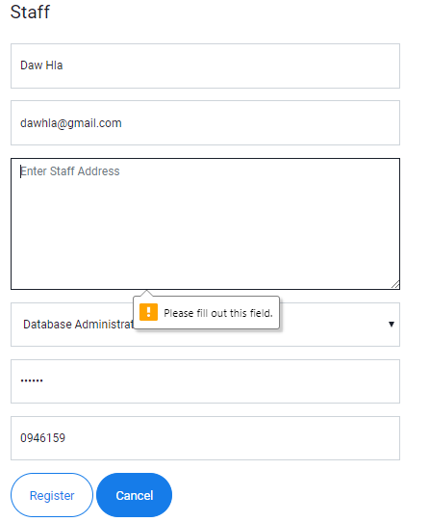

Fig: 3.4.2

|  |  |  |  |  |
| --- | --- | --- | --- | --- |
| Unit Test 3 | | Test Case : 3.5 | Designed by: Min Khant | |
| Data Source: Staff Form | | Objective: Test the Staff Form | Tester: Min Khant | |
| **Test Case** | **Description** | **Test Procedure** | **Expected Result** | **Actual Results** |
| 3.5 | Testing the Staff table with the null value of the Password of the Staff | Set Staff Name as Daw Hla and Email as dawhla@gmail.com and Staff Address as Yangon and Staff Grade as Database Administrator and Phone Number as 0946159. | Show Staff Register Successfully Message. Insert into the database. | See Fig:3.5.2 |

Before Testing



Fig: 3.5.1

After Testing

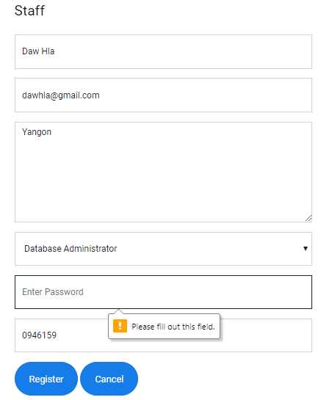

Fig: 3.5.2

|  |  |  |  |  |
| --- | --- | --- | --- | --- |
| Unit Test 3 | | Test Case : 3.6 | Designed by: Min Khant | |
| Data Source: Staff Form | | Objective: Test the Staff Form | Tester: Min Khant | |
| **Test Case** | **Description** | **Test Procedure** | **Expected Result** | **Actual Results** |
| 3.6 | Testing the Staff table with the null value of the Phone Number of the Staff | Set Staff Name as Daw Hla and Email as dawhla@gmail.com and Staff Address as Yangon and Staff Grade as Database Administrator and the Address as Yangon. | Show Staff Register Successfully Message. Insert into the database. | See Fig:3.6.2 |

Before Testing



Fig: 3.6.1

After Testing

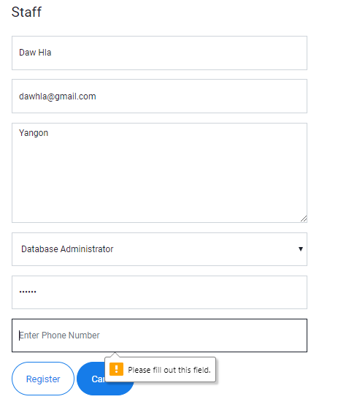

Fig: 3.6.2

|  |  |  |  |  |
| --- | --- | --- | --- | --- |
| Unit Test 3 | | Test Case : 3.7 | Designed by: Min Khant | |
| Data Source: Staff Form | | Objective: Test the Staff Form | Tester: Min Khant | |
| **Test Case** | **Description** | **Test Procedure** | **Expected Result** | **Actual Results** |
| 3.7 | Testing the Staff table with the full and the correct data | Set Staff Name as Daw Hla and Email as dawhla@gmail.com and Staff Address as Yangon and Staff Grade as Database Administrator and the Address as Yangon and Phone Number as 0946159. | Show Staff Register Successfully Message. Insert into the database. | See Fig:3.7.2 , Fig:3.7.3 and Fig:3.7.4 |

Before Testing

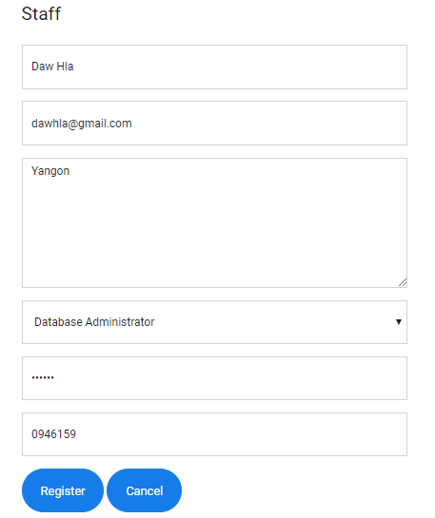

Fig: 3.7.1

After Testing

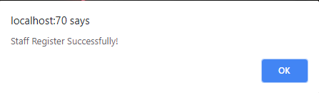

Fig: 3.7.2

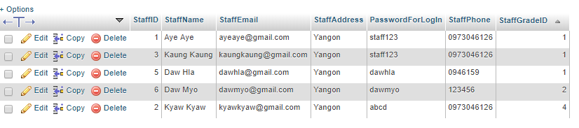

Fig: 3.7.3

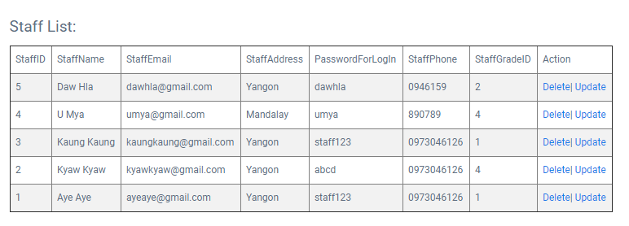

Fig:3.7.4

|  |  |  |  |  |
| --- | --- | --- | --- | --- |
| Unit Test 4 | | Test Case : 4.1 | Designed by: Min Khant | |
| Data Source: Category Form | | Objective: Test the Category Form | Tester: Min Khant | |
| **Test Case** | **Description** | **Test Procedure** | **Expected Result** | **Actual Results** |
| 4.1 | Testing the Category table with the null value of the Name of the Category | Click the Register button without filling anything. | Show Category Register Successfully Message. Insert into the database. | See Fig:4.1.2 |

Before Testing



Fig: 4.1.1

After Testing

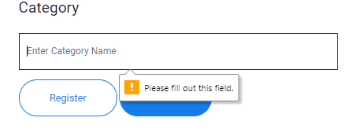

Fig: 4.1.2

|  |  |  |  |  |
| --- | --- | --- | --- | --- |
| Unit Test 4 | | Test Case : 4.2 | Designed by: Min Khant | |
| Data Source: Category Form | | Objective: Test the Category Form | Tester: Min Khant | |
| **Test Case** | **Description** | **Test Procedure** | **Expected Result** | **Actual Results** |
| 4.2 | Testing the Category table with the full and correct data | Set Category as Science and Click the Register button without filling anything. | Show Category Register Successfully Message. Insert into the database. | See Fig:4.2.2 , Fig:4.2.3 and Fig:4.2.4 |

Before Testing

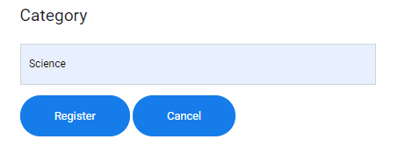

Fig: 4.2.1

After Testing

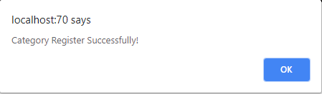

Fig: 4.2.2

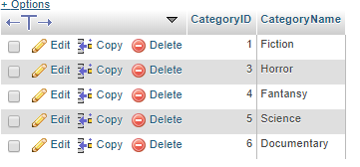

Fig: 4.2.3

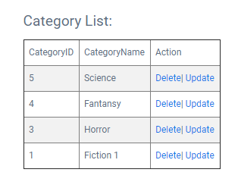

Fig: 4.2.4

|  |  |  |  |  |
| --- | --- | --- | --- | --- |
| Unit Test 5 | | Test Case : 5.1 | Designed by: Min Khant | |
| Data Source: ItemType Form | | Objective: Test the ItemType Form | Tester: Min Khant | |
| **Test Case** | **Description** | **Test Procedure** | **Expected Result** | **Actual Results** |
| 5.1 | Testing the ItemType table with the null value of the ItemType name | Set AllowlanceDays as 1 Week and Amount of Fine as 2000Ks and Click the Register button. | Show ItemType Register Successfully Message. Insert into the database. | See Fig:5.1.2 |

Before Testing



Fig: 5.1.1

After Testing

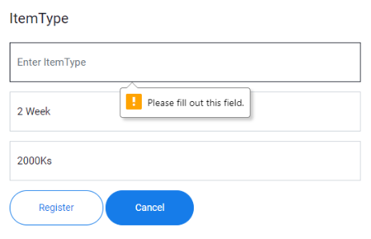

Fig: 5.1.2

|  |  |  |  |  |
| --- | --- | --- | --- | --- |
| Unit Test 5 | | Test Case : 5.2 | Designed by: Min Khant | |
| Data Source: ItemType Form | | Objective: Test the ItemType Form | Tester: Min Khant | |
| **Test Case** | **Description** | **Test Procedure** | **Expected Result** | **Actual Results** |
| 5.2 | Testing the ItemType table with the null value of the Allowlance Days | Set ItemType as References and Amount of Fine as 2000Ks and Click the Register button. | Show ItemType Register Successfully Message. Insert into the database. | See Fig:5.2.2 |

Before Testing



Fig: 5.2.1

After Testing

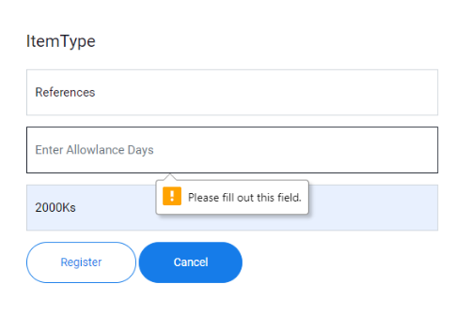

Fig: 5.2.2

|  |  |  |  |  |
| --- | --- | --- | --- | --- |
| Unit Test 5 | | Test Case : 5.3 | Designed by: Min Khant | |
| Data Source: ItemType Form | | Objective: Test the ItemType Form | Tester: Min Khant | |
| **Test Case** | **Description** | **Test Procedure** | **Expected Result** | **Actual Results** |
| 5.3 | Testing the ItemType table with the null value of the Amount Of Fine | Set ItemType as References and Allowlance Days as 2 week and Click the Register button. | Show ItemType Register Successfully Message. Insert into the database. | See Fig:5.3.2 |

Before Testing



Fig: 5.3.1

After Testing

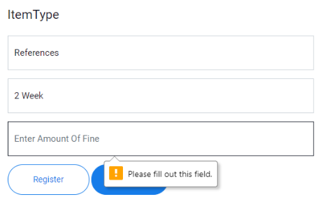

Fig: 5.3.2

|  |  |  |  |  |
| --- | --- | --- | --- | --- |
| Unit Test 5 | | Test Case : 5.4 | Designed by: Min Khant | |
| Data Source: ItemType Form | | Objective: Test the ItemType Form | Tester: Min Khant | |
| **Test Case** | **Description** | **Test Procedure** | **Expected Result** | **Actual Results** |
| 5.4 | Testing the ItemType table with the full and correct data | Set ItemType as References and Allowlance Days as 2 week and Amount of Fine as 2000Ks and Click the Register button. | Show ItemType Register Successfully Message. Insert into the database. | See Fig:5.4.2 , Fig:5.4.3 and Fig:5.4.4 |

Before Testing

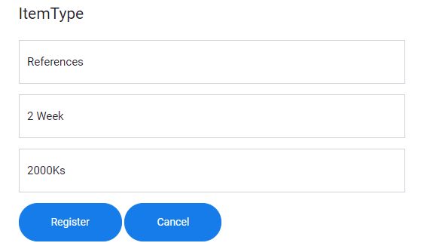

Fig: 5.4.1

After Testing

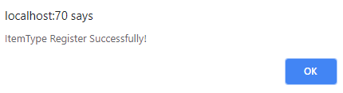

Fig: 5.4.2

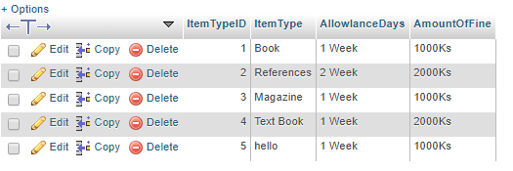

Fig: 5.4.3

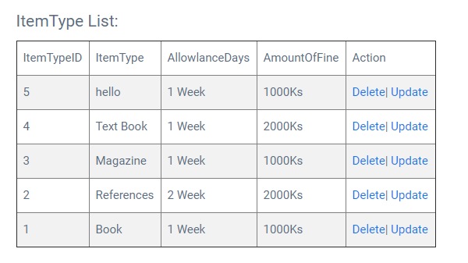

Fig: 5.4.4

|  |  |  |  |  |
| --- | --- | --- | --- | --- |
| Unit Test 6 | | Test Case : 6.1 | Designed by: Min Khant | |
| Data Source: Product Form | | Objective: Test the Product Form | Tester: Min Khant | |
| **Test Case** | **Description** | **Test Procedure** | **Expected Result** | **Actual Results** |
| 6.1 | Testing the Product table with the null value in the name of the proudct | Set Author as Smith and Language as English and Edition as First Edition and Publisher as Smith and Number Of Pages as 20 and Allowlance Days as 1 Week and Amount of Fine as 1000Ks and click on the Register button. | Show Product Register Successfully Message. Insert into the database. | See Fig:6.1.2 |

Before Testing





Fig: 6.1.1

After Testing

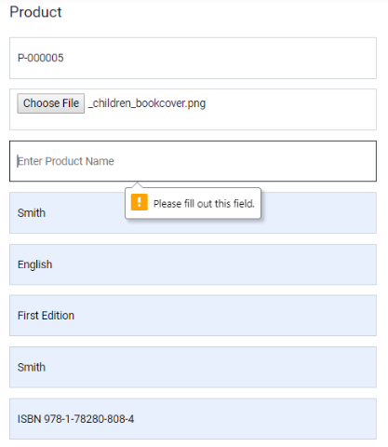

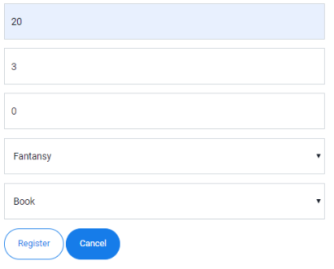

Fig: 6.1.2

|  |  |  |  |  |
| --- | --- | --- | --- | --- |
| Unit Test 6 | | Test Case : 6.2 | Designed by: Min Khant | |
| Data Source: Product Form | | Objective: Test the Product Form | Tester: Min Khant | |
| **Test Case** | **Description** | **Test Procedure** | **Expected Result** | **Actual Results** |
| 6.2 | Testing the Product table with the null value in the name of the author | Set Product Name as FRED and Language as English and Edition as First Edition and Publisher as Smith and Number Of Pages as 20 and Allowlance Days as 1 Week and Amount of Fine as 1000Ks and click on the Register button. | Show Product Register Successfully Message. Insert into the database. | See Fig:6.2.2 |

Before Testing





Fig: 6.2.1

After Testing

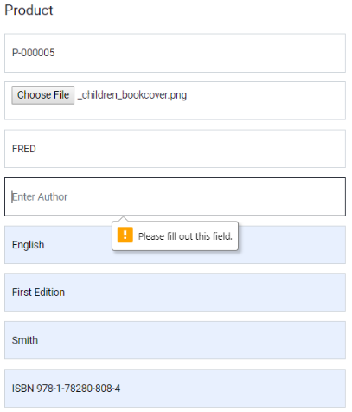



Fig: 6.2.2

|  |  |  |  |  |
| --- | --- | --- | --- | --- |
| Unit Test 6 | | Test Case : 6.3 | Designed by: Min Khant | |
| Data Source: Product Form | | Objective: Test the Product Form | Tester: Min Khant | |
| **Test Case** | **Description** | **Test Procedure** | **Expected Result** | **Actual Results** |
| 6.3 | Testing the Product table with the null value in the language | Set Product Name as FRED and Author as Smith and Edition as First Edition and Publisher as Smith and Number Of Pages as 20 and Allowlance Days as 1 Week and Amount of Fine as 1000Ks and click on the Register button. | Show Product Register Successfully Message. Insert into the database. | See Fig:6.3.2 |

Before Testing





Fig: 6.3.1

After Testing

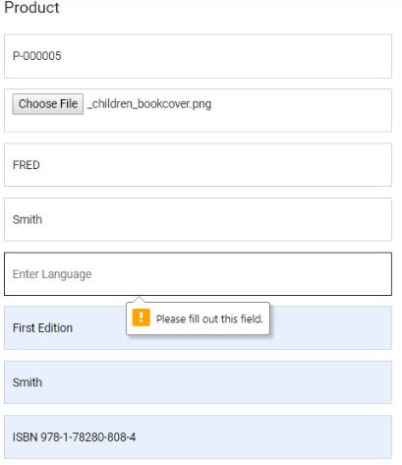



Fig: 6.3.2

|  |  |  |  |  |
| --- | --- | --- | --- | --- |
| Unit Test 6 | | Test Case : 6.4 | Designed by: Min Khant | |
| Data Source: Product Form | | Objective: Test the Product Form | Tester: Min Khant | |
| **Test Case** | **Description** | **Test Procedure** | **Expected Result** | **Actual Results** |
| 6.4 | Testing the Product table with the null value in the Edition | Set Product Name as FRED and Author as Smith and Language as English and Publisher as Smith and Number Of Pages as 20 and Allowlance Days as 1 Week and Amount of Fine as 1000Ks and click on the Register button. | Show Product Register Successfully Message. Insert into the database. | See Fig:6.4.2 |

Before Testing





Fig: 6.4.1

After Testing

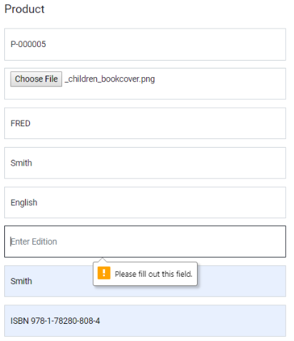



Fig: 6.4.2

|  |  |  |  |  |
| --- | --- | --- | --- | --- |
| Unit Test 6 | | Test Case : 6.5 | Designed by: Min Khant | |
| Data Source: Product Form | | Objective: Test the Product Form | Tester: Min Khant | |
| **Test Case** | **Description** | **Test Procedure** | **Expected Result** | **Actual Results** |
| 6.5 | Testing the Product table with the null value in the name of the Publisher | Set Product Name as FRED and Author as Smith and Language as English and Edition as First Edition and Number Of Pages as 20 and Allowlance Days as 1 Week and Amount of Fine as 1000Ks and click on the Register button. | Show Product Register Successfully Message. Insert into the database. | See Fig:6.5.2 |

Before Testing





Fig: 6.5.1

After Testing

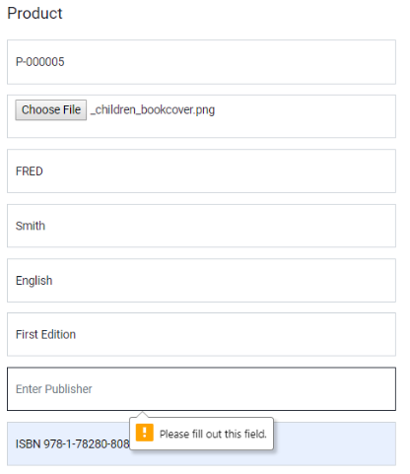



Fig: 6.5.2

|  |  |  |  |  |
| --- | --- | --- | --- | --- |
| Unit Test 6 | | Test Case : 6.6 | Designed by: Min Khant | |
| Data Source: Product Form | | Objective: Test the Product Form | Tester: Min Khant | |
| **Test Case** | **Description** | **Test Procedure** | **Expected Result** | **Actual Results** |
| 6.6 | Testing the Product table with the null value in the Number Of pages | Set Product Name as FRED and Author as Smith and Language as English and Edition as First Edition and Publisher as Smith and Allowlance Days as 1 Week and Amount of Fine as 1000Ks and click on the Register button. | Show Product Register Successfully Message. Insert into the database. | See Fig:6.6.2 |

Before Testing





Fig: 6.6.1

After Testing

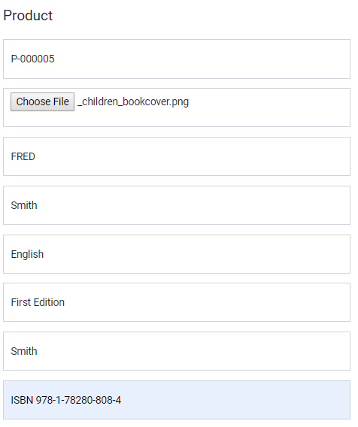

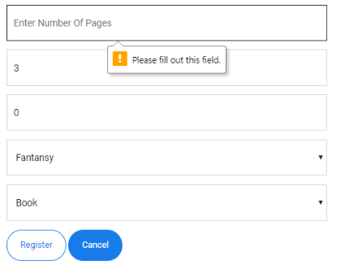

Fig: 6.6.2

|  |  |  |  |  |
| --- | --- | --- | --- | --- |
| Unit Test 6 | | Test Case : 6.7 | Designed by: Min Khant | |
| Data Source: Product Form | | Objective: Test the Product Form | Tester: Min Khant | |
| **Test Case** | **Description** | **Test Procedure** | **Expected Result** | **Actual Results** |
| 6.7 | Testing the Product table with the full and correct data | Set Product Name as FRED and Author as Smith and Language as English and Edition as First Edition and Publisher as Smith and Number Of Pages as 20 and Amount to Display as 3 and Quantity as 0 and Category as fiction and Item Type as Book and Allowlance Days as 1 Week and Amount of Fine as 1000Ks and click on the Register button. | Show Product Register Successfully Message. Insert into the database. | See Fig:6.7.2, Fig:6.7.3 and Fig:6.7.4 |

Before Testing

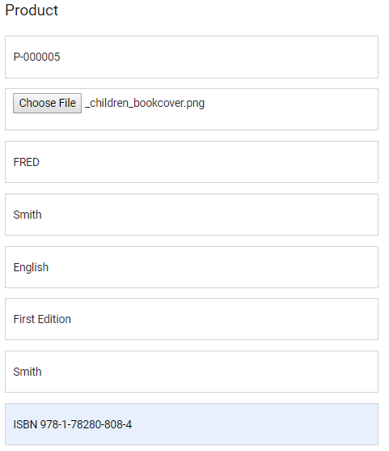

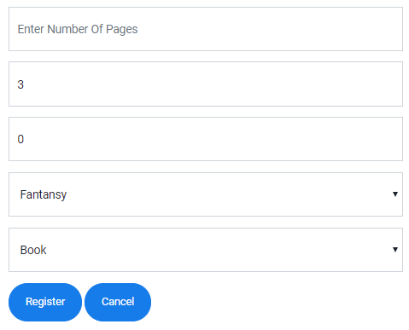

Fig: 6.7.1

After Testing

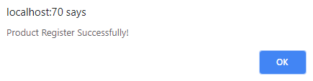

Fig: 6.7.2

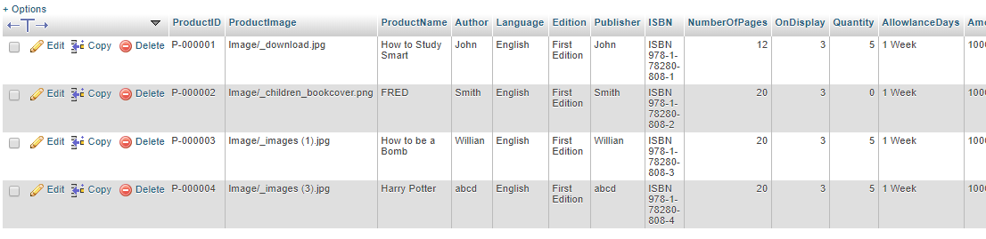

Fig: 6.7.3

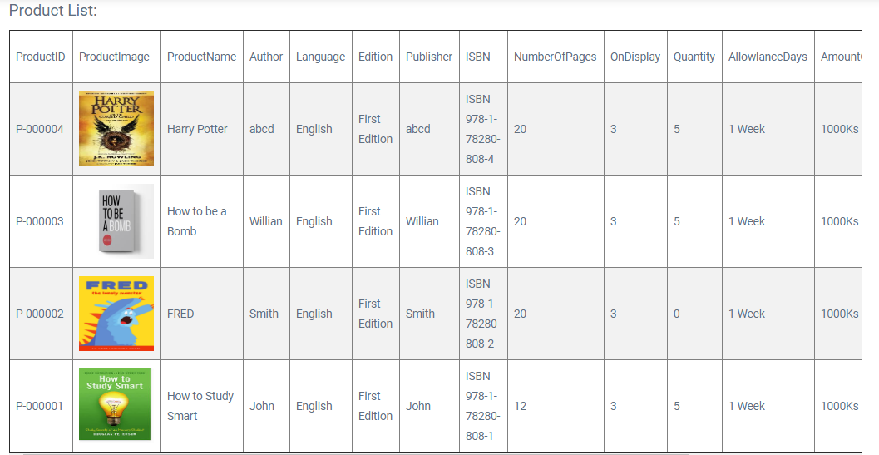

Fig: 6.7.4

|  |  |  |  |  |
| --- | --- | --- | --- | --- |
| Unit Test 7 | | Test Case : 7.1 | Designed by: Min Khant | |
| Data Source: Purchase Form | | Objective: Test the Purchase Form | Tester: Min Khant | |
| **Test Case** | **Description** | **Test Procedure** | **Expected Result** | **Actual Results** |
| 7.1 | Testing the Purchase Form whether the list of the purchase is arrived after the data are added | Select Product as P-000001 – How to Study Smart and Set Purchase Price as 3000 and Purchase Quantity as 5 and click the Add button. | Show the List of the Purchase of the product. | See Fig:7.1.2 |

Before Testing

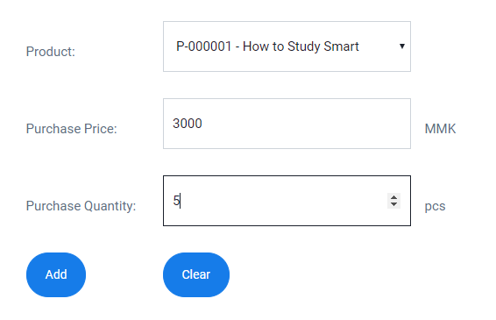

Fig: 7.1.1

After Testing

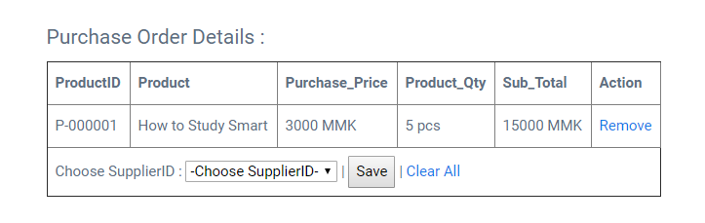

Fig: 7.1.2

|  |  |  |  |  |
| --- | --- | --- | --- | --- |
| Unit Test 7 | | Test Case : 7.2 | Designed by: Min Khant | |
| Data Source: Purchase Form | | Objective: Test the Purchase Form | Tester: Min Khant | |
| **Test Case** | **Description** | **Test Procedure** | **Expected Result** | **Actual Results** |
| 7.2 | Testing the Purchase Form that Grand Total and Vat and Total Amount are caulated automatically or not | Select Product as P-000001 – How to Study Smart and Set Purchase Price as 3000 and Purchase Quantity as 5 and click the Add button. | Show all the automatically calculated data at the associated places. | See Fig:7.2.2 |

Before Testing



Fig: 7.2.1

After Testing

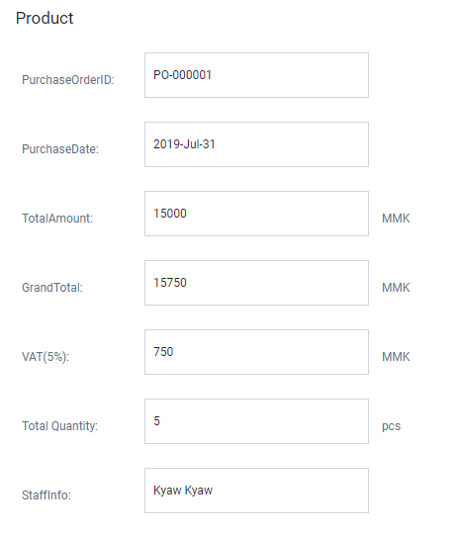

Fig: 7.2.2

|  |  |  |  |  |
| --- | --- | --- | --- | --- |
| Unit Test 7 | | Test Case : 7.3 | Designed by: Min Khant | |
| Data Source: Purchase Form | | Objective: Test the Purchase Form | Tester: Min Khant | |
| **Test Case** | **Description** | **Test Procedure** | **Expected Result** | **Actual Results** |
| 7.3 | Testing if the other purchase can be done whether the previous is listed | Select Product as P-000002 – FRED and Set Purchase Price as 2000 and Purchase Quantity as 5 and click the Add button. | . Show the List of the Purchase of the product. | See Fig:7.3.2 |

Before Testing

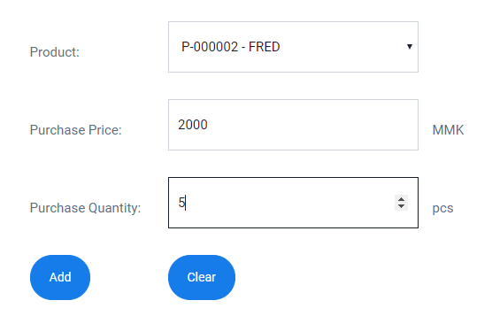

Fig: 7.3.1

After Testing

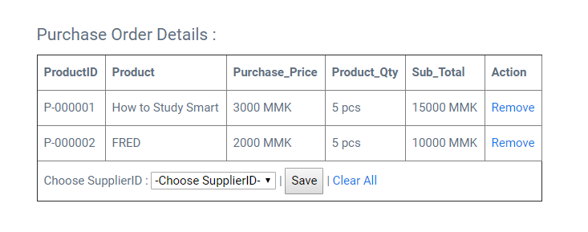

Fig: 7.3.2

|  |  |  |  |  |
| --- | --- | --- | --- | --- |
| Unit Test 7 | | Test Case : 7.4 | Designed by: Min Khant | |
| Data Source: Purchase Form | | Objective: Test the Purchase Form | Tester: Min Khant | |
| **Test Case** | **Description** | **Test Procedure** | **Expected Result** | **Actual Results** |
| 7.4 | Testing the Purchase Form that data are recorded into the database after choosing Supplier and Save button to register it into the database with the status Pending | After listing the product purchase is complete, choose Aye Aye from the supplier combo box and click Save button. | Show Purchase Order Process Complete and added into the database. | See Fig:7.4.2, Fig:7.4.3 and Fig:7.4.4 |

Before Testing

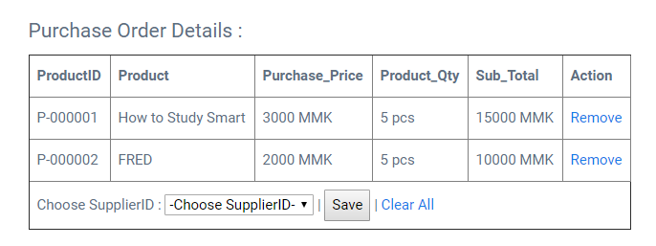

Fig: 7.4.1

After Testing

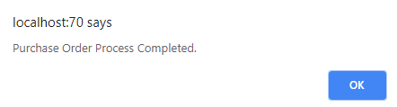

Fig: 7.4.2



Fig: 7.4.3

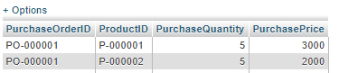

Fig: 7.4.4

|  |  |  |  |  |
| --- | --- | --- | --- | --- |
| Unit Test 7 | | Test Case : 7.5 | Designed by: Min Khant | |
| Data Source: PurchaseReport Form | | Objective: Test the PurchaseReport Form | Tester: Min Khant | |
| **Test Case** | **Description** | **Test Procedure** | **Expected Result** | **Actual Results** |
| 7.5 | After Purchasing the Product is complete, it register it into the database as Pending, in order to register it into the database actually the staff need to confirm it that it reaches into the library storage or not. | Click the Detail link from the Purchase Order List from PurchaseReport and click Confirm button to finish purchasing the product. | Show Product Order Process Successfully confirmed by the admin and change the record of Status from Purchase table of the library database. | See Fig:7.5.2 , Fig:7.3.3 and Fig:7.5.4 |

Before Testing

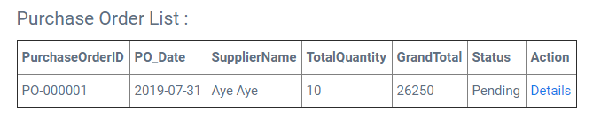

Fig: 7.5.1

After Testing

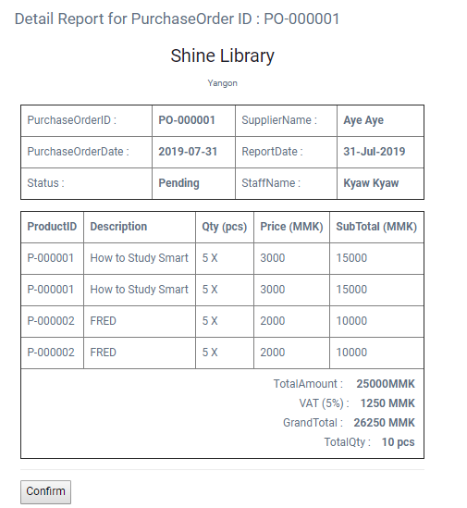

Fig: 7.5.2

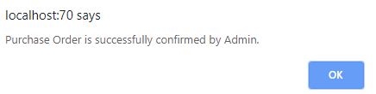

Fig: 7.5.3



Fig: 7.5.4

### Time Box 2: Member Register and Borrow Function

|  |  |  |  |  |
| --- | --- | --- | --- | --- |
| Unit Test 1 | | Test Case : 1.4 | Designed by: Min Khant | |
| Data Source: MemberType Form | | Objective: Test the MemberType Form | Tester: Min Khant | |
| **Test Case** | **Description** | **Test Procedure** | **Expected Result** | **Actual Results** |
| 1.4 | Testing with with the full and correct data of the MemberType Form | Set MemberType as Gold and AllowlanceItemAmount as 3 and Card Cost as 30000. Then click Register button. | Show MemberType Register Successfully Message. Insert into the database. | See Fig: 1.4.2 , Fig: 1.4.3 and Fig: 1.4.4 |

Before Testing

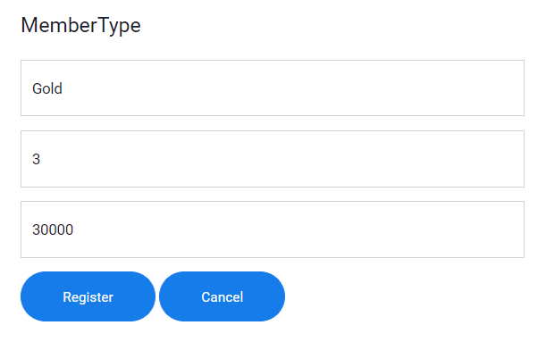

Fig: 1.4.1

After Testing

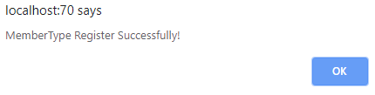

Fig: 1.4.2

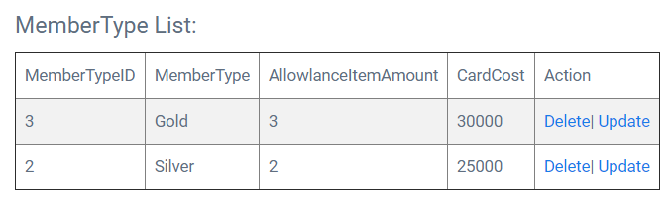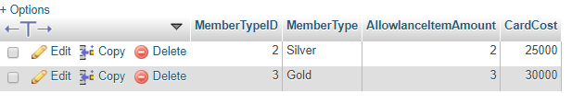

Fig: 1.4.3 Fig; 1.4.4

|  |  |  |  |  |
| --- | --- | --- | --- | --- |
| Unit Test 2 | | Test Case : 2.1 | Designed by: Min Khant | |
| Data Source: Member Form | | Objective: Test the Member Form | Tester: Min Khant | |
| **Test Case** | **Description** | **Test Procedure** | **Expected Result** | **Actual Results** |
| 2.1 | Register the Member data into the database without filling the MemberName | Null in MemberName, [zaw@gmail.com](mailto:zaw@gmail.com) in Email, Yangon in Address, 123456789 as NRC, 30 in age, 09789654 in Phone Number, 26/07/2019 in Register Date, 26/07/2020 in Expire Date and MemberType as Silver | Show Member Register Successfully Message. Insert into the database. | See Fig: 2.1.2 |

Before Testing

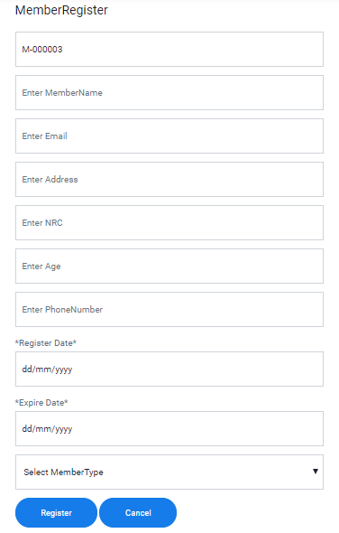

Fig: 2.1.1

After Testing

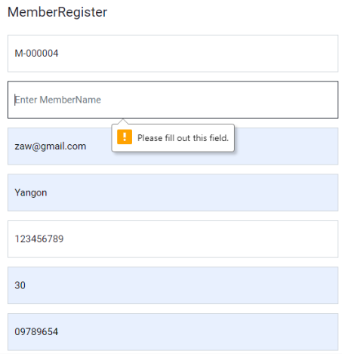

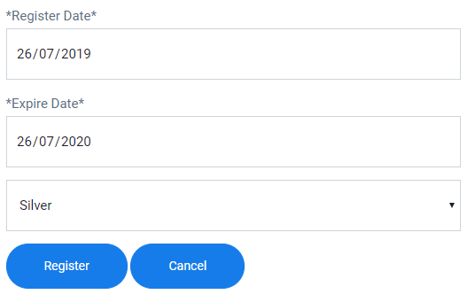

Fig: 2.1.2

|  |  |  |  |  |
| --- | --- | --- | --- | --- |
| Unit Test 2 | | Test Case : 2.2 | Designed by: Min Khant | |
| Data Source: Member Form | | Objective: Test the Member Form | Tester: Min Khant | |
| **Test Case** | **Description** | **Test Procedure** | **Expected Result** | **Actual Results** |
| 2.2 | Register the Member data into the database without filling the Member Email Address | Zaw Zaw in MemberName, null in Email, Yangon in Address, 123456789 as NRC, 30 in age, 09789654 in Phone Number, 26/07/2019 in Register Date, 26/07/2020 in Expire Date and MemberType as Silver | Show Member Register Successfully Message. Insert into the database. | See Fig: 2.2.2 |

Before Testing



Fig: 2.2.1

After Testing

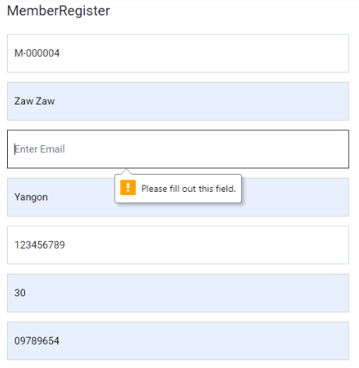



Fig: 2.2.2

|  |  |  |  |  |
| --- | --- | --- | --- | --- |
| Unit Test 2 | | Test Case : 2.3 | Designed by: Min Khant | |
| Data Source: Member Form | | Objective: Test the Member Form | Tester: Min Khant | |
| **Test Case** | **Description** | **Test Procedure** | **Expected Result** | **Actual Results** |
| 2.3 | Register the Member data into the database with the wrong format of Email Address | Zaw Zaw in MemberName, zawzaw in Email, Yangon in Address, 123456789 as NRC, 30 in age, 09789654 in Phone Number, 26/07/2019 in Register Date, 26/07/2020 in Expire Date and MemberType as Silver | Show Member Register Successfully Message. Insert into the database. | See Fig: 2.3.2 |

Before Testing



Fig: 2.3.1

After Testing

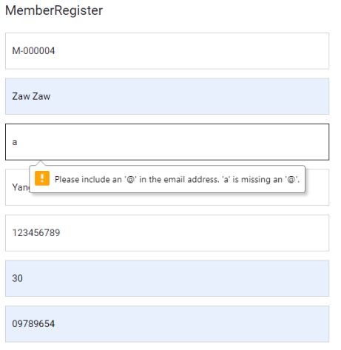



Fig: 2.3.2

|  |  |  |  |  |
| --- | --- | --- | --- | --- |
| Unit Test 2 | | Test Case : 2.4 | Designed by: Min Khant | |
| Data Source: Member Form | | Objective: Test the Member Form | Tester: Min Khant | |
| **Test Case** | **Description** | **Test Procedure** | **Expected Result** | **Actual Results** |
| 2.4 | Register the Member data into the database without filling the Member Address | Zaw Zaw in MemberName, [zaw@gmail.com](mailto:zaw@gmail.com) in Email, null in Address, 123456789 as NRC, 30 in age, 09789654 in Phone Number, 26/07/2019 in Register Date, 26/07/2020 in Expire Date and MemberType as Silver | Show Member Register Successfully Message. Insert into the database. | See Fig: 2.4.2 |

Before Testing



Fig: 2.4.1

After Testing

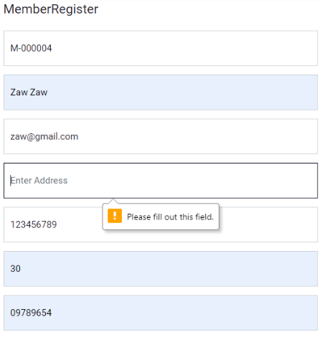



Fig: 2.4.2

|  |  |  |  |  |
| --- | --- | --- | --- | --- |
| Unit Test 2 | | Test Case : 2.5 | Designed by: Min Khant | |
| Data Source: Member Form | | Objective: Test the Member Form | Tester: Min Khant | |
| **Test Case** | **Description** | **Test Procedure** | **Expected Result** | **Actual Results** |
| 2.5 | Register the Member data into the database without filling the NRC | Zaw Zaw in MemberName, [zaw@gmail.com](mailto:zaw@gmail.com) in Email, Yangon in Address, null as NRC, 30 in age, 09789654 in Phone Number, 26/07/2019 in Register Date, 26/07/2020 in Expire Date and MemberType as Silver | Show Member Register Successfully Message. Insert into the database. | See Fig: 2.5.2 |

Before Testing



Fig: 2.5.1

After Testing

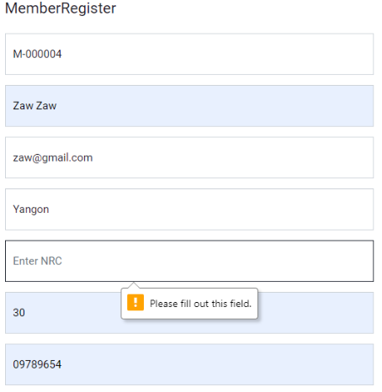



Fig: 2.5.2

|  |  |  |  |  |
| --- | --- | --- | --- | --- |
| Unit Test 2 | | Test Case : 2.6 | Designed by: Min Khant | |
| Data Source: Member Form | | Objective: Test the Member Form | Tester: Min Khant | |
| **Test Case** | **Description** | **Test Procedure** | **Expected Result** | **Actual Results** |
| 2.6 | Register the Member data into the database without filling Age | Zaw Zaw in MemberName, [zaw@gmail.com](mailto:zaw@gmail.com) in Email, Yangon in Address, 123456789 as NRC, null in age, 09789654 in Phone Number, 26/07/2019 in Register Date, 26/07/2020 in Expire Date and MemberType as Silver | Show Member Register Successfully Message. Insert into the database. | See Fig: 2.6.2 |

Before Testing



Fig: 2.6.1

After Testing

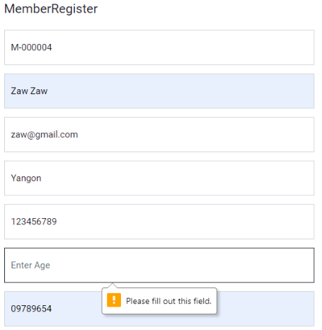



Fig: 2.6.2

|  |  |  |  |  |
| --- | --- | --- | --- | --- |
| Unit Test 2 | | Test Case : 2.7 | Designed by: Min Khant | |
| Data Source: Member Form | | Objective: Test the Member Form | Tester: Min Khant | |
| **Test Case** | **Description** | **Test Procedure** | **Expected Result** | **Actual Results** |
| 2.7 | Register the Member data into the database without filling Phone Number | Zaw Zaw in MemberName, [zaw@gmail.com](mailto:zaw@gmail.com) in Email, Yangon in Address, 123456789 as NRC, 30 in age, null in Phone Number, 26/07/2019 in Register Date, 26/07/2020 in Expire Date and MemberType as Silver | Show Member Register Successfully Message. Insert into the database. | See Fig: 2.7.2 |

Before Testing



Fig: 2.7.1

After Testing

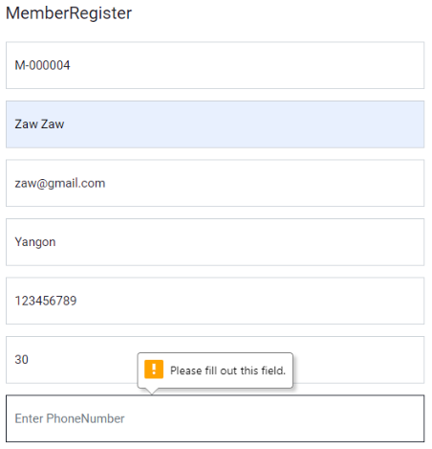



Fig: 2.7.2

|  |  |  |  |  |
| --- | --- | --- | --- | --- |
| Unit Test 2 | | Test Case : 2.8 | Designed by: Min Khant | |
| Data Source: Member Form | | Objective: Test the Member Form | Tester: Min Khant | |
| **Test Case** | **Description** | **Test Procedure** | **Expected Result** | **Actual Results** |
| 2.8 | Register the Member data into the database without filling Register Date information | Zaw Zaw in MemberName, [zaw@gmail.com](mailto:zaw@gmail.com) in Email, Yangon in Address, 123456789 as NRC, 30 in age, 09789654 in Phone Number, null in Register Date, 26/07/2020 in Expire Date and MemberType as Silver | Show Member Register Successfully Message. Insert into the database. | See Fig: 2.8.2 |

Before Testing



Fig: 2.8.1

After Testing

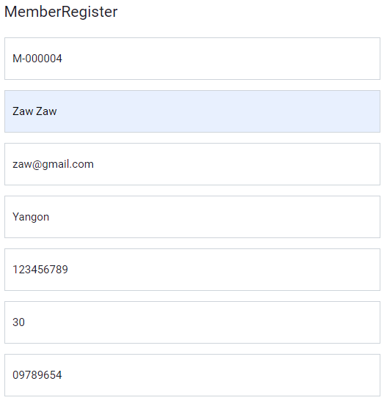

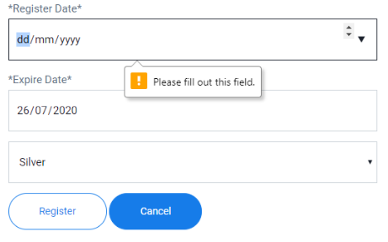

Fig: 2.8.2

|  |  |  |  |  |
| --- | --- | --- | --- | --- |
| Unit Test 2 | | Test Case : 2.9 | Designed by: Min Khant | |
| Data Source: Member Form | | Objective: Test the Member Form | Tester: Min Khant | |
| **Test Case** | **Description** | **Test Procedure** | **Expected Result** | **Actual Results** |
| 2.9 | Register the Member data into the database without filling Expire Date information | Zaw Zaw in MemberName, [zaw@gmail.com](mailto:zaw@gmail.com) in Email, Yangon in Address, 123456789 as NRC, 30 in age, 09789654 in Phone Number, 26/07/2019 in Register Date, null in Expire Date and MemberType as Silver | Show Member Register Successfully Message. Insert into the database. | See Fig: 2.9.2 |

Before Testing



Fig: 2.9.1

After Testing



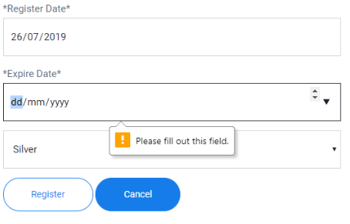

Fig: 2.9.2

|  |  |  |  |  |
| --- | --- | --- | --- | --- |
| Unit Test 2 | | Test Case : 2.10 | Designed by: Min Khant | |
| Data Source: Member Form | | Objective: Test the Member Form | Tester: Min Khant | |
| **Test Case** | **Description** | **Test Procedure** | **Expected Result** | **Actual Results** |
| 2.10 | Register the Member data into the database with correct and fully data | Zaw Zaw in MemberName, [zaw@gmail.com](mailto:zaw@gmail.com) in Email, Yangon in Address, 123456789 as NRC, 30 in age, 09789654 in Phone Number, 26/07/2019 in Register Date, 26/07/2020 in Expire Date and MemberType as Silver. | Show Member Register Successfully Message. Insert into the database. | See Fig: 2.10.2, Fig: 2.10.3 and Fig: 2.10.4 |

Before Testing



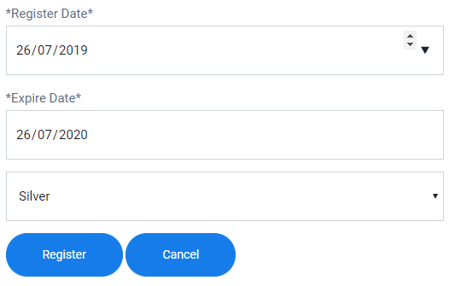

Fig: 2.10.1

After Testing

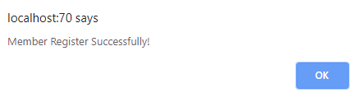

Fig: 2.10.2

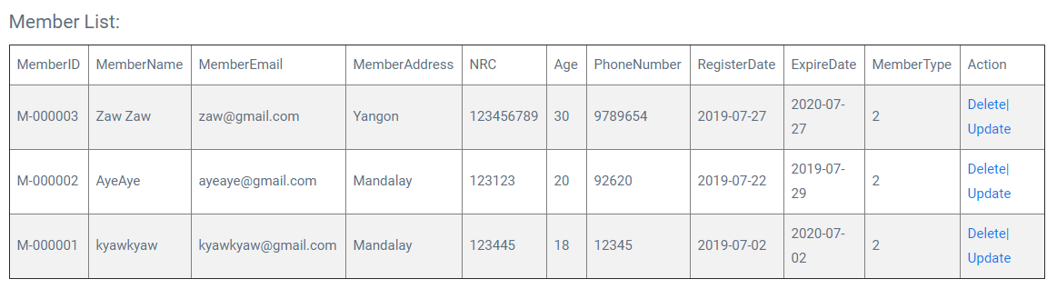

Fig: 2.10.3

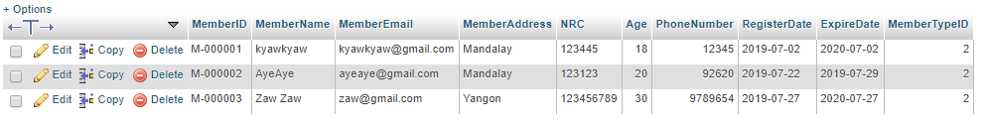

Fig: 2.10.4

|  |  |  |  |  |
| --- | --- | --- | --- | --- |
| Unit Test 3 | | Test Case : 3.1 | Designed by: Min Khant | |
| Data Source: Borrow Form | | Objective: Test the Borrow Form | Tester: Min Khant | |
| **Test Case** | **Description** | **Test Procedure** | **Expected Result** | **Actual Results** |
| 3.1 | Add all the filled data into the temporary table of the Borrow Form after clicking Add button | BO-000003 in BorrowID, How to Study Smart in BookName and 03/08/2019 in Return Date are filled. And then click Add button. | Show Borrow is listed Message and add the filled information into the temporary table. | See Fig: 3.1.2 and Fig: 3.1.3 |

Before Testing

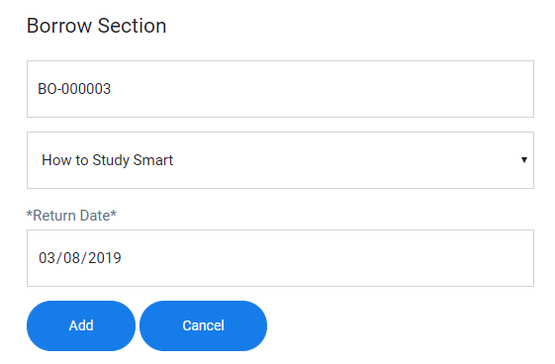

Fig: 3.1.1

After Testing

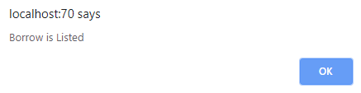

Fig: 3.1.2

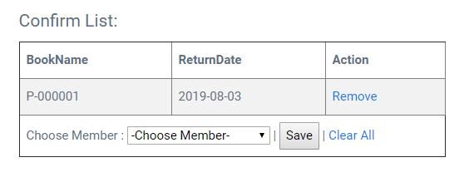

Fig: 3.1.3

|  |  |  |  |  |
| --- | --- | --- | --- | --- |
| Unit Test 3 | | Test Case : 3.2 | Designed by: Min Khant | |
| Data Source: Borrow Form | | Objective: Test the Borrow Form | Tester: Min Khant | |
| **Test Case** | **Description** | **Test Procedure** | **Expected Result** | **Actual Results** |
| 3.2 | After the information are added into the temporary table, add the another information into the table like the first method | BO-000003 in BorrowID, How to be a Bomb and 03/08/2019 in Return Date are filled. And then click Add button. | Show Borrow is listed Message and add the filled information into the temporary table. | See Fig: 3.2.2 and Fig: 3.2.3 |

Before Testing

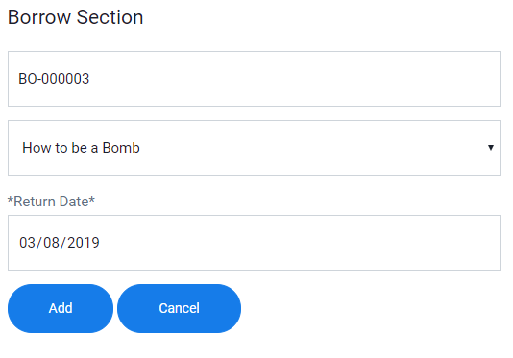

Fig: 3.2.1

After Testing



Fig: 3.2.2

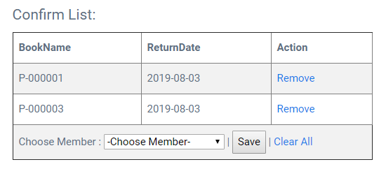

Fig: 3.2.3

|  |  |  |  |  |
| --- | --- | --- | --- | --- |
| Unit Test 3 | | Test Case : 3.3 | Designed by: Min Khant | |
| Data Source: Borrow Form | | Objective: Test the Borrow Form | Tester: Min Khant | |
| **Test Case** | **Description** | **Test Procedure** | **Expected Result** | **Actual Results** |
| 3.3 | After the filled information are reached into the table, select Member that is going to borrow those book and click Save to store into the database. | Select M-000002 – Aye Aye from the combo box and click Save button to register it into the Borrow table and BorrowDetail table. | Show Borrow Submitted Message and add the filled information into the Borrow table of the Library database. | See Fig: 3.3.2, Fig:3.3.3 and Fig:3.3.4 |

Before Testing

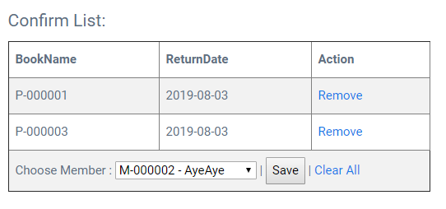

Fig: 3.3.1

After Testing

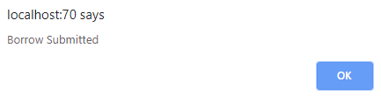

Fig: 3.2.3

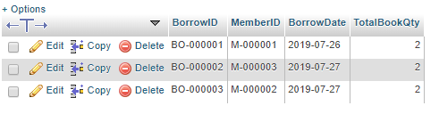

Fig: 3.3.2

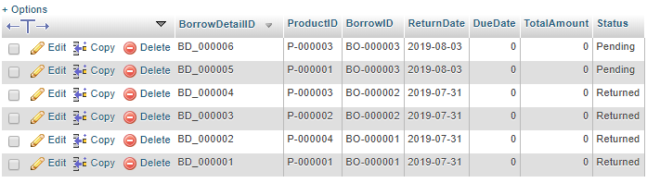

Fig: 3.3.3

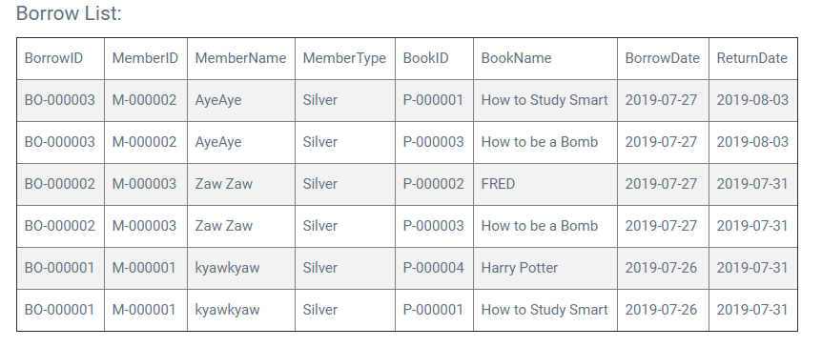

Fig: 3.3.4

|  |  |  |  |  |
| --- | --- | --- | --- | --- |
| Unit Test 3 | | Test Case : 3.4 | Designed by: Min Khant | |
| Data Source: Borrow Form | | Objective: Test the Borrow Form | Tester: Min Khant | |
| **Test Case** | **Description** | **Test Procedure** | **Expected Result** | **Actual Results** |
| 3.4 | When the borrow is stored into the database of the library, the associated amount of display books need to be reduced | Select M-000002 – Aye Aye from the combo box and click Save button to register it into the Borrow table and BorrowDetail table. Then the amount of OnDisplay needs to be reduced from Product table. | Reduce the amount of associated books from database. | See Fig: 3.4.2 and Fig:4.4.3 |

Before Testing



Fig: 3.4.1

After Testing



Fig: 3.4.2

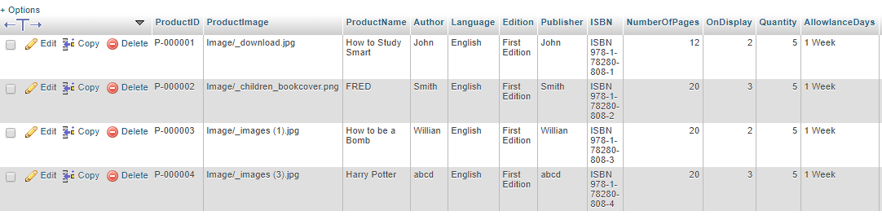

Fig: 3.4.3

### Time Box 3: Return and DueDate Calculation Function

|  |  |  |  |  |
| --- | --- | --- | --- | --- |
| Unit Test 1 | | Test Case : 1.4 | Designed by: Min Khant | |
| Data Source: Return Form | | Objective: Test the Return Form | Tester: Min Khant | |
| **Test Case** | **Description** | **Test Procedure** | **Expected Result** | **Actual Results** |
| 1.4 | After calculation of due date is done, select the returned bookname from the combox of the list and click return button to record in the database | After calculation is done, choose BO-000002 – FRED and click return button. | Show Return Process Successful and record into the database | See Fig:1.4.2 and Fig:1.4.3 |

Before Testing

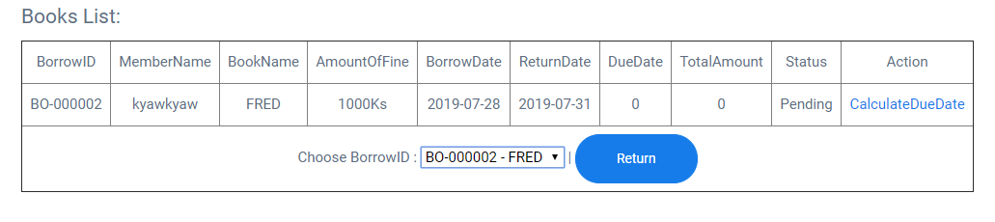

Fig: 1.4.1

After Testing

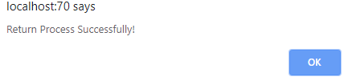

Fig: 1.4.2

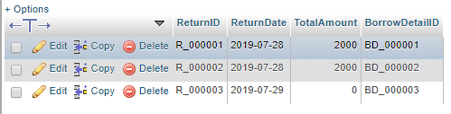

Fig: 1.4.3

|  |  |  |  |  |
| --- | --- | --- | --- | --- |
| Unit Test 1 | | Test Case : 1.5 | Designed by: Min Khant | |
| Data Source: Return Form | | Objective: Test the Return Form | Tester: Min Khant | |
| **Test Case** | **Description** | **Test Procedure** | **Expected Result** | **Actual Results** |
| 1.5 | After the recording the return is success, On Display from the Product table and Status from BorrowDetail will change | After the return process is complete, the information from OnDisplay from Product and Status from BorrowDetail will automatically change. | The data from the database change | See Fig:1.5.2 and Fig:1.5.3 |

Before Testing



Fig: 1.5.1

After Testing

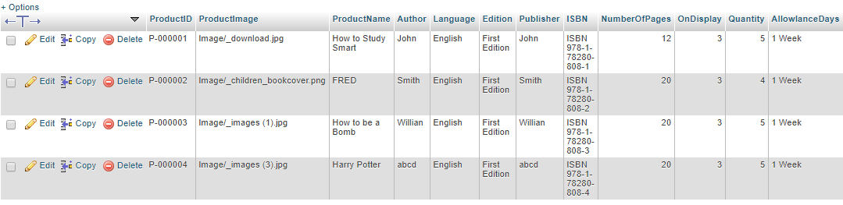

Fig: 1.5.2

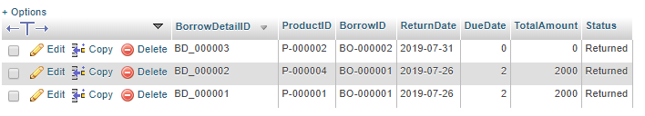

Fig: 1.5.3

|  |  |  |  |  |
| --- | --- | --- | --- | --- |
| Unit Test 1 | | Test Case : 2.1 | Designed by: Min Khant | |
| Data Source: Damage&Lost Form | | Objective: Test the Damage&Lost Form | Tester: Min Khant | |
| **Test Case** | **Description** | **Test Procedure** | **Expected Result** | **Actual Results** |
| 2.1 | All the other information from the from are filled expect the Status and save it | DL-000002 as DLID, M-000001 – kyawkyaw as MemberName, P-000002 – FRED as ProductName, Damage as Status, Description as null and 5000 as Amount to Pay and click Save button. | Show Damage&Lost Register Successful Message and register it into the database | See Fig:2.1.2 |

Before Testing

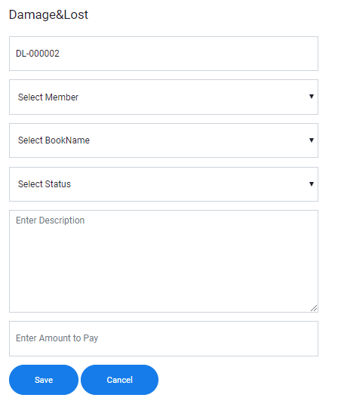

Fig: 2.1.1

After Testing

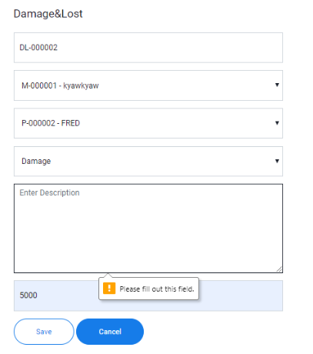

Fig: 2.1.2

|  |  |  |  |  |
| --- | --- | --- | --- | --- |
| Unit Test 1 | | Test Case : 2.2 | Designed by: Min Khant | |
| Data Source: Damage&Lost Form | | Objective: Test the Damage&Lost Form | Tester: Min Khant | |
| **Test Case** | **Description** | **Test Procedure** | **Expected Result** | **Actual Results** |
| 2.2 | All the other information from the from are filled expect the Amount To Pay and save it | DL-000002 as DLID, M-000001 – kyawkyaw as MemberName, P-000002 – FRED as ProductName, Damage as Status, Description as can be reuse if maintenance is performed and 0 as Amount to Pay and click Save button. | Show Damage&Lost Register Successful Message and register it into the database | See Fig:2.2.2 |

Before Testing



Fig: 2.2.1

After Testing

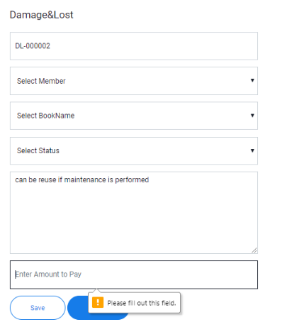

Fig: 2.2.2

|  |  |  |  |  |
| --- | --- | --- | --- | --- |
| Unit Test 1 | | Test Case : 2.3 | Designed by: Min Khant | |
| Data Source: Damage&Lost Form | | Objective: Test the Damage&Lost Form | Tester: Min Khant | |
| **Test Case** | **Description** | **Test Procedure** | **Expected Result** | **Actual Results** |
| 2.3 | All the other information from the from are filled and click Save button | DL-000002 as DLID, M-000001 – kyawkyaw as MemberName, P-000002 – FRED as ProductName, Damage as Status, Description as can be reuse if maintenance is performed and 5000 as Amount to Pay and click Save button. | Show Damage&Lost Register Successful Message and register it into the database | See Fig:2.3.2, Fig: 2.3.3 and Fig:2.3.4 |

Before Testing

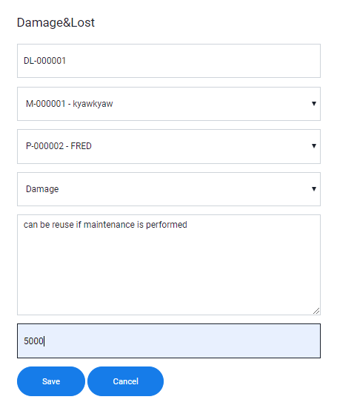

Fig: 2.3.1

After Testing

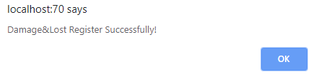

Fig: 2.3.2



Fig: 2.3.3

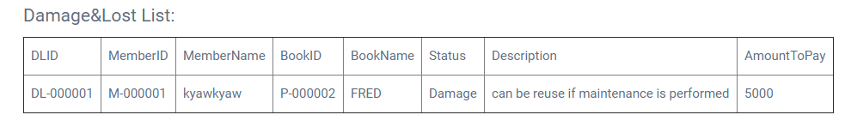

Fig: 2.3.4

|  |  |  |  |  |
| --- | --- | --- | --- | --- |
| Unit Test 1 | | Test Case : 2.4 | Designed by: Min Khant | |
| Data Source: Damage&Lost Form | | Objective: Test the Damage&Lost Form | Tester: Min Khant | |
| **Test Case** | **Description** | **Test Procedure** | **Expected Result** | **Actual Results** |
| 2.4 | After the registering of Damage&Lost information is successful, the record from Quantity of Product table and Status of BorrowDetail are changed | Record of Quantity from Product will reduce and the status from BorrowDetail will change automatiocally | Change the record from database | See Fig:2.4.2 and Fig:2.4.3 |

Before Testing



Fig: 2.4.1

After Testing

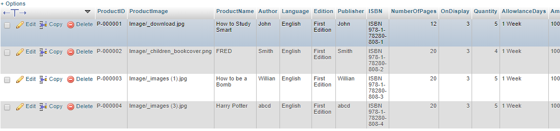

Fig: 2.4.2

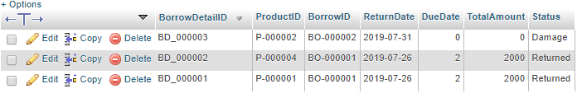

Fig: 2.4.3

## Class Diagram Detail (The Whole)

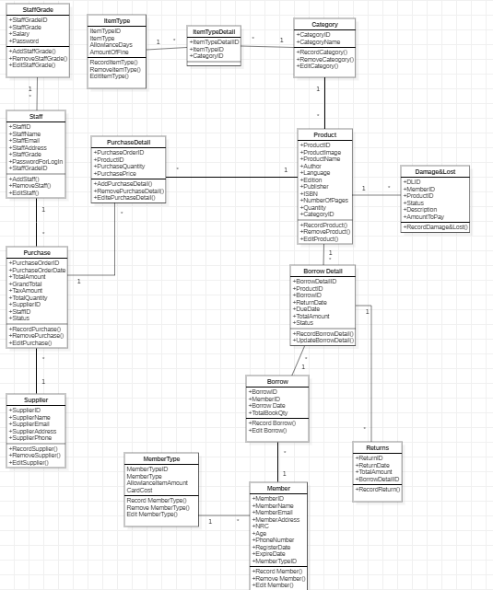

## Usecase Diagram (The Whole)

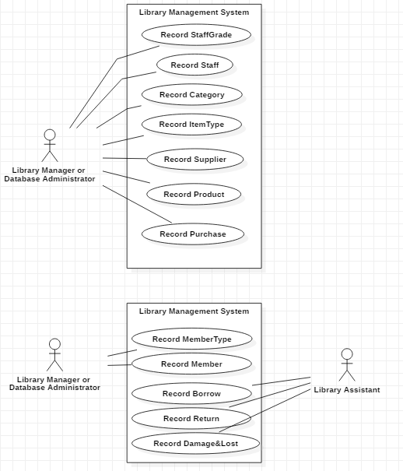

# Reference

*EDUCBA*. (-, - -). Retrieved from https://www.educba.com/asp-net-vs-php/: https://www.educba.com

*EDUCBA*. (-, - -). Retrieved from https://www.educba.com/ms-sql-vs-mysql/: https://www.educba.com

*flatworldsolutions*. (-, - -). Retrieved from https://blog.flatworldsolutions.com/10-differences-agile-waterfall-methodology/: https://blog.flatworldsolutions.com

*Medium*. (-, - -). Retrieved from https://medium.com/@mindfiresolutions.usa/a-comparison-between-mysql-vs-ms-sql-server-58b537e474be: https://medium.com

*PixelCrayons*. (-, - -). Retrieved from https://www.pixelcrayons.com/blog/web/php-vs-asp-net-how-to-choose-the-right-one/: https://www.pixelcrayons.com

*Quora*. (-, - -). Retrieved from https://www.quora.com/What-are-some-disadvantages-of-SSADM: https://www.quora.com/

*RISHABLESOFT*. (-, - -). Retrieved from https://www.rishabhsoft.com/blog/php-vs-asp.net: https://www.rishabhsoft.com

*smartsheet*. (-, - -). Retrieved from https://www.smartsheet.com/agile-vs-scrum-vs-waterfall-vs-kanban: https://www.smartsheet.com

*TECH ACADEMY*. (-, - -). Retrieved from https://agile.tech-academy.co.uk/8-principles/: https://agile.tech-academy.co.uk

*techopedia*. (-, - -). Retrieved from https://www.techopedia.com/definition/3983/structured-systems-analysis-and-design-method-ssadm: https://www.techopedia.com

*techopedia*. (-, - -). Retrieved from https://www.techopedia.com/definition/1180/data-migration: https://www.techopedia.com

*Techopedia*. (-, - -). Retrieved from https://www.techopedia.com/definition/3498/mysql: https://www.techopedia.com

*Techopedia*. (-, - -). Retrieved from https://www.techopedia.com/definition/1243/sql-server: https://www.techopedia.com/

*TechTarget*. (-, - -). Retrieved from https://searchstorage.techtarget.com/definition/data-migration: https://searchstorage.techtarget.com

*Vethics*. (-, - -). Retrieved from http://vethics.com/agile-software-development-and-its-advantages-and-disadvantages/: http://vethics.com